SR LAW SOLICITORS

INTRODUCTORY LEGAL GUIDE TO SONGWRITERS, PART 1

- songwriting splits: The very first thing a young/old/1st time songwriter who is recording, writing with a second party or 3 or 4 additional ‘co-writers’ should do is agree the writing shares between each party. If there are 2 songwriters it could be agreed that the songwriting share would be split down the middle 50/50. 3 writers: 2 at 33.3%, One at 33.34%. 4 writers: 25% for each writer.
- session agreements: If you are financing your single/album/EP project privately you may need ‘session’ musicians to provide musical accompaniment eg; Bass Guitar, Electric Guitar, Piano/Keyboards, Backing Vocals etc You would be best served to have agreements in place that state that the ‘session’ players have been paid an agreed fee and their recordings are owned by you the owner of the ‘sound recordings’ (Master File, Audio, Metadata, Streams) and as ‘Owner’ you have the right to cut, edit, delete ‘recordings’ as and how you wish, without prior approval for the ‘session’ musician.
- production agreements. You may wish to engage an individual to supervise the recordings and enhance those recordings by expanding the original basic ‘composition’ (song) with orchestrations, specific sounds that he has created, developed, is recognised throughout the Music industry eg: Drum ‘N’ Bass, R’n’B, House, ‘Pop’, Vocal Production etc
- What are percentages (%) for producers, arrangers. These percentages need to be agreed in advance and contracted. The Producer will receive an agreed amount of the RRP (Recommended Retail Price of album/single). It is the Owner of the ‘Sound Recordings’ responsibility and should be made clear in writing, to register with the correct Collection Society (PRS, MCPS, Harry Fox, ASCAP). This should be a featured clause in you ‘Production’ Agreement.
- Do engineers get a Percentage? Not in most situations. An Engineer is paid a flat hourly rate and is signed off for his services. There can be occasions when an Engineer will act as co-Producer of a ‘title’s recording session. This again, must be addressed before the first instrument is recorded.
- What are Sync’s? This is a License/written agreement to exploit/use your ‘title’/song/words & music in the use of a television programme, Feature Film, Commercial, Radio Jingle/’Ident’
- How do you earn from them? All Majors and a great many Independent broadcasting companies pay a fee for the use of music in their broadcasts. It is calculated at a 30 second usage rate determine by the time of day the broadcast airs, what channel and which territory it is broadcast in.
- How much can you earn from sync’s? There are two forms of income. The production company may opt for a straight ‘buy-out’. Offering you a single fee for the ‘ownership’ of the copyright. If this is the case, you will earn nothing more than that fee. If you opt to retain your rights, you will earn a royalty rate for the amount of time the ‘title’ is used and territories it is broadcast in. For example. If you wrote the title music for ‘Eastenders’ or ‘I’m A Celebrity’, you will be paid a Royalty for every time the music is played: Opening credits, Advert Breaks, End Credits, Commercials to advertise the upcoming series. Sample rates for radio broadcasts: 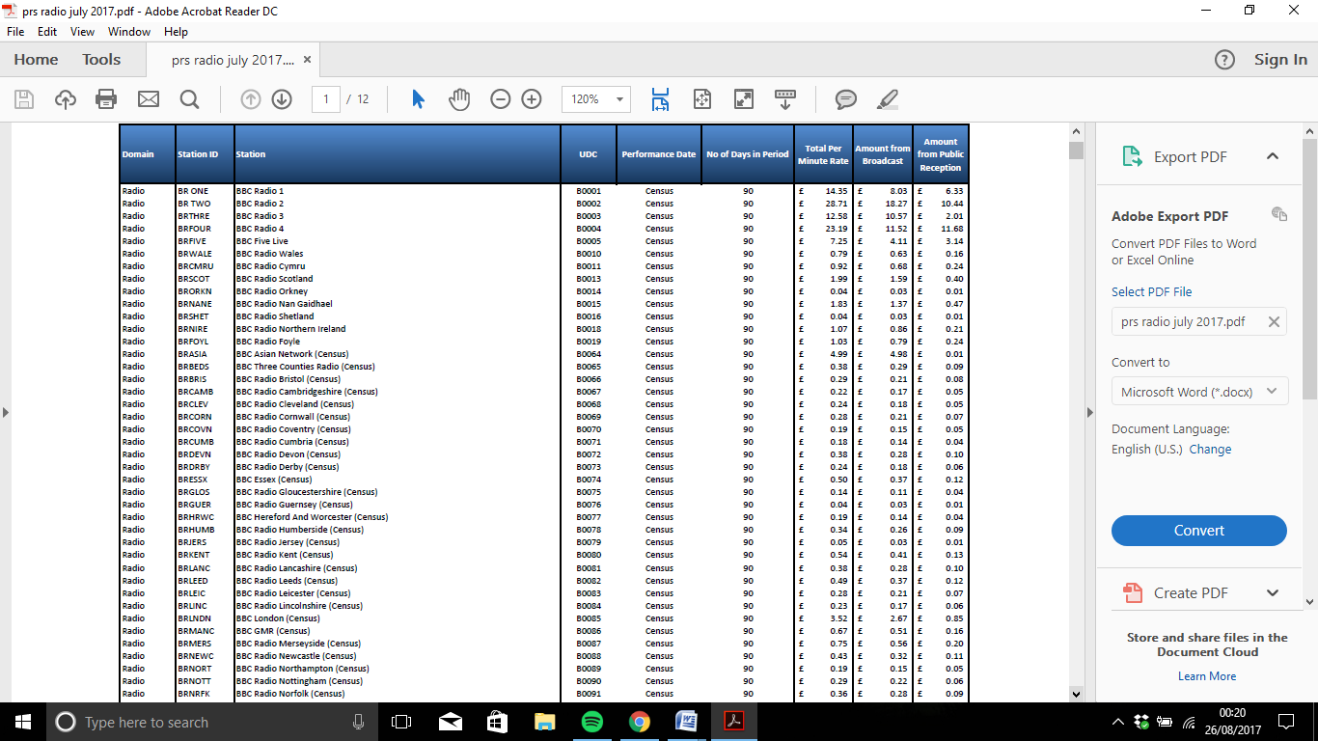

- Management Agreements – Why have them? A reputable Manager will be willing to promote your music through-out the Industry. Preferably, having had previous successes in the industry with artists/bands/songwriter and/or producer. Some Managers will focus on a particular style of music; R’n’B, Pop, Guitar based, Soul, Funk, Indie etc. A Manager will negotiate any contracts that arise from his formal introductions to Music Publishers, Record Companies, Promoters, PR Companies. Everyone that you will come into contact in your pursuit of commercial success.
- Who gets what? In the United Kingdom it is ‘common practice’ for the Manager to receive 20% of all Gross monies received from the exploitation of your ‘talents’ eg: songwriting, ‘Live’ Performances, record sales, music publishing royalties, promotional sponsorship. If your manager negotiates to engage another Manager for territories outside the UK, they will receive a % based commission also i.e.: for a territory such as the United States it is common place to engage a US Manager as the laws and jurisdictions across that country are different to the laws and jurisdictions of the United Kingdom.

Simons Rodkin Solicitors LLP – Music Division
We are an experienced legal firm, and are particularly strong in dealing with contentious/legal dispute work.

Our Music Consultant, David A.Nash, adds value to our work within the music law field,.

David is a music professional (composer, publisher and manager). He is also able to register works with relevant collection societies in different territories throughout the world.

Areas of music law work which we can/will assist include:
- Management Disputes
- Reviewing Publishing Agreements for Composers
- Producer Agreements
- Copyright Infringement
- Title Registrations
- Royalty Collection
- Session Agreements
- Artists Disputes
- Intellectual Property Rights
- Artistic Estate Management
Our hourly rates are cost effective, and competitive in comparison to other Law Firms.

We do and will consider fixed fees.

Contact us through email and/or by telephone.

Email (s) for Lawrence Rodkin (Partner) and/or David A.Nash (Music Consultant) are available on our company website: www.sr-law.co.uk

Telephone Numbers-
Finchley Offices 020 8446 6223
London (WC1) Offices 020 7112 8841
Out of Hours, text 0795 690 4537

Once we’ve received your enquiry, you’ll receive a no charge, initial telephone consultation to discuss your case. We may require you to have documented details ready to email/mail to us for our full understanding of your matter.

If your matter is urgent we can see you on the same day.

SR Law Solicitors, Music Lawyers

