Terms & Conditions of Hire
30 Mancroft Road Caddington Beds. LU1 4EL.
Tel: 01582 730 000
Email: info@riorodeo.com Mobile: 07540 572 701 / 07714 203 587

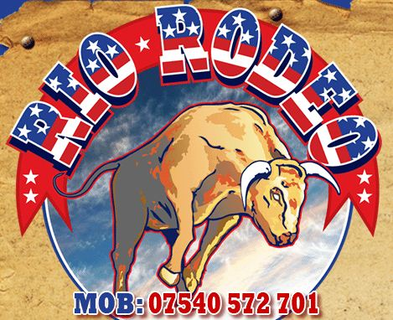
It is the responsibility of the Customer (Hirer) to work with the operator (Rio Rodeo) to ensure that all possible steps are taken to avoid damage to the operator, the inflatable, the motion ride, and injury to patrons.
Please ensure that the following safety instructions are adhered to:
- A space of up to 19ft and a clearance of 9ft in height is required – please ensure this is available.
(Be aware of hanging monitors, lighting, heaters etc. which can encroach into this space).
- NO person under the age of five is permitted on the equipment.
- NO food or drink to be consumed on the inflatable.
- ALL sharp items, including shoes, badges, jewellery, (ie. large earrings, necklaces, etc.) MUST be removed. It is recommended that spectacles are also removed.
- NO face-paints, party poppers, coloured streamers, or “silly-string” may be used in the vicinity of the inflatable. They can make a dreadful mess and can permanently damage the inflatable.
- NO smoking near the inflatable.
- NO climbing or sitting on the inflatable ring – this is particularly DANGEROUS when the ride is in motion and will not be allowed at any time.
- NO-one with a history of medical problems (ie. heart, back, neck or limb issues), will be allowed on the equipment. Pregnant ladies are also excluded.
- FOR personal safety, alcohol consumption must be kept to a minimum. The operator has the authority to refuse access to the ride, and will not be held liable should an accident occur for this reason.
- FOR their own safety, users ARE NOT allowed on the equipment until the inflatable mattress is fully inflated. They are also excluded during inflation or deflation.
- Riders take part at their own choice and risk and there is always a possibility of injury. All users of this equipment do so at their own risk and (subject to being operated in compliance with HSE and Manufacturers guidelines) the rider has no redress against the supplier, the operator, the venue or the hirer.
- IN the event of rain (if the equipment is sited outside), the equipment will be switched off and covered. If the cover is deployed, the equipment will remain operational.
- You must not participate on this equipment if you suffer from any heart, neck, back or limb problems, high blood pressure, bone weakness, pregnant or under the influence of drugs or alcohol.

These steps are designed to ensure maximum safety and enjoyment for riders, spectators and operator.
- A £50 deposit must be paid on return with a completed booking authorisation form.
- ALL deposits are non-refundable. If an alternative date is booked by you, your deposit will be carried forward.
- THE balance is payable 1 week before the function date by way of a cheque made payable to B Johnson, or by BACS, or by cash on arrival - if agreed with Rio Rodeo when making the booking.
- REFUNDS due to forecast adverse weather conditions will be made at 75% of the balance remaining. 25% will be retained by Rio Rodeo and charged as an administration fee. This only applies if no alternative date is booked with Rio Rodeo, whereby your full deposit will be carried over and no chargeable administration will be charged.

Thank you for your co-operation.
I hereby agree to abide by the terms and conditions listed above and enclose my deposit cheque made
payable to B Johnson.

HIRE DATE: ……………………………………………………
SIGNED: ……………………………………………………
NAME: ……………………………………………………
COMPANY NAME (if applicable): ……………………………………………………
JOB TITLE (if applicable): ……………………………………………………

