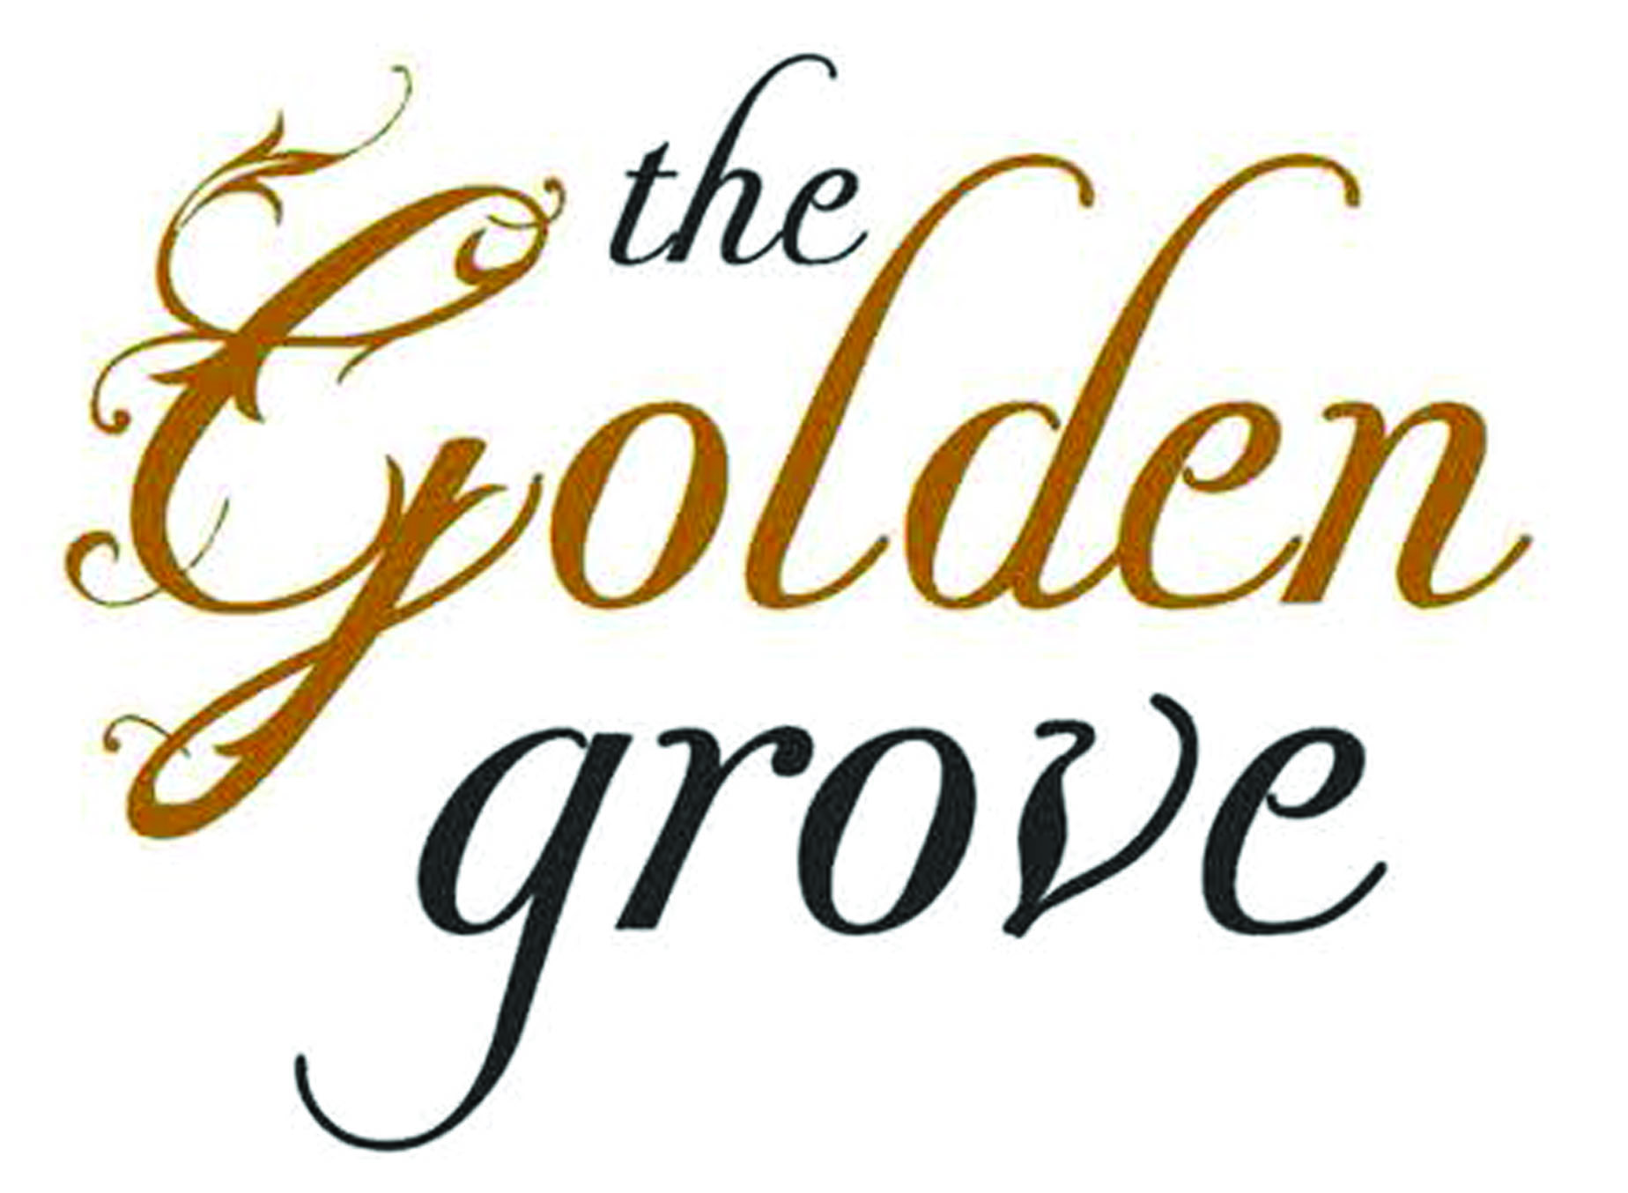

The Sunday Menu

Our food at the Golden Grove:

We always use fresh ingredients, and we always source
from local suppliers when we are able.

‘Fresh food, locally supplied’

Sandwiches: Locally baked White or Granary Bloomer served with dressed
salad leaves & potato crisps:
Locally salted Beef, Dill pickle, Mustard Mayo £7.00
In house Smoked Chicken Breast, Saffron Aioli, Rocket £7.00
Grilled Brioche, Parma Ham, Brie, Roasted Tomato Soup £7.00

Ciabattas: Locally baked rustic Ciabatta served with dressed salad leaves
& served with Home Fries:
Roast Mediterranean Vegetables, Mozzarella, Rocket £8.50
Char grilled Chicken Breast, Garlic Mayo, Baby Spinach £8.50
Steak, Caramalised Onions & Tomatoes, Rocket £8.50

Starters:
Seasonal Soup, Wensleydale Bon-bons £5.50
Potted Chicken Parfait, Port Jelly, Spiced Grape Chutney, Toasted Sour Dough £6.50
Pork Belly, Vanilla Apple Puree, Crackling, Smoked Apple reduction, Shakura Cress £7.50
Pan seared Scallops, Cauliflower Puree, Confit Chicken, Apple & Red Wine Jus £8.00

Salads:
Classic Caesar Salad: Char Grilled Chicken Breast, Little Gem Leaves, Crispy Pancetta, £12.50
Anchovies, Garlic Croutons, In house Dressing, Shaved Parmesan

Cob Salad: Smoked Chicken Breast, Baby Leaves, Cherry Tomatoes, Egg, Crispy Bacon, £14.50
Fine Beans, Stilton cheese, Avocado, Pear & Mustard Dressing

Burgers: Home-made Gourmet Burgers, Toasted Brioche Bun, Beef tomato,
Relish, Mayo, Iceberg Lettuce, Pickle, Home Fries & Dressed leaves:
Plain Burger £10.50
‘Veggie’ Grilled Field Mushrooms, Blue Cheese £8.50
Cheese Burger – Cheddar or Blue Cheese £11.50
Cheese & Bacon £12.00
Tommy ‘D’ Burger: 10oz Gourmet Burger, Crispy Pancetta, Beef Tomato, Cheese, £13.00
Mayo, Dill Pickle, Crispy Lettuce, Chilli Jam, Dressed leaves & Home Fries

Main Courses
Deep Fried Haddock in our Beer Batter, Pea & Tarragon Puree, In-house Tartare Sauce,
& Home Fries. £12.50

Sunday Roasts: All Roasts come with Goose Fat Roast potatoes, a dish of Cauliflower
Cheese, a dish of Seasonal Vegetables, and Roast Gravy:

Half Roast Chicken, Pork, Sage & Onion Stuffing £12.50
Roast Leg of Lamb, Apricot, Pork & Thyme Stuffing £12.50
Roast English Sirloin of Beef, Yorkshire Pudding £12.50
Children - Half portion of above roasts £6.00

Sides: £3.00
Fresh Seasonal Vegetables, House Coleslaw, Onion Rings, House Mixed Salad,
Garlic Ciabatta, Home Fries, Skinny Fries

Desserts: £5.00
Fresh Strawberries & Shortbread Tower
Cider Sticky toffee Pudding, Toffee Sauce, Vanilla Ice Cream
Lemon Verbena, Meringue
Pimms Fruit Jelly, Pouring Cream
Chocolate Brownie, Pistachio Crumb Vanilla Ice Cream
Cheese plate, House Chutney, Basket of Breads & Biscuits, Celery, Apple Add £2.50

SPECIALS BOARD
Please see our Specials board for more options when available

CATERING FOR ALL OCCASIONS
We cater for all occasions: Christmas, Birthdays, Weddings, Parties, Business meetings etc.
Please ask for details.

ALLERGY INFORMATION
“We work closely with our suppliers and our food safety partners to ensure that our information is correct and
customers with allergies feel reassured that we will look after their needs properly. We therefore ask that you inform your bar staff or waiter before ordering of any specific dietary requirements that you may have.”

NB: All prices inc VAT. All items subject to availability. Ice cream not suitable for lactose intolerant persons.

Free Wi-Fi, car parking. All major credit cards accepted.
The Golden Grove, Ruxbury Rd, Chertsey, KT16 9EN
www.thegoldengrove.co.uk. Email: info@thegoldengrove.co.uk Tel: 01932 562 132

