International Certified Master Groomers UK offer qualifications for dog grooming professionals. The CSP course is ideal if you want to begin working in the dog grooming industry and want to learn the skills you require for working within the dog grooming industry. The course is run within the commercial salon Sue Oliver Dog Grooming Studio in Derbyshire. You will work within the commercial grooming salon and gain a realistic experience within the grooming industry. Assessment’s will take place at the end of the course and are in the form of one written exam and one practical exam to become a Certified Salon Professional.

Times

Dates
Mondays starting 6th Feb 2017
Tuesdays starting 7th Feb 2017
Fridays starting 17th March 2017
More dates throughout the year

Course Content
You will learn a range of dog grooming skills which include:
Bathing and drying
Clipping and styling
Hand stripping techniques
The healthy pet
Vaccinations, ears, eyes, teeth, anal gland care.
Skin and hair growth, shedding
Bathing and drying methods and considerations
Health and Safety for the Professional Groomer
Canine behaviour and handling tips
Professionalism and ethics within grooming
Grooming Cats -Knowledge and understanding
Diseases
Cleaning and disinfecting
Business and legal matters

10am to 4pm - 15 weeks

Where is the Course Delivered
Sue Oliver Dog Grooming Studio
Stanley Common
DE76FP

Cost
Tuition Fees: £1432.00
This includes exam fees and study guides.
Classes are a maximum of 5 people so you get great one to one training.
You must be a member of ICMG to take the exam.

Entry Requirements
You should have a keen interest in dog and become a member of ICMG UK

Additional Costs and/or Specialist Equipment
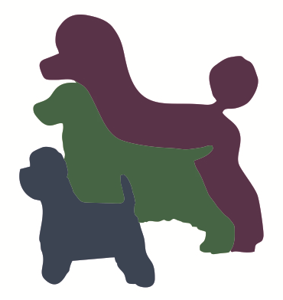
You are required to purchase a scissor set and salon grooming shirt when you enrol at a cost of £135.00
Clothing should be sensible footwear, trousers/jeans
The salon will provide grooming equipment to be used whilst on the course.

