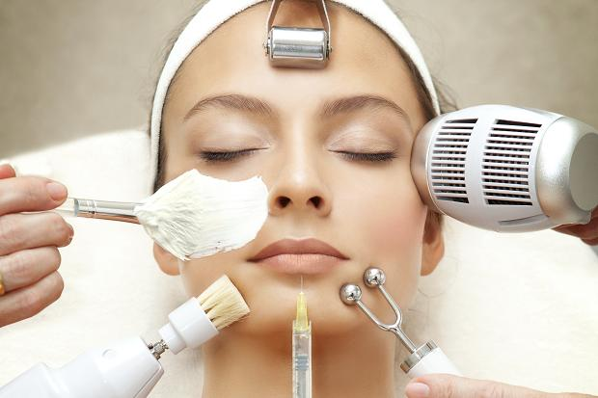
NEW!!
Electronic Facials/Non Surgical Face Lifts Available
Electronic facials are a professional salon treatment using Microcurrent for face contour lifting. In combination with a deep cleanse and penetration of active ingredients in the form of targeted gels and ampoules, the treatment offers THE Ultimate in Facial Skin Care. It is preventative and corrective, so suitable for all ages.
Treatments Include...
High Frequency Direct Vacuum Suction
Warms skin tissues Improves lymphatic flow
Increases blood circulation Improves blood circulation
Increases lymphatic flow Reduces puffiness
Increases cell metabolism Removes dead skin cells
Stimulation of nerve endings Cleansing effect
Suitable for Dry/Oily skin types Reduces fine lines & wrinkles
Stimulates sebaceous glands activity
High Frequency In-Direct Galvanic
Increases activity of sebaceous glands Cleansing action
Increases blood circulation Increases blood circulation
Nourishes the skin Increases lymphatic flow
Suitable for Dry skin Introduces water-soluble ingredients
Reduces fine lines and wrinkles to the skin
Improves colour of the skin Removes dead skin cells
Improves texture of the skin Reduces swelling
Suitable for different skin types & conditions

MANY MORE TREATMENTS AVAILABLE, ASK BEAUTY THERAPIST IN SALON FOR FURTHER INFORMATION.
Circa Carrino.

