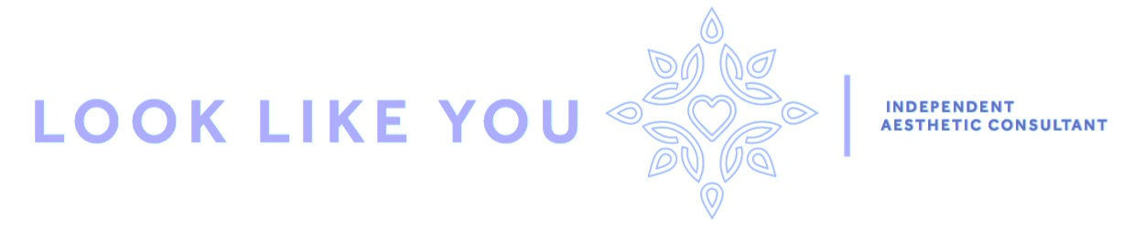
Friendly, North Yorkshire based anti wrinkle and dermal filler consultant with over 25 years medical training and specialist infection control experience
My aim is to make people feel confident and self-assured with their appearance without invasive surgery. Helping people feel great about the way they look but on their best day.
Full information on treatments and prices can be found on my website. www.looklikeyou.co.uk
Anti Wrinkle Treatment | Product - Botox
Prices are dependant on the areas treatment is required. For example around the eyes is classed as 1 area with the forehead and glabella classed as 2 areas.
1 Area | £170
2 Areas | £240
3 Areas | £285
Dermal Fillers | Product - Juverderm
Prices are dependant on the amount of filler required to ensure a good treatment outcome. eg 1cc of filler will probably treat moderate marionette lines. You can use a 1cc syringe to enhance lips and naso-labial folds etc. 2cc may be needed if creases are deeper etc.
5cc | £165
1cc | £250
1.5cc | £300
2cc | £440
Consultation
Free consultation offered to ensure the client suitability for treatment including complete consultation. During the consultation it is necessary to obtain medical history including allergies and previous treatment and to discuss any potential side effects ensuring clients are fully informed of the expectations of treatment and any risks.
I am a member of both the British Association of Cosmetic Nurses and The Royal Society of Medicine. I have indemnity Insurance to practice anti-wrinkle treatment (Botox) and Dermal fillers through Hamilton Fraser Cosmetic Insurance.
Sharon Hunter
Aesthetic Nurse Practitioner
Registered General Nurse DipIC

