From Paper to Fabric
Keeping the Mountains close…
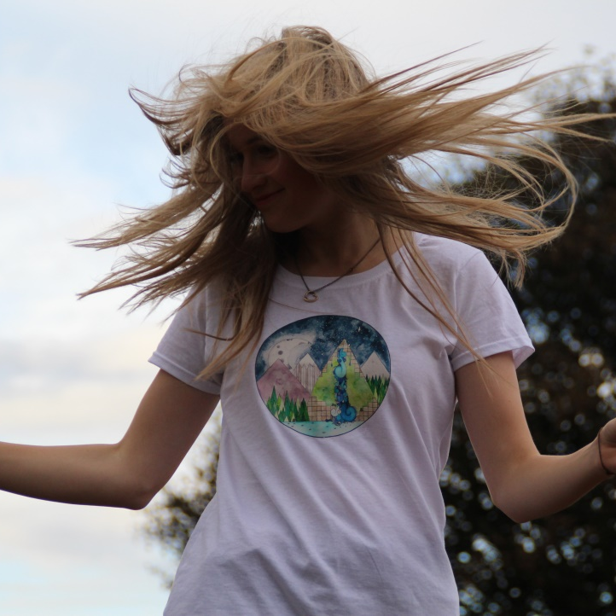
My name is Rebecca Eaton, more commonly known as Becky. I'm twenty years old and was born in Surrey, raised in Scunthorpe. My passions in life are Art and skiing, they seem to complement each other as when the snow melts in April, I can draw, paint and design until the next snowfall.
I love nature and it’s the main feature in my artwork. One person that hugely developed my love of nature was my Geography teacher, Mr Wharton. He was incredible. I think I got a C in GCSE Geography, but his love of the environment and passion for the world was what encouraged me to create pieces full of nature. To this day I continue to appreciate and enjoy nature, and try to represent it through my art as beautifully as I can.
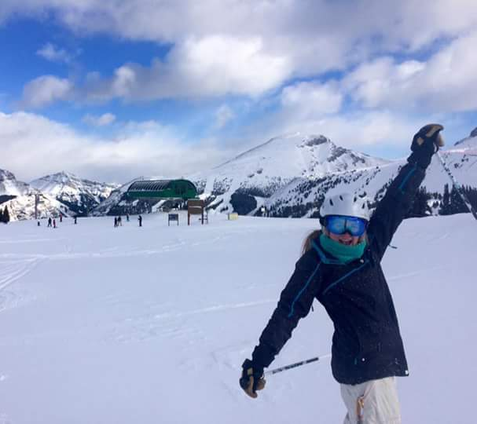
I started attending an art group in Winteringham with my boyfriend’s Grandma. I remember going on the first Friday morning with nothing and being given paper and my first set of watercolour paints. I’m so grateful to the men and women at this group as this totally inspired me and changed the way I worked as an artist.
In November 2016 I, along with my boyfriend, jetted off to Canada to become ski instructors for a season. We lived and worked in Banff, a town in the Rockies and of course the centre of Banff National Park. This has been the biggest influence of my art today. Inspired by the mountains above me, the nature around me and the people I met. You’ll see in my artwork that mountains are the main part, I try to include the people and all their walks of life, even the animals I encountered get a spot!
While visiting various ski resorts throughout my life I’ve tried to collect a souvenir, usually a t-shirt. This, along with family and friends support gave me the idea of creating t-shirts with my artwork on them! I hope you enjoy wearing yours and keep the mountains close!
Becky
x

