What are the top 10 drug rehab marketing blog mistakes?
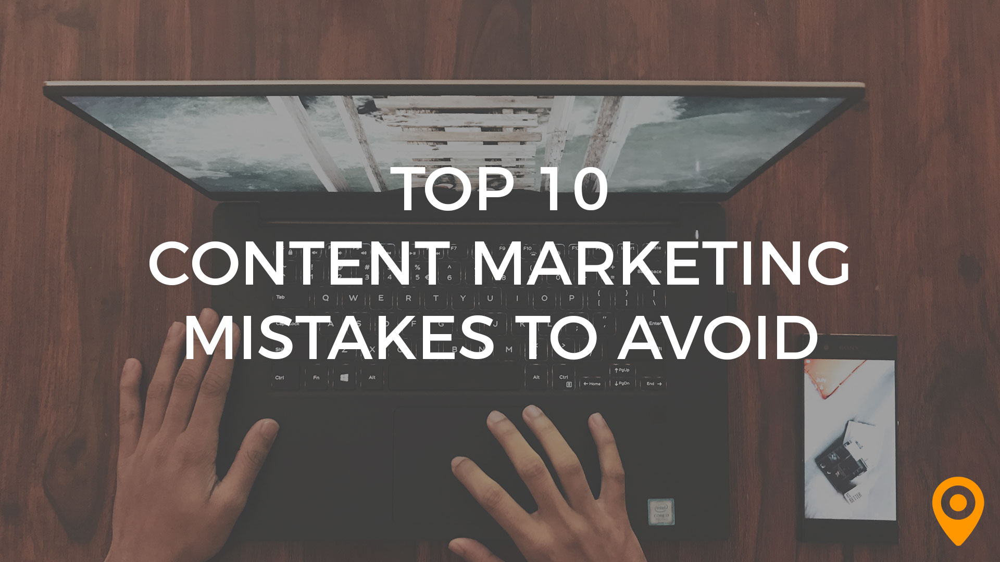

Drug rehab SEO blog writing is a vital area that many addiction treatment centers are missing. Above all, a blog has one main purpose and that is to generate leads. Similarly, it is the most important web marketing tool. Many drug rehabilitation centers are missing the big picture when it comes to their blog.

The Main Goal of Drug Rehab SEO Blogs
The behavioral health industry has operated for years with short-term solutions in generating clients. CEO and marketing directors expect immediate results. This is because they have been able to get by with Google Adwords and buying treatment calls. The business and marketing landscape have changed. The mentality of buying or obtaining a singular thing to generate immediate calls is gone.
Ranking organically on Google for keywords is one of the biggest area’s centers can generate treatment leads. However, understanding of SEO is paramount. Google uses over 200 things to rank for SEO. Think of Google as the most popular kid at school. The first thing you have to do is introduce yourself. After that, you have to become friends and let Google get to know you. Then you need to get intimate, so Google knows everything about you. The only way to do that is through content.
The main goal of blogs is to get your target audience to read it. The #1 way to accomplish this is to get your blog posts on page one of Google. However, it takes many specific components to achieve this status. This is also the best way to compete against the big players.
We look at substance abuse treatment centers websites every day. Over half of them do not even have a blog. Out of the remaining, only a few have any search engine optimization. Just throwing up a 600-800 word blog post has very little chance of ranking. A blog needs to be strategically built to rank.

Wasted Marketing Budget on AdWords and Legit Script
Remember the big picture is to get ranked organically on page one of Google for the long-tail keyword. Getting on page one could mean 1000’s of high quality and targeted organic calls. Many centers think the only way to accomplish this is through AdWords and PPC. They could save big money if they spoke with a drug rehab SEO marketing consultant.
There is a high cost to play in that game. You have the initial Legit Script certification, then an annual fee. The bigger picture is you are competing against big players spending in excess of $500,000 per month. In addition, you have to pay over and over again for the leads. Once you get organically on page one, you tend to stay there for a long time.
AdWords and PPC will produce calls however, their quality is generally poor. A small budget of $5000 – $10,000 a month will get eaten up quickly. A fraction of the budget would be better spent on organically ranking. In addition, with AdWords, you tend to get a lot of Medicaid and Medicare calls. Consider this, PPC ads on page one only receives 1.81% of the click-throughs. The Google Maps and top three organic listings get 60-70% of page one clicks.
The #1 mistake made in our industry is treatment centers produce blogs that are all about them. This not only shows through on their blogs but also with their poor social media marketing. You need high-quality content that is valuable to the reader. If your blog is poor, then your web marketing strategy is poor.

Top 10 Mistakes Made with Drug Rehab SEO Blog Writing
What are the top 10 mistakes made with drug rehab SEO blog writing? CEO’s and Marketing Directors tend not to completely understand the common mistakes made with their blog. You may also be interested in the common mistakes made in drug rehab SEO website development. In addition, you must be aware that blogs should touch the reader on an emotional level. If the blog post is attracting, engaging and touches on that level, chances are high they will call.
- Google My Business Listing is incomplete and not updated regularly.
- A long-tail keyword is not in the URL.
- The long-tail keyword is not the blog title.
- Improper use H Tags (H1, H2, H3, etc…)
- ALT descriptions are not completely filled in (main title, ALT title and 2 sentence description with the keyword.
- SERP description should be 160 charters and include the long-tail keyword.
- Blog posts are too short, they should be at least 1,500 words.
- Content is not attracting and engaging to the reader (blogs are not about the services offered by the center.)
- LSI words are not used.
- Too many orphaned posts.

Take Inventory of Blog Posts and Where They Rank on Google
Get an SEO keyword report for your treatment center. If you cannot do this, give us a call at 561-235-6195 and we will run one for you. This report will show how many words your center is ranking for and what pages they are on. It is often best to have a third party provide this information. Having this report will provide valuable intelligence on the effectiveness of your marketing.
This report will also aid in finding out what your competition is doing with their drug rehab SEO marketing strategy. Some savvy operators are raking in organic rankings because many centers are not utilizing SEO. You should at the very least be ranking for your main services followed by the city your center is located in. Here are just a few you should be ranking for, there are many more. Try and Google some of the following:
- drug rehabs (followed by your city)
- inpatient drug rehabs (followed by your city)
- outpatient drug rehabs (followed by your city)
- intensive outpatient drug rehabs (followed by your city)
- sober homes (followed by your city)

Leading by Example with our Drug Rehab SEO Marketing and Blog Writing
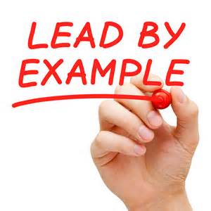
Behavioral Health Network Resources leads by example with our drug rehab SEO blog writing. Our organization ranks for over 750 keywords. Some of these keywords are for marketing like drug rehab SEO and drug rehab marketing.
We also purposely rank for keywords that centers need to rank for. Ranking for keywords on services your website doesn’t offer is more difficult. Below is a list of some ranking keywords for our organization and our customers:
- drug rehabs West Palm Beach (Behavioral Health Network Resources)
- opiate detox West Palm Beach (Behavioral Health Network Resources)
- sober homes West Palm Beach (Behavioral Health Network Resources)
- California drug rehabs (Behavioral Health Network Resources)
- drug rehabs New Jersey (SOBA College Recovery)
- young adult drug rehabs New Jersey (SOBA College Recovery)
- outpatient drug rehabs New Jersey (SOBA College Recovery)
- drug rehabs Los Angeles
- substance abuse billing (Behavioral Health Network Resources and Advanced Data Systems Corp)
- drug rehabs in Florida

These are all highly competitive keywords in large markets. Getting these profiles and blogs to rank is no easy feat. It takes strategically built blogs with distribution channels to get them to rank.

Addiction Conferences Educating on Business and Drug Rehab Marketing
We educate CEO’s, Executives, and Directors on ethical business and marketing strategies. Our Addiction Conferences EMP series has held 15 c-suite conferences. These conferences provide proven strategies and techniques to survive the changes in our industry.
Each behavioral health event has 5 Executive thought leader panelists. The conferences are in a talk show host/town hall forum. We interview the panelists in front of our audiences of 100-200 attendees. We then turn over the event to the entire audience. They have been successful because they get to the operating pain points of treatment center operators.
Our next addiction conferences EMP Series event is in California on 8/6/19. The Recover is Co-host, and Rehab Marketing Pros is Co-hosting. For more information go to https://www.benhavioralhealthnetworkresources.com, or call Charles Davis at 561-235-6195.

Blog Content Relates to Lead Generation
We get 100’s of posting requests in our 60 social media groups every day. These groups have in excess of 210,000 members. They are on LinkedIn (12 groups and Facebook 40 groups.) These groups are unlike other groups in that we check all the posts before we approve of them. We do not let poor quality posts through. The content we do approve must be of high quality. They must be on a website and provide value to the reader. Check out our Facebook leading addiction professional referral group with over 19,000 members.
Many outreach professionals are attempting to post poor quality content. This does not produce calls and also damages the brand of the organization. Some of the poor-quality posts include:
- memes
- any posts that do not link through to a website
- we are an intensive outpatient treatment center and JACHO accredited
- we have beds available
- telling a story not linked to a website or blog and saying CALL XXX-XXX-XXXX, I can help.
These are only a few examples there are many more. Part of the problem is the management doesn’t respect or understand how to use drug rehab social media marketing. Providing marketing tools and developing a plan with all employees plays a critical role. Part of that is the blog writing MUST be attracting and engaging while hitting the pain point.

Learn More About Our Drug Rehab SEO Marketing Blog Writing Service
The behavioral health industry has experienced many business, operational and marketing changes over the last 12 months. Drug and alcohol addiction treatment centers are closing because they refused to change. They thought they could continue to operate without a detailed marketing plan. They thought they could survive with just boots on the ground tactics and Google AdWords. Relying only solely on these is extremely risky.
Search engine optimization takes time and is a long-term strategy. We get many calls where the CEO or Marketing Director has waited too long. They are 30-60 days away from closing their doors or being forced to merge with another company.
Our drug rehab SEO blog writing service provides high-quality 1,500-word blog posts. These posts will be specific to your target keywords. We can also repurpose existing blogs and enable SEO. We also have a 90-day SEO program that increases your SEO and teaches you how to perform search engine optimization. Give our CEO, Charles Davis a call at 561-235-6195 and let’s chat about getting your center organically on page one of Google.

