**Floor Plans £50**

Our Floor Plan service is quick and simple; the plan will be produced in 24hrs and sent to you as a PDF or in any format you require. The plan can be black & white or colour at no extra cost. We also provide 3D plans at £60 and interactive plans with embedded pictures for use online at £75.

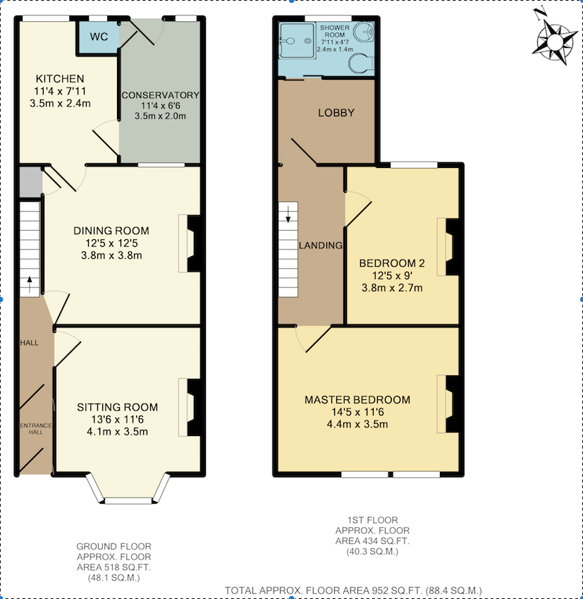

|  |  |
| --- | --- |
| **Mobile:** **07872 516 786**  **Tel: 0116 212 3843** | **Email:** [**epc4you@live.co.uk**](mailto:epc4you@live.co.uk)  **Web: www.epcleicester.com** |

**Energy Performance Certificates £60**

All properties Let or Sold require an Energy Performance Certificate (EPC).

At Leicester EPC we charge just £60 for Domestic EPCs, no extras, no VAT.

We will visit the property at a time convenient to you or the homeowner and produce the EPC the same day. The EPC is then emailed to you along with the link to the EPC Register.

Call Carl, Accredited Energy Assessor, on **07872 516 786** to arrange an EPC.

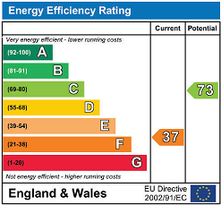

**What is an EPC?** An EPC is the Government’s way of complying with the Energy Performance of Buildings Directive. The EPC shows how energy efficient a property is. The certificate will provide a rating of the energy efficiency and CO2 emissions of a building from A to G similar to the ratings found on white goods.

Prospective buyers or tenants can then see a building’s energy efficiency and consider this along with fuel costs before they rent or buy the property. EPCs are accompanied by a recommendation report that lists measures that will improve the energy rating of the building and improve its energy efficiency to bring fuel costs down.

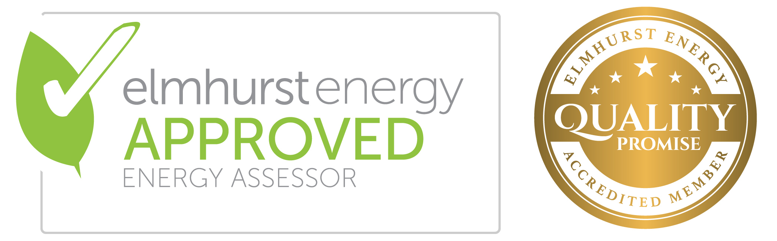

|  |  |
| --- | --- |
| **Mobile:** **07872 516 786**  **Tel: 0116 212 3843** | **Email:** [**epc4you@live.co.uk**](mailto:epc4you@live.co.uk)  **Web: www.epcleicester.com** |

**Legionella Risk Assessments £50**

**What is Your Legal Duty?** In the right conditions Legionella bacteria can exist in the water system of a domestic property, which can lead to Legionnaires’ disease. Landlords who provide residential accommodation are responsible for the water system in their premises. They have a legal duty to ensure the risk of exposure of tenants to legionella is properly assessed and controlled.

For a Legionella Risk Assessment call Carl on **07872 516 786.**

**What Do You Need To Do?** A Legionella Risk Assessment will help landlords and Letting Agents meet their legal obligations. They should arrange for a competent person to conduct a risk assessment of the water system in any properties they are responsible for. They must document this and take action to ensure that any risks of potential exposure are properly controlled. They should also inform tenants of the potential risk of exposure to legionella and its consequences.

**Legionella Risk Assessment Service.** We will visit the property at a time convenient to you or the property occupants and produce the assessment within 24hrs. We will:

* Carry out a Legionella Risk Assessment of the property
* Identify and assess the sources of any risk
* Provide a written Legionella Risk Assessment Record
* Provide written advice for tenants
* Produce a Legionella Risk Assessment Certificate

|  |  |
| --- | --- |
| Macintosh HD:Users:carl:Documents:Legionella Info:Elmhurst_Approved_Legionella_Risk_Assessor.jpg | ★★★ ★★ Accredited  Membership No: EES/016979 |

|  |  |
| --- | --- |
| **Mobile:** **07872 516 786**  **Tel: 0116 212 3843** | **Email:** [**epc4you@live.co.uk**](mailto:epc4you@live.co.uk)  **Web: www.epcleicester.com** |

**Display Energy Certificates**

A DEC and Recommendation Report are required for buildings with a total useful floor area over 259m2 that are occupied in whole or part by public authorities and frequently visited by the public.

**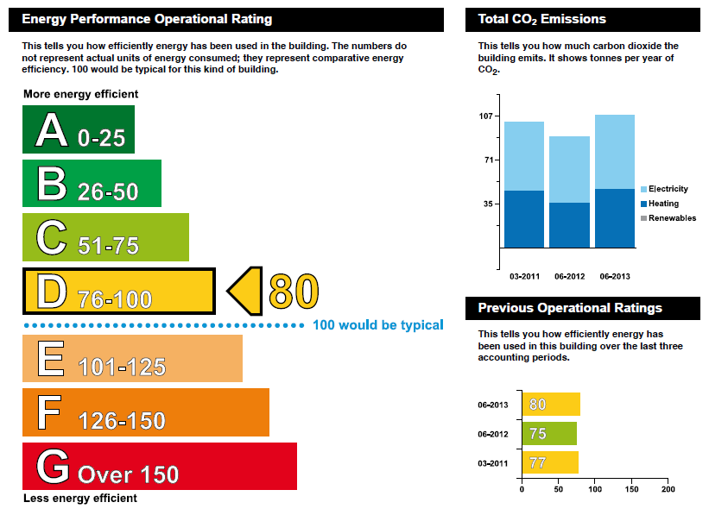**

**What is a DEC?** A DEC is the Government’s way of complying with the Energy Performance of Buildings Directive and its aim is to encourage building occupiers to reduce their energy usage year on year. It is an operational energy rating that identifies the actual energy use of a building. The operational rating is a numerical indicator of the actual annual carbon dioxide emissions from the building. The rating is shown on a scale from A to G, where A is the lowest CO2 emissions (or best rating) and the G band is the highest CO2 emissions.

The building energy consumption used for the DEC will be affected by the performance of the building fabric, that is to say, the levels of insulation, heating, cooling, ventilation and lighting systems. However, unlike EPCs (Energy Performance Certificates), the DEC will account for how the building is being used by the occupants. It is therefore possible that a building constructed to a high energy efficiency standard could have a poor rating, due to the fact that it is managed poorly with high energy wastage.

DECs are accompanied by a Recommendation Report that lists measures that will improve the energy rating of the building and improve its energy efficiency.

|  |  |
| --- | --- |
| **Mobile:** **07872 516 786**  **Tel: 0116 212 3843** | **Email:** [**epc4you@live.co.uk**](mailto:epc4you@live.co.uk)  **Web: www.epcleicester.com** |