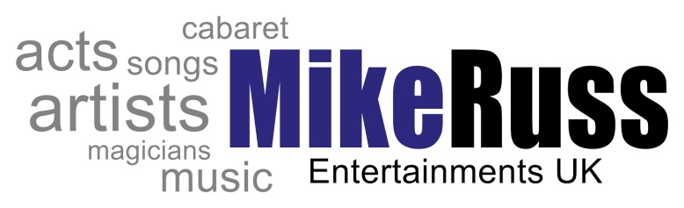
Enquiry
Form
Office Only
Event Ref Number
Clients Name
Company Name
Ent System Entry
CLIENTS DETAILS
Name
Address
Tel No
Email Address
TYPE OF EVENT
 |  | W | □ | E | □
DETAILS OF VENUE
Name of Venue
Contact Name
Address
Tel No
EVENT DETAILS
Budget
No of Guests
Brief Requirements
About The Event
Dressing Room Avail |  | Y | □ | N | □
Sound Equipment |  | Y | □ | N | □
Lighting Equipment |  | Y | □ | N | □
Proposed Times
How many sets |  | 2 x 45 min | □ | 1 x 60 | □
Acts Refreshments |  | Y | □ | N | □
Acts Meals |  | Y | □ | N | □
Travel Exp |  | Y | □ | N | □

