11Have you always wanted to become a teaching assistant but lacked the confidence to apply for the job?

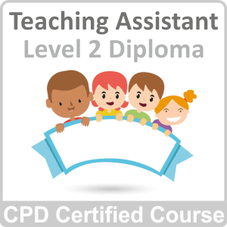

Are you already working in a school setting but haven’t got the formal qualifications to progress your career?

Then this Level 2 Award in Supporting Teaching and Learning is the ideal qualification to pave the way to your success in the world of teaching and education.

11Designed to give you the key practical skills and theoretical insights required to excel in a support role, this teaching assistant course offers the best opportunity to develop professionally and secure a future of working in education.



By investing in your own training, you will be ready to support children and help them achieve their academic and personal potential:-

* by offering a guiding hand when a child is in need of learning or emotional support
* enabling them to flourish.

The results of your work will be evident in the achievements and progression of the children you work with. Watching children develop their abilities is something truly special and makes the job extremely worthwhile and valuable.