

**Naturally 4 U- Product Information**

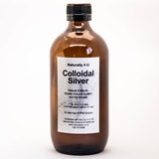

**COLLOIDAL SILVER 500ml $45.00 1 Litre $75.00**

**Ingredients:-10 ppm solution of 99.9% Silver in distilled water**

A natural antibiotic and immune system booster liquid, with no side effects or contraindications (unless you have an allergy to silver jewellery).

This product is great for just about anything that ails you: from colds, viruses, sinusitis and flu, and internal infections such as cystitis and bladder infections, to arthritis and parasites, and many more.

It is great for skin problems such as eczema, psoriasis, acne, and cellulitis, and can be applied topically as well as taken internally. It can be sprayed into the ears, eyes, and mouth for ear and eye infections, sore throats, mouth ulcers, or just sore and tired eyes from driving, computer work. It acts as a steriliser, so can be sprayed on cuts or grazes to sterilise the area. It can be taken internally in liquid form, as a preventative or as a treatment when an infection arises. It is great for animals, and can be added to their drinking water to prevent and/or treat infections. It has no taste or smell, so is easy for both animals and children to take. A great natural alternative to antibiotics and steroidal treatments.

*Available in Sizes, 500ml, 1 Litre (or larger 2.5 Litre if required)*

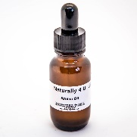

**COLLOIDAL SILVER EYE DROPS $15.00**

**Ingredients:- 8 ppm solution of 99.9% Silver in distilled water**

A natural antibiotic and immune system booster liquid, with no side effects or contraindications (unless you have an allergy to silver jewellery).

This product is an easy-to-dispense form of Colloidal Silver liquid in drop form. These drops will soothe sore, tired or overworked eyes, and will treat infections or allergic reactions such as conjunctivitis, styes and hay fever. It is useful to have in the car, and easy to use if you are travelling with children.

It makes a fantastic addition to a car, home or school first aid kit, and is useful to sterilise eyes

when getting dust or small bits of debris out of them.

This product is easy to use for animals with infections in their ears and/or eyes.

A great natural alternative to antibiotics and steroidal treatments.

*Available in 25l Dropper.*

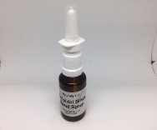

**COLLOIDAL SILVER NASAL SPRAY $15.00**

**Ingredients:- 6-8 ppm solution of 99.9% Silver in distilled water**

A natural antibiotic and immune system booster liquid, with no side effects or contraindications (unless you have an allergy to silver jewellery).

This spray is an easy-to-dispense form of Colloidal Silver liquid, which is a fantastic addition to a car, home, or school first aid kit. It is small, portable, and easy for both children and adults to use. It will naturally and gently help to treat flu and other respiratory viral conditions. Just a quick spray or two can rapidly help with blocked noses and colds, allergies, sinusitis, hay fever and any other nasal conditions. (No nose bleeds with this product)

A great natural alternative to antibiotics and steroidal treatments.

*Available in 25ml Spray.*

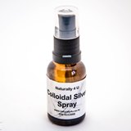**COLLOIDAL SIVLER SPRAY $15.00**

**Ingredients:- 8 ppm solution of 99.9% Silver in distilled water**

A natural antibiotic and immune system booster liquid, with no side effects or contraindications (unless you have an allergy to silver jewellery).

This spray is an easy-to-dispense form of Colloidal Silver liquid, which is a fantastic addition to a car, home, or school first aid kit. It is small, portable and easy for both children and adults to use. It will naturally and gently help to treat flu and other respiratory viral conditions. Just a quick spray or two can rapidly help with blocked noses and colds, allergies, sinusitis, hay fever, and any other nasal conditions. (No nose bleeds with this product)

A great natural alternative to antibiotics and steroidal treatments.

*Available in 25ml Spray.*

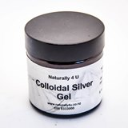

**COLLOIDAL SILVER GEL $25.00**

**Ingredients:- 8ppm solution of 99.9% Silver in Gel**

A natural antibiotic and immune system booster liquid, with no side effects or contraindications (unless you have an allergy to silver jewellery). This gel can be used on any skin infections, especially eczema and psoriasis, and is particularly effective when combined with the Colloidal Silver liquid taken internally. The gel goes on smoothly, and is absorbed quickly into the skin, creating a sterile barrier above to prevent further bacteria, while providing a healing environment below. It is effective for healing burns, grazes, and can be used directly on cuts. It is safe for use on all skin areas, apart from mucous membranes and wet areas such as eyes and nasal passages.

A great natural alternative to antibiotics and steroidal treatments.

*Available in 50 gram jar*

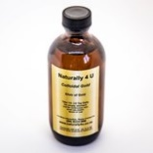**COLLOIDAL GOLD 200ml $55.00**

Colloidal Gold enhances, relieves and interacts with nervous and glandular systems as it helps to rejuvenate glands and stimulate nerves. It helps to release pressure on neural pathways (neural heart rhythm, neural transmitters), allowing nerve signals to function unimpeded and reach the various organs and glands. Improves glandular function, blood circulation, heart health, reduces obesity. It is also said to reduce the craving for alcohol and other addictive drugs.

“The Chinese value the gold as an elixir of great therapeutic value”

Mental stimulation – is said to improve communication inside the brain by stimulating the electrical signals being transmitted. Helping certain brain disorders, brain IQ, ADD, memory, headache, Migrane, nerve complaints, depression, insomnia, pain and stress, libido, relaxing while increasing IQ, physical and emotional health, and even inner ear balance.

Calming – feel calm, a rush of Chi (energy) rushes to the brain, the rush of chi gives a feeling of calm that relieves anxiety and nervousness and has been used to treat brain related conditions like Parkinson’s. There are benefits for use with Parkinson’s disease and other brain degradation conditions, controlling, natural heart rhythm. Inhibits or prevents pathogenic progression in rheumatoid arthritis that damages cartilidge and bone, improves blood.

Pain relief – may improve the movement of arthritic joints, upper back pain, numbness,

Reduce pain, swelling and tenderness,

The healing possibilities with Gold treatment include inhibition of infection, viral and bacterial, can be used for skin conditions ulcers and puncture wounds, stimulates and stabilises collagen, regulates the body temperature, rejuvenates sluggish organs. Assists digestive systems, promotes longevity anf is thought to prolong life for those with terminal illnesses

In brief:- Improves neural and circulatory system, reduces joint pains, increases strength of immune system, gains a sense of euphoria helping to reduce depression

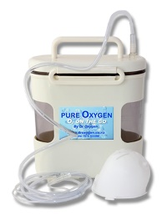 **DR OXYGEN STARTER KIT $329.**

**DR OXYGEN - Portable Oxygen Generator**

The Dr Oxygen Generator Unit is completely portable, economical, easy to run and very efficient

And is used to promote healthy living

* It needs no power or highly pressurised Oxygen

* Dr Oxygen works on the basis of a safe chemical reaction

* US Patent (No 043487) their quality control warrant this stabiliser and the safe chemical reaction.

**Package Contents:-**

**\*** 1 - Oxygen Generator, Lid and see through core

**\*** 1 – Supporter **\*** 2– Masks and Elastic * 2 Nasal Tubes **\*** 10 sets of A and B Sachets

**Our Bodies Need Oxygen -** reasons why we need oxygen include

Oxygen is a detoxification agent metabolizes the food we eat

Oxygen is great for Cellular Regeneration and supports the brain to work at its best

Oxygen nourishes our muscles so they can work to the best of their ability

Oxygen is needed to build proteins and hormones that our bodies use for proper function

Oxygen is beneficial for viruses, parasites, bacteria and strengthens the Immune System

*More information available*

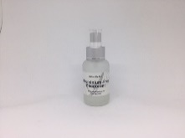

**ALUMINIUM FREE DEODORANT $15.00**

**Ingredients: Vegetable Glycerine, Aloe Vera Gel, Citrus Seed Extract, Lavender Essential Oils**

Our deodorant contains only natural ingredients and contain no Aluminium Chlorohydrate that is found in most commercial deodorants and is used as an antiperspirant.

Antiperspirants have been attributed to one of the leading causes of Breast Cancer and Breast Cancer is the second most common cause of cancer. It has also been linked to Alzheimer’s disease, memory problems and nervous system problems.

Aluminium Chlorohydrate is a chemically active form of chlorine which is emulsified enabling it to plug up and closes the underarm pores entering the skin through the lymphatic system. It has a corrosive effect on the skin.

The human body has a few areas that it uses to purge toxins these toxins are in the form of perspiration, the areas it purges from are behind the knees, ears, groin area and under the armpits.

*Available in a 50gram Glass Spray.*

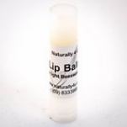**LIP BALM $7.00**

**Ingredients:- Beeswax, Coconut Oil, Glycerine, Sunflower Oil**

A light moisturizing balm, for dry, cracked, sunburnt lips- helps the lips to stay moisturised and to heal quickly.

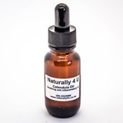**ARNICA OIL $20.00**

Arnica Oil can be applied to the **skin** in order to heal bruises more quickly, soothe inflammation,

ease muscle pain, and even alleviate stiffness caused by arthritis or other joint injuries. It's also a potent **skincare** ingredient and can be used for bags under the eyes

Comes in 25 ml

**CALENDULA OIL $20.00**

Calendula Oil often used as a complementary or alternative treatment. **Calendula** oil has antifungal, anti-inflammatory, antibacterial and antiseptic properties that might make it useful in healing wounds, soothing relieving diaper rash, rashes, skin irritations. Can be used on young and sensitive skins.

Comes in 25 ml

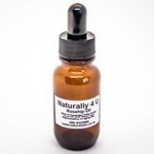**ROSEHIP OIL $25.00**

Not only do the fatty acids and Vitamin A in **rosehip oil** moisturize the **skin**, but they also promote **skin** regeneration, can improve **skin** flexibility and permeability. This means that **rosehip oil** products can improve **skin** texture and even reduce the appearance of acne scars or stretch marks.

Comes in 25 ml

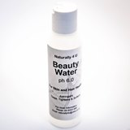 **BEAUTY WATER $15.00**

Beauty Water is a mildly acidic water with a pH 6.0

Beauty water can be used frequently as a spray throughout your day, frequently used for best results.

While internally our body is healthiest if it is alkaline, your skin pH is ideally around pH 6.0. Beauty Water makes your skin feel soft and moisturised like you have used lotions or oils; it makes your skin feel hydrated.

When used instead of a conditioner after shampoo, it tightens your scalp, reduces tangles and brings a radiant shine to your hair. in fact, many users report significant hair re-growth.

Beauty Water is astringent and oxidative, making it beneficial for the overall health and beauty of your skin and hair. The results of using it are similar to those of expensive toners from exclusive department stores and beauty salons. It tightens, softens and provides an environment for healing which is excellent for many common skin conditions.

For some users, Beauty Water has eliminated a vast spectrum of facial blemishes.

Should you require warm Beauty Water, werecommend slowly heating it on a stove/cooker to the desired safe temperature. Collect in a bowl or ina spray bottle and massage or spray over your body after a bath or shower. Your skin can feel tight and dry after showering; using Beauty Water in this way leaves your skin hydrated and feeling like you have used lotion. It also closes all your pores.

For men, it’s great to use as a toner after shaving - leaving your skin soft and feeling good.

Mix Beauty Water with essential oils, spray on skin to hydrate, reduce lines & wrinkles, even skin tone and produce younger, healthier skin. Spray it on, splash it on, soak in it, get it on your skin when you want to have the best looking skin around.

*Comes in 120 gram Plastic Packaging*

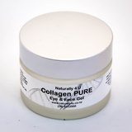**COLLAGEN PURE CREAM $45.00**

**Ingredients: A lovely natural healing cream containing Vegetable derived Fatty Acids, Pro Vitamin B5, Citrus Seed Extract, plus added to enhance the AntiAging properties is Marine Collagen, Organic Rosehip Oil, and Jojoba Oil.**

With these ingredients this cream is a lovely nourishing and moisturizing Antiaging cream for the skin.

This can be used in the morning as a base for under your makeup or on its own during the day for nourishing and can be used every night for added AntiAgeing Benefits, apply a liberal amount in the

Evening before retiring to bed let it soak in overnight.

*Available in 50 gram Glass packaging*

**COLLAGEN PURE EYE & FACE GEL $45.00**

**Ingredients:- Aloe Vera Gel, Marine Collagen, Jojoba Oil, Rosehip Oil, Calendula Oil**

Apply morning and night, this lovely aloe vera gel based product is oxygenating your skin and nourishing with Marine Collagen and Hyaluronic Acid,

*Available in 50 gram Glass packaging*

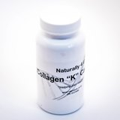**COLLAGEN CAPSULES $65.00**

**Ingredients: Collagen, Vitamin B12, Keratin**

The ***glue*** that holds us together : **Collagen**

We talk about Collagen, we usually relate it to the skin, the importance of Collagen is not only for our skin,

but it is also great for the hair and nails. It is also very important for looking after the structure or the connective tissue like tendons, cartilages and ligaments and joints in the body.

SO, when you take Collagen you are not only helping the appearance of your skin.

The word Collagen is from the Greek word “Kolla” which means glue the suffix “gen” means producing Collagen. Collagen is a living protein and is the second most abundant protein in the body.

As we age our Collagen levels decline and less is produced, the elastin fibres break get thicker and clump therefore losing the elasticity, by age 40 Collagen is depleted quicker than it is produced, by the time you are 60 over half of the body’s Collagen is depleted.

**Collagen Capsules**

As we age, Collagen in our body diminishes, Collagen and Keratin are crucial in maintaining structure

of the living organisms within the body.

Collagen “K” capsules, taken internally are absorbed into the small intestine, this way the collagen does not get lost in the body, it goes to where it is needed, helping to restore lost collagen. This starts to replace lost collagen by stimulating the body’s collagen process rejuvenating your body.

This formula is a breakthrough with two key nutrients required for the support of the Skin, Hair and Nails. With extensive use of the Collagen Hydrosolate formula incorporating a compound called Complex K, this new exclusive ingredient is a food grade keratin. 100% Collagen “K” capsules will help you to feel younger*,* improve your skins elasticity, reduce fine lines, sagging skin and wrinkles. Collagen will help to knit your skin together, give you better hair condition and strengthen your nails

*Contains 90 capsules*

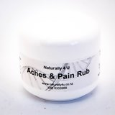**ACHES & PAINS RUB (or use as a Sports Rub) $25.00**

**Ingredients:- In a natural cream base of Vegetable derived Fatty Acids, Pro Vitamin B5,**

**Citrus Seed Extract and blended with the Essential oils of Cajeput, Peppermint, Rosemary**

**and Wintergreen**

This rub is anti inflammatory, making it great for sports injuries, or recurrent painful muscular conditions. It is soothing and warming, and effective for general aches and pains, and acts as a

useful part of any treatment programme. This rub also relieves pains and discomfort caused by Arthritis and Rheumatism, and can assist in the treatment of RSI and occupational overuse conditions. The all-natural ingredients have a positive effect on the skin, and leave no toxic after-effects.

*As A Sports Rub* - This is a multi-purpose rub, which is extremely useful when used as a warm-up rub, in preventing pulled or strained muscles during exercise. It can also be used as a cool-down rub, to help ease muscles which have been working hard, and help to prevent muscle stiffness and soreness in the days following exercise. It’s a great rub to use on sore muscles and other sports injuries, helping to relieve pain and ease aches. The ingredients help the healing process at a tissue level. An excellent addition to team or sports ground first aid kits.

*Available in 50g plastic packaging.*

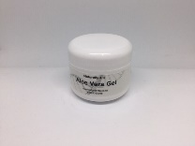**ALOE VERA GEL $20.00**

**Ingredients: 99.9% all natural Aloe Vera Gel.**

Aloe Vera Gel is a natural, pulpy type of gel, extracted from the leaves of the aloe vera plant, which is a succulent plant.

It has an anti-inflammatory effect on the skin, so works quickly and efficiently to soothe burns, sunburn, and any other sore inflamed skin condition.

The all-natural gel helps to heal the skin, and provides a barrier to any further harm while the skin is healing. Aloe vera gel is famed for its moisturising properties, and can be used as a preventative to dry skin.

The gel has a pleasant, subtle smell, dries quickly on application, and leaves no toxic after-effects.

*Available in 50g plastic packaging or larger sizes*

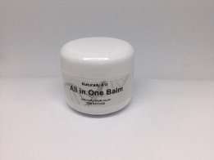**ALL IN ONE BALM $25.00**

**Ingredients:- Beeswax, Cocoa Butter, Olive Oil.**

This all-natural, unscented balm is a great allrounder. Use on your lips, hair, heels, hands, elbows, and even gently on your face if you have run out of your usual moisturiser.

It applies smoothly, and is easily absorbed in all areas of dry skin.

Beeswax is a natural emulsifier, which has been used since pre-historic times. It is nourishing to your skin, and helps to seal and protect the skin.

Cocoa butter is an emollient which acts as a water repellent. It protects, softens and lubricates the skin, making it ideal to sooth chapped and sore areas. It also relieves irritation, diminishes signs of wrinkling and stretch marks, and improves skin flexibility.

Olive oil soothes, heals and lubricates the skin, and is deeply penetrating. These ingredients combine to create a barrier between your skin and the outside world, keeping harmful elements such as air pollution, cold and wind damage, at bay, whilst also nourishing your skin cells.

*Available in 50g plastic packaging.*

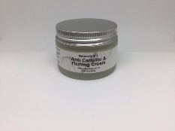**ANTI CELLULITE & FIRMING CREAM $40.00**

**Ingredients:- in a natural plant based chemical-free cream base of Vegetable derived Fatty Acids, Pro Vitamin B5, Citrus Seed Extract and carefully blended with essential oils Vetiver, Lemon, Black Pepper, Lemongrass for Cellulite and to help with the toning of the skin.**

This is an all- natural, plant based cream, with a particular blend of essential oils, especially created to gently break down adipose cells containing cellulite, and assist the body to detoxify. When massaged into the skin, twice a day, a positive effect can be seen in the reduction of cellulite. Over time, with consistent application, your skin will appear firmer, smoother, and less puffy overall. The all-natural ingredients are easily absorbed into the skin, and leave it subtly yet pleasantly scented**.**

*Available in 50g or 100g Glass packaging.*

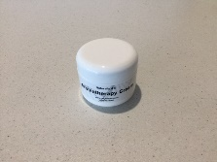**AROMATHERAPY CREAM $40.00**

**Ingredients:- in an all natural plant based chemical-free cream base of Vegetable derived**

**Fatty Acids, Pro Vitamin B5, Citrus Seed Extract and carefully blended with Essential oils**

**of Lavender and Neroli.**

This cream combines the wonderful-smelling oils of neroli, and lavender, which helps to relieve headaches, stress, tension, jetlag, insomnia. Gently rub into the temples, neck, shoulders, or other problem area. You will feel the soothing effect, as the cream works to relax the muscles, and the nervous system. This rub is great to use at bedtime, to aid gentle sleep, and is good to help when preparing for new challenges or disruptions, such as interviews, moving house

*Available in 50g plastic packaging.*

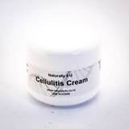**CELLULITIS CREAM $35.00**

**Ingredients:- in an all natural plant based chemical-free cream base of Vegetable derived**

**Fatty Acids, Pro Vitamin B5, Citrus Seed Extract and carefully blended for the condition**

**Of Cellulitis.**

Carefully selected plant ingredients, is particularly beneficial in the healing of cellulitis. The cream soothes the infection, and begins the healing process, thus showing improvement in the symptoms of raw redness, and swelling. This cream can assist in the healing of ulcers in the skin, and shows special benefit in the healing of leg ulcers. It is easily absorbed into the skin, and leaves no sticky or damp residue. When used appropriately and consistently, as part of an overall treatment programme, a definite improvement will be noticed.

*Available in 50g – we can do larger in 100g plastic packaging.*

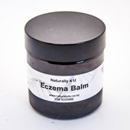**ECZEMA BALM $25.00**

**Ingredients:- Beeswax, Sunflower Oil, Calendula Oil, Arnica Oil, blended with Essential Oils of Clove, Eucalyptus, Lavender, Peppermint, Tea Tree oils.**

This balm is extremely effective in relieving the itching, raw redness, and pain of eczema, dermatitis, and other itching skin conditions. The arnica oil promotes skin tissue healing, whilst reducing the pain. Calendula oil is great for skin and tissue healing, following damage, and helps to prompt the closure of wounds, thus providing relief from the cracking and rawness of eczema. Calendula speeds the healing process, and reduces inflammation to a large extent. Tea tree oil acts as an antiseptic and antifungal along with being good for healing skin rashes and irritations along with infected skin. Lavender helps to relieve tension, and promotes relaxation of the nervous system, as well as having a soothing effect when applied to irritated and itching skin.

*Available in 50 grams*

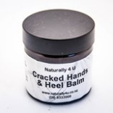**CRACKED HANDS AND HEEL BALM $25.00**

**Ingredients:- Shea butter, Cocoa butter, Sunflower and Olive Oils with carefully blended Lemon Essential Oil**

This is an all-natural, super-nourishing balm blend, for cracks, dry patches, and overall maintenance of several problem areas. Shea butter is a natural fat from the karite tree in Africa. It is extremely moisturising to the skin, helping to heal cracked, prematurely aged and damaged skin. It contains vitamin A and E, which provide protection from the harsh UV rays of the sun. Cocoa butter is an emollient which acts as a water repellent. It protects, softens and lubricates the skin, making it ideal to sooth chapped and sore areas. It also relieves irritation, diminishes signs of wrinkling and stretch marks, and improves skin flexibility. Olive oil soothes, heals and lubricates the skin, and is deeply penetrating.

*Available in 50g, but can be made into 100g, 200g or 300g on request.*

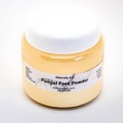**FUNGAL FOOT POWDER $20.00**

**Ingredients:- Bicarbonate of Soda, Cornflour, Essential Oil of Tea tree, Lemon Balm.**

This is a smooth, easily applied, pleasantly scented powder, which, when brushed onto the feet after bathing, helps to thoroughly dry and disinfect, preventing conditions such as tinea, and other fungi. The powder rapidly absorbs residual moisture, and leaves behind a soft, pleasantly scented skin surface. It can be sprinkled into the socks and shoes, to help prevent itching and irritation, and help heal fungal foot conditions all day long, whilst keeping footwear smelling fresh.

*Available in 100g plastic packaging*

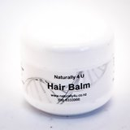**HAIR BALM $20.00**

**Ingredients:- Cocoa butter, Beeswax, Olive oil, Lemon Essential oil**

With a pleasant yet subtle scent of Lemon Essential Oil this balm will help you control your fly away, dry, and frizzy ended hair. It is a nourishing balm, containing cocoa butter, an emollient which acts as a water repellent. It protects, softens and lubricates cells, making it ideal to soften dry and damaged hair. Olive oil soothes, heals and lubricates, and is deeply penetrating, helping to moisturise and heal the hair cells from within. Beeswax is a natural emulsifier, which has been used since pre-historic times. It is nourishing to your skin and hair cells, and helps to seal and protect the skin and hair, keeping damaging elements such as wind, sea, chemical pollutants and excessive exposure to UV rays. Use this balm to help define a stylish new haircut, such as a blow wave or a new set of curls. It will help to relax tightly curled hair, and while it will not provide a firm holding factor, it will help to reduce frizz and fuzz. Tart with a small amount, and rub into palms of hands, then rub and scrunch it through the hair to define curls and waves. You can run your fingers through tightly curled hair, in downward strokes, to relax and reduce curls and frizz. Apply more as needed.

*Available in 50g plastic packaging.*

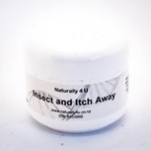**INSECT & ITCH AWAY $25.00**

**Ingredients:- Beeswax, Sunflower Oil, Calendula Oil, Arnica Oil, blended with Essential Oils of Clove, Eucalyptus, Lavender, Peppermint, Tea Tree, Lemongrass.**

Combined with the essential oils of tea tree and eucalyptus act as a repellent, keeping pesky mosquitoes and other irritating insects away with a pleasant, natural scent.

If bitten, however, this balm provides a soothing effect, taking away the itching, stopping any bruising or swelling, and preventing the bite from becoming infected.

Beeswax is a natural emulsifier, which has been used since pre-historic times. It is nourishing to your skin, and helps to seal and protect the skin. Tea tree is an antiseptic and antibacterial agent, helping to kill any bacteria on the skin, and keep the area clean. Lemongrass has a cleansing astringent effect, helping to prevent further infection. Arnica oil promotes tissue healing, reduces bruising along with reducing the pain and itching, whilst lavender soothes the nervous system, and promotes relief and relaxation, as well as having a mild anaesthetic effect,

Apply to skin at night, to prevent night-time bites, and use liberally over any bitten areas to relieve painful itching symptoms and promotes healing.

*Available in 50g or 100g plastic packaging.*

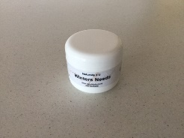**WINTER’S NEEDS $25.00**

**Ingredients: eucalyptus, lavender, peppermint, tea tree, beeswax, sunflower oil**

Use this warming rub to aid congestion, bronchial conditions, painful sinuses, stuffiness in the head, sleepless nights and other painful symptoms associated with winter’s colds and flu. The ingredients of this product help to ease tightness caused by excessive mucus in the chest and airways, and help the body to progress the elimination of mucous and bacteria. Also helping to ease painful headaches and sinuses, and help relieve throbbing and pounding associated with congestion. The ingredients of … help calm and relax you, allowing the body to heal itself more rapidly and efficiently. Rub generously onto the chest and throat area, after bathing, and before going to bed. Leave clothes open at the neck, and inhale deeply whilst in bed. Alternatively, if driving or whilst at work, dab a portion onto a handkerchief, and inhale regularly as required/ This rub can also be used as an inhalation - place a teaspoon in a bowl of boiling water, cover with a towel, and carefully duck your head under the towel, slowly and gently breathing in the steam.

*Available in 50g plastic packaging*

**EYE OIL MAKE UP REMOVER AND NOURISHING OIL $25.00**

**Ingredients:- Jojoba Oil, Sunflower Oil, Wheatgerm Oil**

Sunflower oil contains high levels of the nourishing vitamins A and E, as does linoleic acid. These ingredients help to deeply and thoroughly nourish the delicate skin around the eyes, whilst gently removing traces of eye make-up. Your skin will feel softer and smoother, and gently cleansed, with no sticky or residual traces left behind. The antioxidants in the wheat germ oil will help to repair aged and damaged skin, leaving it looking fresher and healthier.

Gently apply using a cotton wool ball, or gaze eye pad. Wipe over eye, and then remove thoroughly. Non-scented, chemical and irritant-free.

*Available in 120ml*

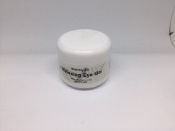**RELAXING EYE GEL $30.00**

**Ingredients:- Aloe Vera Gel, Carrot Oil Rosehip Oil**

This is a gentle, soothing, cooling eye gel which is ideal for helping relieve tired, sore, putty or itchy eyes, eyes which have been exposed to too much sunlight, eyes strained from long driving or sitting at the computer, and many other ailments. The ingredients help to reduce puffiness and bags under the eyes, reducing the appearance of tiredness, and making you look fresher and awake. The cooling of the gel ingredient helps to soothe soreness, redness and irritated eyes, and help to relax the delicate skin around the eye. The ingredients are also nourishing, and help to soften lines around the eye, over time. Use twice daily for best results.

*Available in 50 gram Plastic packaging*

**“COOL ME DOWN” SPRITZER $25.00**

**Ingredients:- Distilled Water, Polysorbate 20 Lavender and Peppermint Essential Oil**

This spritzer is great for use in the summer, rehydrate and cools your body fantastic if you have been on your feet all day, helps aching feet and legs, or on the sports field. Good for smelly feet as well. Menopausal women are finding great relief from their hot flushes when using this product.

*Available in 120ml*

**DETOXIFYING - SEAWEED BATH SALTS $15.00**

**Ingredients: Epsom Salts, Sea Salt, Baking Soda, Dried Kelp**

Your very own private hydrotherapy treatment, in a jar. These specially formulated bath salts contain the rejuvenating and detoxifying ingredients which gently draw out toxins from the body, whilst simultaneously replacing essential salts such as magnesium, iodine, which are needed by the body for adequate nutrition and cell functioning. Place a handful in your bath, and soak your cares away, while doing your body good. Soak for no longer than 10-15 minutes, to ensure that the body can relieve itself of toxins and does not re-absorb them. Shower afterwards to stop the detoxification process, and wash away any traces of seaweed salts.

*Available in 50 grams*

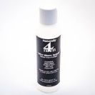**NATURALLY 4 MEN - AFTER SHAVE SPLASH $25.00**

**Ingredients:- Distilled Water, Aloe Vera, Witch Hazel**

This gentle, alcohol-free, natural splash can be used after shaving, to close up the pores and tone the skin, which will give you a healthy glowing looking complexion. It is made as a non-sting formula, and is lightly scented with patchouli, an essential oil with skin nourishing properties. Your skin will feel fresh and ready for the day. Use the Naturally 4 Men Moisturise Me after using the Splash.

*Available in 120ml*

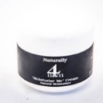**NATURALLY 4 MEN - MOISTURISE ME $25.00**

**Ingredients:in a natural plant based chemical-free cream base of Vegetable derived Fatty Acids, Pro Vitamin B5, Citrus Seed Extract with Essential Oil**

A light moisturizer for the guys, easily applied and absorbed, containing essential oil, for skin nourishing and rejuvenating. This all-natural cream, with a plant base, is especially formulated for

the particular requirements of men’s skin, and helps to protect against damage caused by harmful pollutants, wind and sun exposure, and age-related changes.

Use daily, after shaving, as part of your regular facial care routine.

*Available in 50grams*

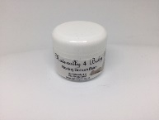**NATURALLY 4 BABY - HEALING BOTTOM BALM $25.00**

**Ingredients: beeswax, sunflower oil, evening primrose oil, chamomile, lavender essential oil**

This is a loving, gentle, all-natural balm, suitable for use on delicate skin. Pleasantly scented, with essential oils of Lavender and Chamomile help to calm any soreness or inflammation on the skin, and the antiseptic properties of lavender help to prevent any skin eruptions or infections. Chamomile is healing to the skin, and ensures that it stays soft and smooth. The balm base acts as a barrier, keeping skin dry and promoting an effective healing environment. Baby will love you for it!

*Available in 50g plastic packaging*

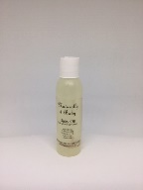**NATURALLY 4 BABY - BABY OIL $25.00**

**Ingredients: sunflower oil, grapeseed oil, chamomile, lavender essential oil**

The gentle, healing oils of Lavender and Chamomile to sooth, soften, heal, and nourish the skin, keeping it clean, dry and pain-free. Lavender’s antiseptic properties help to prevent infections or raw areas, it has a calming effect on the skin and on baby. Chamomile is calming, helps keep skin soft and smooth. The all-natural plant-based oils help to keep the skin soft, and nourish it gently with vitamins A and E. Use as an essential part of your baby’s daily bath routine. And it’s good for mum’s skin too!

*Available in 120ml*

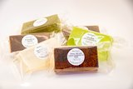

**GLYCERINE SOAP RANGE WITH ESSENTIAL OILS & HERBS $4.00 each**

**Chamomile (Marigold Flowers)**

Use as an antiseptic and ant- inflammatory Soap

Use on babies and for sensitive skins – very gentle

**Exfoliating**

Use to slough off dead, dry, flaking skin makes skin smoother

**Lavender**

Relaxing, soothing, healing and stress relieving

**Tea Tree**

Antifungal, great for infected skin and rashes

**Green Tea & Lemon**

Cleansing antioxidant & antibacterial, good for cuts/boils

**Orange**

Use for dull complexions, irritated or acne type of skins

**Lemongrass**

Stimulates circulation, toning skin tissue and helping cellulite

Also available – Lime / Himalayan Salt / Ginger / Oat Bran and Honey

Patchouli / Sandalwood / Rose Garden / Rose Geranium / Ylang Ylang

***Or made to order to suit your requirements***

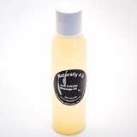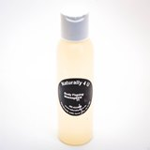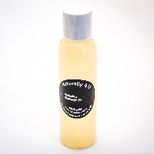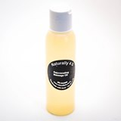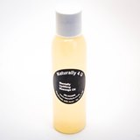

**MASSAGE OIL RANGE: $25.00**

All our Massage Oils are in a Sunflower base carrier oil, blended with the appropriate essential oils for blends listed below. Size is 120ml Plastic Bottle

*Please note:- we can make other blends to suit, and we do larger quantities.

**ACHES & PAINS**

Use this to massage on all over the sore place on your body – better still get someone else to massage on you. Massage into you body to take away your aches and pain whether it is from sports injury, or From Arthritis / Rheumatism or Fibramyalgia type of conditions.

**RELAXING**

After that hard day where you just want to relax – this blend is perfect for just that.

**ANTI CELLULITE**

Cellulite is usually brought on by hormonal changes.

The body tissues retain Water which gives the “Orange Peel” look over the body.

After showering and drying yourself well, massage over the affected areas daily for optimum results.

**BODY FIRMING**

Massage improves circulation which will help to tone and firm up the body.

Massage into areas daily after showering especially good done at night before bed.

(Can be done in the morning also)

**DETOXIFYING**

This toxin eliminating blend should be used only for a few days at a time, with a break in between using this blend again. Your skin should start to get more life into it again.

**FRIDAY NITE LIFT**

Needing a pick up or exhausted after your week at work and still have that social engagement to attend. Use a few drops of oil in your bath or after showering massage in well all over your body, will give you the lift needed.

**HANGOVER**

After effects of too much alcohol, or suffering a headache.

This blend is helpful is reducing the effects of a Hangover.

*Don’t forget to drink water also!!!

**ROMANCE / SENSUAL**

Use this blend in the bath prior to going out on that romantic evening to get you in the mood for romance, or trade off with your partner for an all over Body Massage.

**STRETCH MARK / SCARRING**

Massage in twice daily to help reduce stretch marks and scars.

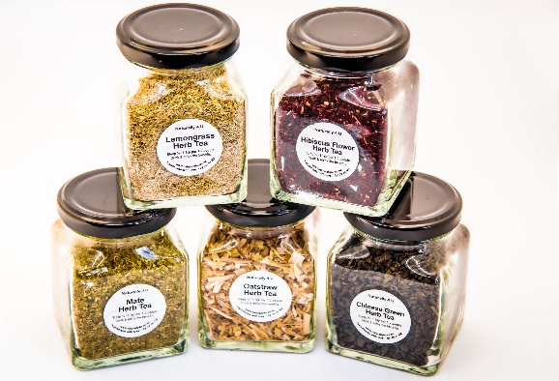

**HERB TEA RANGE**

**Chinese Green Tea**  **$14.00** Good for Headaches, Depression, Cancer, Rheumatoid Arthritis, Cardiovascular Disease and Infections. Helps to lower Cholesterol and improves the ratio of good Cholesterol to bad Cholesterol

**Hibiscus Flowers Tea $14.00** Lowers Fever, Blood Pressure, relieves Coughs, helpful for Respiratory Conditions. Has Antibacterial properties and is a good source of Vitamin C. Lovely in the summer as an Iced Tea.

**Lemongrass Tea $12.00** Cleansing and Astringent. Helpful for Stress and soothing on the Stomach. Relieves Fatigue, Dizziness and helps to induce Sleep. Loosens and reduces Mucous. Use for Female Cramps. High in Vitamin A and Vitamin C.

**Mate Tea $12.00** A good tea for the soul, lovely tonic and good for the Adrenal Glands, reduces Fatigue. A diuretic, promotes cleansing and excretion of waste and suppresses appetite **Nettle $12.00** Blood Purifier, helps Circulation and High Blood Pressure. Good for Asthma, when taken over a long period. Rich in Iron, Chlorophyll, Protein, Vitamins A and E

**Oatstraw $12.00** Has Antiseptic properties. Good for Panic Attacks. Calming for Hyperactive Children. Great for the Skin is high in Vitamin A, Vitamin C, Silicon, Calcium.

**Peppermint $12.00** Helps to calm the stomach, aids digestion, relieves flatulence. Reduces pain and relaxes muscles. Can be used for Congestion.

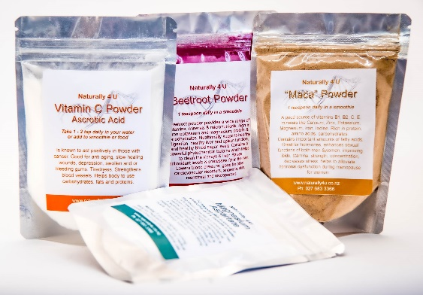

**FRUIT & VEGETABLE POWDERS FOR SMOOTHIES**

**BEETROOT $18.00** supplies a wide range of vitamins, minerals and micronutrients, high in iron potassium and magnesium, protein and carbohydrates Nutritionally supports healthy digestion, healthy liver and spleen function healthy blood sugar levels. Contains a powerful phytochemical betaine which helps the clean the kidneys & liver. Raises antioxidant levels & processes fat in the liver. Lowers blood pressure, good for other cardiovascular disorders anaemia, skin, menstrual, osteoporosis.

**MACA $25.00** is a good source of vitamins B1, B2, C, E, minerals like Calcium, Zinc, Potassium, Magnesium, Iron, Iodine, is rich in Protein, Amino Acids, carbohydrates, contains important amounts of fatty acids great for hormones, enhances sexual functions of both men & women, improving libido, stamina, strength, concentration, decreases stress, helps to alleviate hormonal dysfunction during menopause for women.

**VITAMIN C $20.00** is an essential vitamin – meaning it cannot be produced in the body. It is an antioxidant, it is good for slow healing wounds, swollen or bleeding gums, and strengthens blood vessels. Acts positively for those with Cancer. Good for Anti-aging, tiredness and depression. Helps the body to use carbohydrates, fats and proteins

**MAGNESIUM ASPARTATE** **$20.00** is a mineral that has a fundamentally important physiological function in the body. Dietary magnesium is required by every cell in the body and is a necessary component in hundreds of metabolic processes. Magnesium supports muscle, immune and nerve function along with energy support.

Take 1-2 teaspoons daily in juice or in a smoothie as it is insoluble in water. **Warning:**If you are pregnant, nursing, taking any medications or have any medical condition consult your physician before use.