32 Nest Estate

Directions: From New Road proceed towards Crag Vale  taking your right turn into Stocks Lane, then left and  proceed up the hill looking out for and taking your right  turn into Nest Estate, then right again, where the property  will be found on your right hand side, identified by our  ‘For Sale’ board.  Accommodation:  Entrance:  Via side door giving access into the:-  Hallway:  Staircase access to the first floor.  Storage Cupboard:  Guest cloakroom:  Fitted with two piece coloured suite, comprising of a low flush wc and pedestal wash hand basin  Lounge: 16’1” x 11’6”(4.90m x 3.51m)  Window to the front, Adam style fire surround with inset  living flame gas fire, double doors open into the:-  Fitted Kitchen: 9’0” x 6’0” (2.74m x 1.83m)  Being fitted with matching base units, inset sink with  matching drainer, mixer tap, built in electric oven, with gas  hob and extractor hood above, varnished wood panelling,  French doors give access into the:-  Conservatory: 12’10” x 9’11” ( 3.91m x 3.02m)  Good sized conservatory enjoying views over the rear  garden, double doors give access onto the paved patio area. | First Floor:  Landing Area:  Giving access to the loft space, feature window to the rear  Bedroom 1: 11’0” x 11’0”(3.35m x 3.35m)  Window to the front, fitted wardrobes  Bedroom 2: 11’0” x 8’0” ( 3.35m x 2.44m)  Window to the rear enjoying the open views  Bathroom:  Fitted with a three piece white suite, comprising of a  panelled bath with electric shower unit over, pedestal  wash hand basin, low flush and window to front  External:  Gravelled area to the front providing off road parking,  side pathway leads to the paved patio, steps lead down to  the enclosed rear garden.  E.P.C Graph  Our Ref: M01  Details Produced: 22/10/2015 |  | First Floor:  Landing Area:  With window to the side, access via a pull down ladder to the loft with wood panelling to the walls and ceiling, laminate flooring, power and light, exposed beam and under eaves storage.  Bedroom 1: 11’1” x 9’9”  Window to the front, fitted wardrobes in quality pine with matching bedside cabinets and overhead matching cupboards, single radiator and laminate flooring.  Bedroom 2: 10’9 x 5’2”  Formerly one bedroom, this room has been split to create two bedrooms. Window to the rear, laminate flooring and single radiator.  Bedroom 3: 7’9” x 5’4”  Window to the rear, laminate flooring and single radiator.  Bedroom 4: 9’0” x 6’8”  Window to the front, bulk head to the stairs, built in cabin bed, single radiator and laminate flooring.  Bathroom:  Being fitted with a three piece white suite comprising of a panelled bath with electric shower over and shower screen, pedestal wash hand basin, low flush w.c., tiling to the walls, painted wood panelling to the ceiling with recessed spotlight, single radiator and window to the rear.  External:  To the front of the property there is a lawned garden with paved driveway leading to the detached garage with up and over door, power and light. To the rear the conservatory leads onto a decked area with steps leading down to the lawned garden, garden shed with power and light.  Our Ref: 825  Details produced: 01/02/2005

IMPORTANT INFORMATION

New Road Properties Registered Office: 7 New Road, Mytholmroyd. HX7 5DZ

Property Misdescriptions Act 1991
We endeavour to make sales details accurate and reliable but they should not be relied on as statements or
representations of fact and they do not constitute any part of an offer or contract.
Services, fittings and equipment referred to in the sales details have not been tested
(unless otherwise stated) and no warranty can be given as to their condition.
All measurements are taken by laser and cannot be relied upon as accurate.

32 NEST ESTATE
MYTHOLMROYD
HX7 5BJ

PRICE OFFERS IN REGION OF: £99,950.00 NO-CHAIN
IDEAL PROPERTY FOR THE FIRST TIME BUYER/ PROPERTY INVESTOR

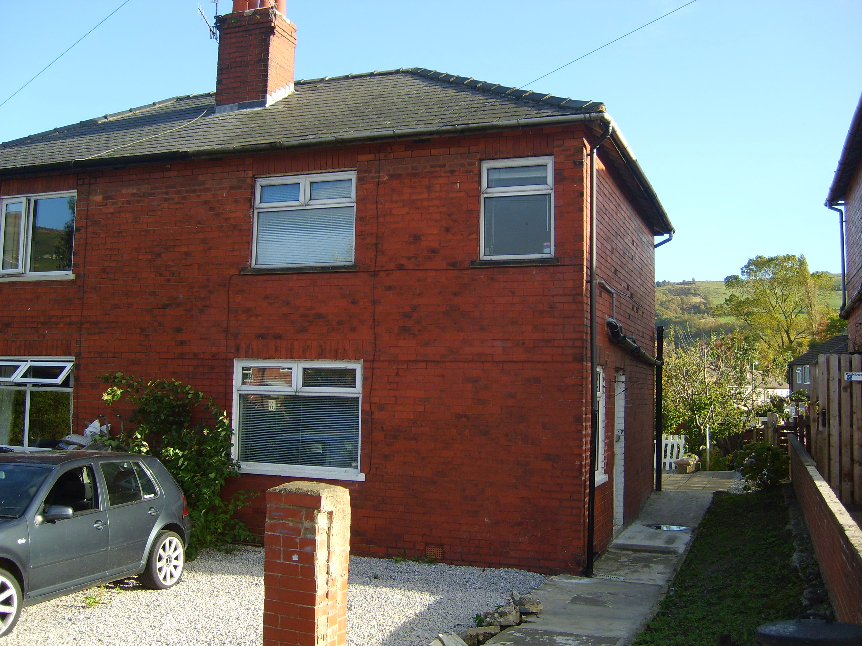

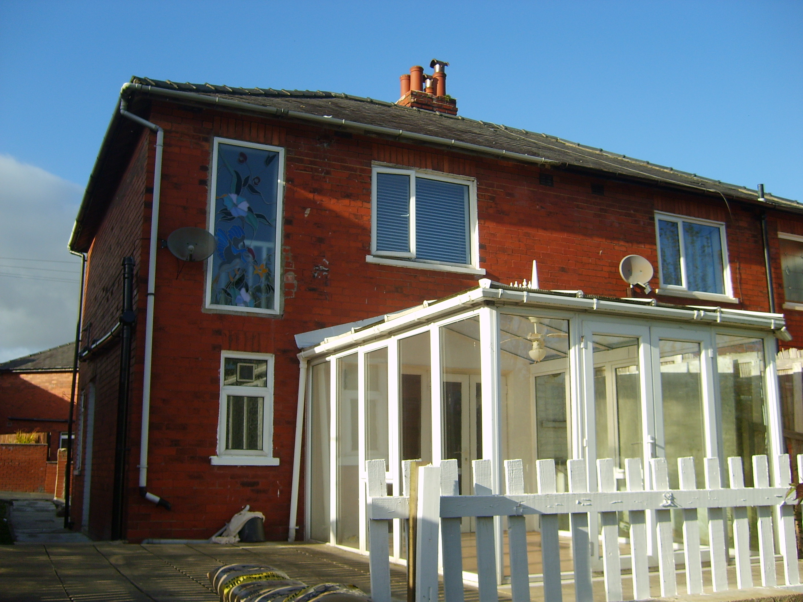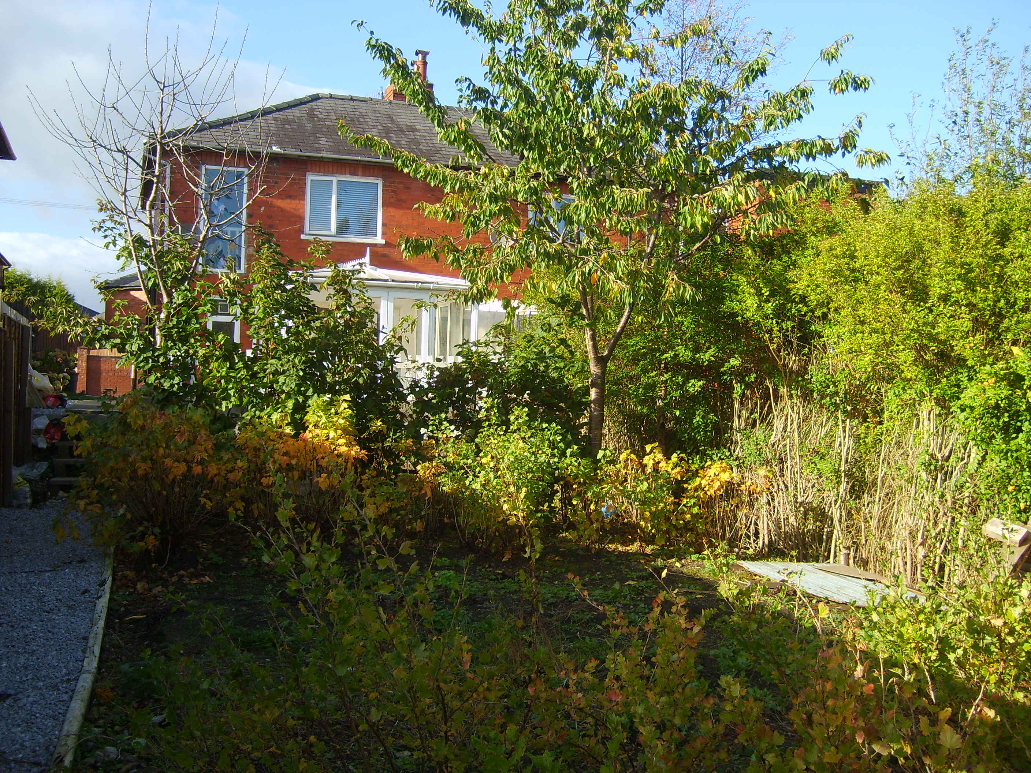
Situated to this cul-de-sac location is this two bedroom semi-detached brick property being situated within easy access to local amenities in Mytholmroyd, making this an ideal home for the first time buyer or a good investment property.
The accommodation briefly comprises of: side entrance hallway, guest cloakroom, lounge with French doors leading in to the fitted kitchen with built in appliances and access into the conservatory. Two bedrooms and bathroom on the first floor,
Gas central heating and double glazing installed
Externally there is off road parking to the front, side access leads to the paved patio area, steps lead down to the enclosed garden area.
THE PROPERTY REQUIRES SOME UP GRADING

