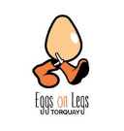 Eggs On Legs Torquay 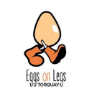

**Saver Stack of Extra Fresh Free-Range Farm Eggs**

**Delivered Free to Your Workplace**

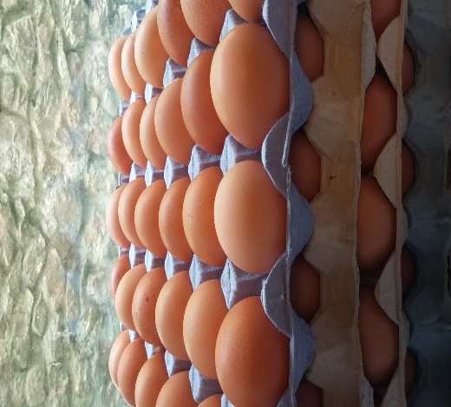

**5 Trays of 30 Large / Medium Eggs £25**

**Share The Cost With Your Colleagues**

Or Tray of 30 L/M Extra Fresh Free-Range Farm Eggs £5.50

Or 1 dozen L/M Extra Fresh Free-Range Farm Eggs £2.80

Or ½ dozen L/M Extra Fresh Free-Range Farm Eggs £1.60

Pay in Whole or Part by cash or card

Message us on Facebook “eggsonlegstorquay”

Text 07985 307 486

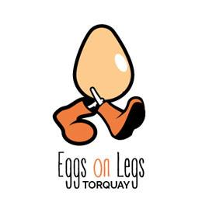

Eggs On Legs Ltd Company No 12038293 VAT No 324 465 116