Tours & Tastings At Yorkshire Heart
Yorkshire Heart now offer both Brewery & Vineyard Tours & Tasting sessions. The Vineyard is best visited between May & September, at this time of year there is plenty to see i.e. the difference in the growth patterns of the vines (we have 15 varieties) and weather is more favourable (hopefully!).
Here are some of our available packages however here at Yorkshire Heart we will try to tailor our wine tours and tastings to specific needs so the below are only as example and are certainly not set in stone :
- Guided Tour of the Vineyard followed by a tasting of 3 of our own produced wines.
Approx. time: 1.5 hours
Price: £10 per head (minimum group of 6)
- Guided tour of the vineyard followed by a tasting of 3 still and 2 sparkling of our own wines served with light refreshments, followed by a fun wine quiz
Approx. time: 2 hours
Price: £15 per head . (minimum group of 6)
- Guided Tour Of The Vineyard & Brewery Plus Tasting Guided tour of the beautiful vineyard & see how our beer is made with a tour of the brewery, followed by a wine tasting of 5 of our wines (3 still and 2 sparkling) and 3 beers all served with matching refreshments and lots of fun including a beer & wine quiz to see who was listening!
Approx time: 3-4 hours
Price: £25 per head (minimum group of 6)
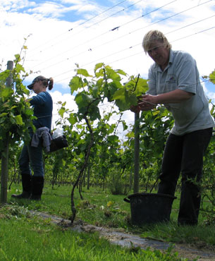
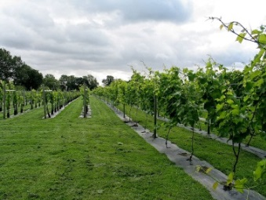
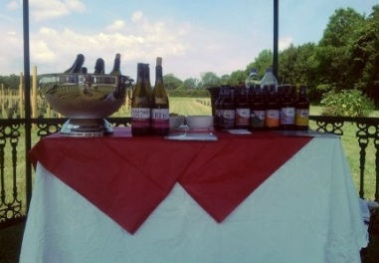
- An Evening In The Vineyard Guided tour of the beautiful vineyard followed by canapés & sparkling wine reception & 2 course dinner served with our own wines finishing with tea/coffee & a wine quiz
Approx. time: 3-4 hours
Price: £35 per head (minimum group of 10)

Please note that to enable us to give you the best possible vineyard experience all group tour places need to be booked at least 7 days in advance & please let us know of any special requirements you may have.
For further information or to book your vineyard experience then please contact Karen on 01423 330716 or email sales@yorkshireheart.com

