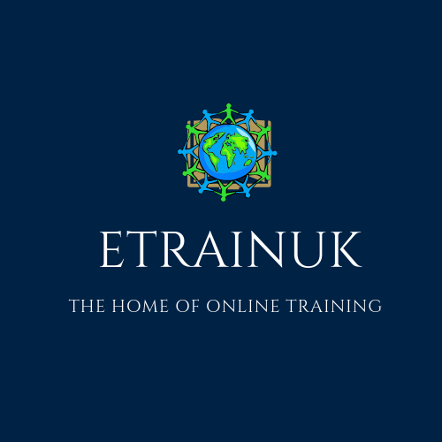

Etrain UK –Find Health And Social Care Courses at low prices Online.

Learning from in your own office or home is something that has grown in popularity in recent years. More and more people are choosing to boost their career prospects and their CV by choosing to enrol on a course suited to their aspirations. Particularly the care industry, who struggle to release valuable staff.

Our team at [Etrain UK](http://www.etrainuk.com/) is constantly looking to help people seeking to gain expertise in the world of Health and Social Care with our array of courses you can complete from online.

In the world of home offices and portable laptops, you can combine our [Health and Social Care courses from home](https://www.awin1.com/cread.php?awinmid=15642&awinaffid=531955&clickref=&p=https://www.learning247.co.uk/collections/healthcare-social-care) with part-time work, travelling and take everything on the go.

Whether you prefer studying from your local coffee shop, office or you have a kited-out office in your home, our hub of courses at Etrain UK could be perfect for you.

**What Health and Social Care courses from home / online can you find through our service?**

As a referral service for at home courses, our online collection of Health and Social care courses spans everything you could possibly want to learn.

Are you looking to earn a care certificate online? Do you need to enrol on dementia courses to support your application for a job? Is there something you want to learn about in the social care world?

Fortunately for you, our website, at Etrain UK is a hub of information and resources for your career or to improve the knowledge of your staff.

[Check out our website for more courses](http://www.etrainuk.com/).

Kind regards

A Raybould

[Assistance@etrainuk.com](mailto:Assistance@etrainuk.com)