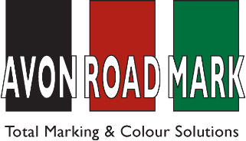
Our experts offer free design, advice and practical solutions assuring you of quality work whatever your requirements.

Our technicians operate 24 hours per day, 7 days per week giving customer’s excellent response rates and the ability for us to carry out work at times most convenient to you.

w for a free, no obligation quotation on 01454 322766.

ANTI SKID |  | CAR PARKS |  | HEALTH & SAFETY
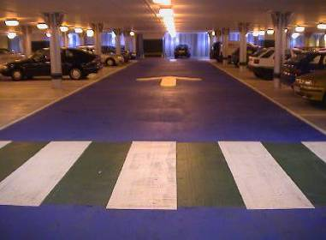  Coloured textured surfaces for highways, car parks, cycle tracks and pedestrian areas. |  | 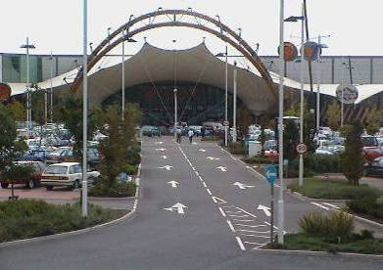  Applied in hot screed thermoplastic to BS EN 1436 and sprayed chlorinated rubber paint to BS EN 1871. |  | 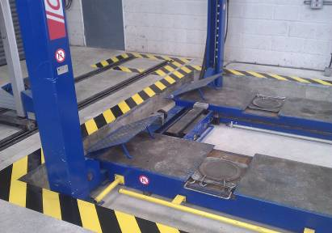  Full range of health and safety markings – undertaken both internally and externally.
ROADS |  | REMOVAL |  | OTHER SERVICES
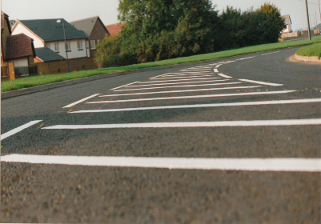  Highway markings to local authority specification with screed applied reflectorised thermoplastic. |  | 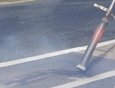 Elimination of existing markings by hot thermal lancing, scabbling or grit blasting. |  | 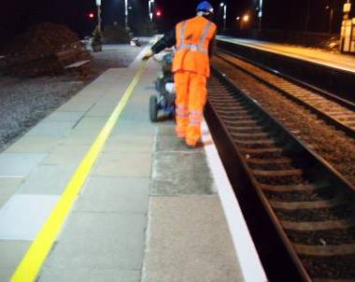  Railway Platform Markings, Airfield Markings, Warehouse, Factory and Industrial Line Markings.
FLOOR GRAPHICS |  | PLAYGROUNDS |  | SPORTS COURTS
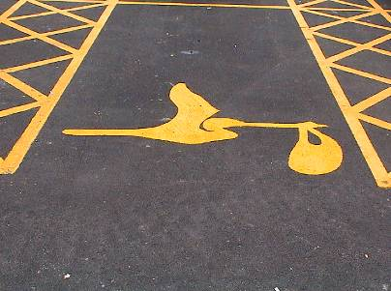  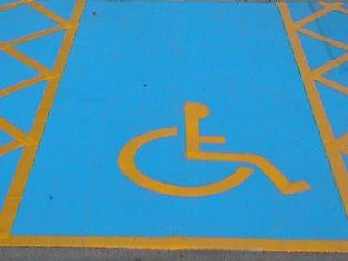  Virtually any design or logo can be produced to meet your requirements. |  | 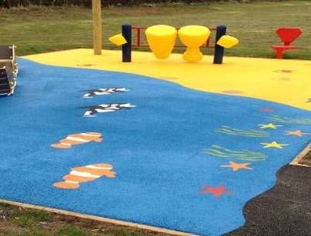  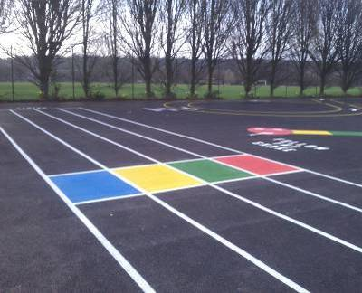  Imaginative areas to stimulate a child’s development and play skills. Virtually any pattern, shape or game can be created. |  | 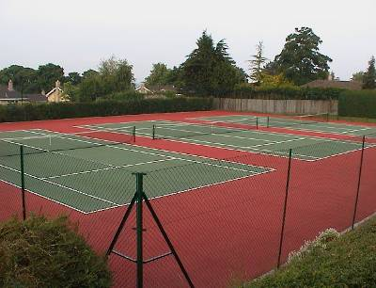  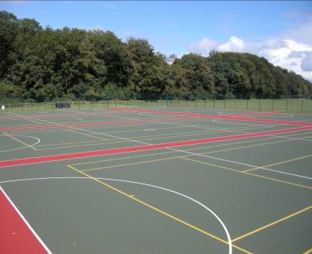  Slip-resistant coloured sports coatings for tennis courts and multi-use areas.  Sports court lining.

