DIY

Step By Step guide for home improvement.

Start to finish presentation on dry lining; Carpentry; plastering; painting; floor sanding and varnishing.

Hello every one, in this presentation I will try to guide you the best I can through a project I have recently completed for a customer of mine who was complaining about mould on the external walls of her house. We decided to insulate the walls by dry lining them with insulated plasterboard (30mm). So here is how it was done:

Step 1

We washed the mould off the walls with bleach. That action alone is very effective if you’re dealing with mould. Other things are ventilation and heating.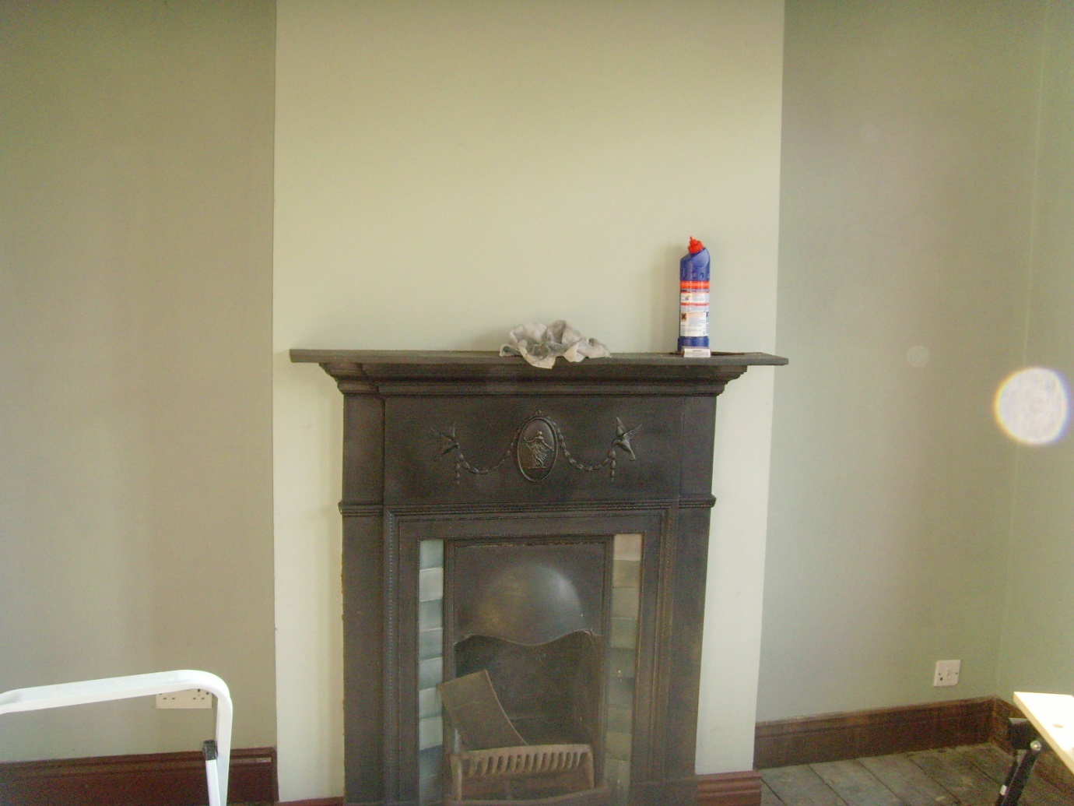

As you can see from the photo it looks good already.

Step 2

We remove the Skirting board and window seals because our walls are going to be 3cm thicker so the woodwork needs to be readjusted accordingly. In our case the window boards will be replaced with wider ones.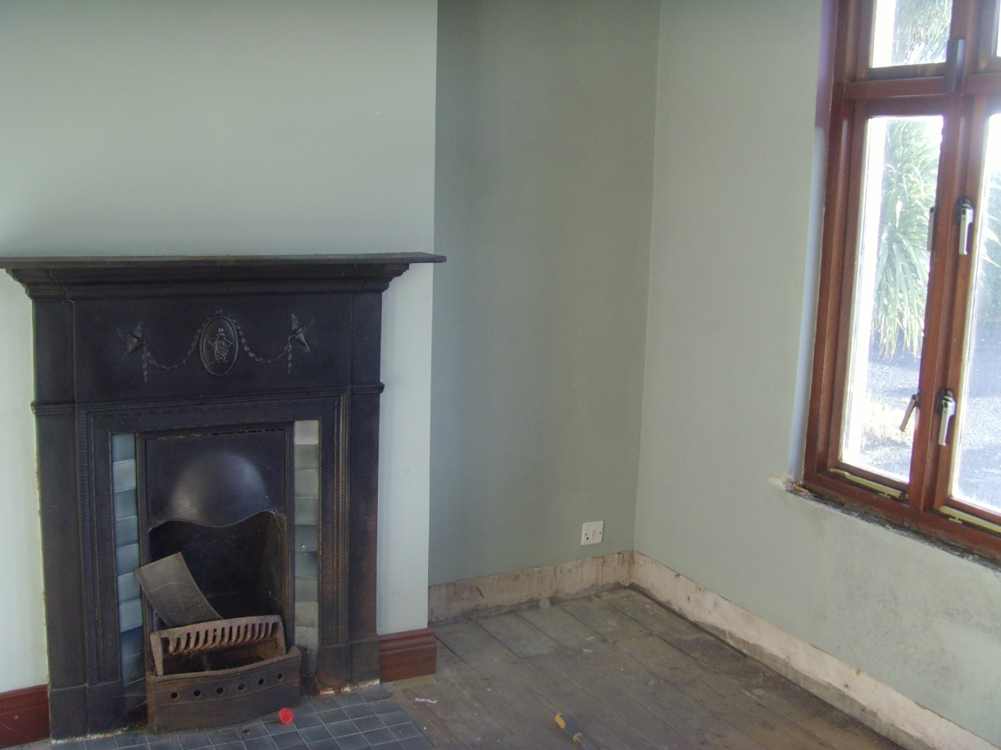

Use a chisel and a hummer or a screw driver if the boards are screwed on.

Step 3

Dry lining.

There are a few ways to fix the plasterboard on the walls, we used metal 110 fixings…or ‘Mushrooms’ as they are also known.

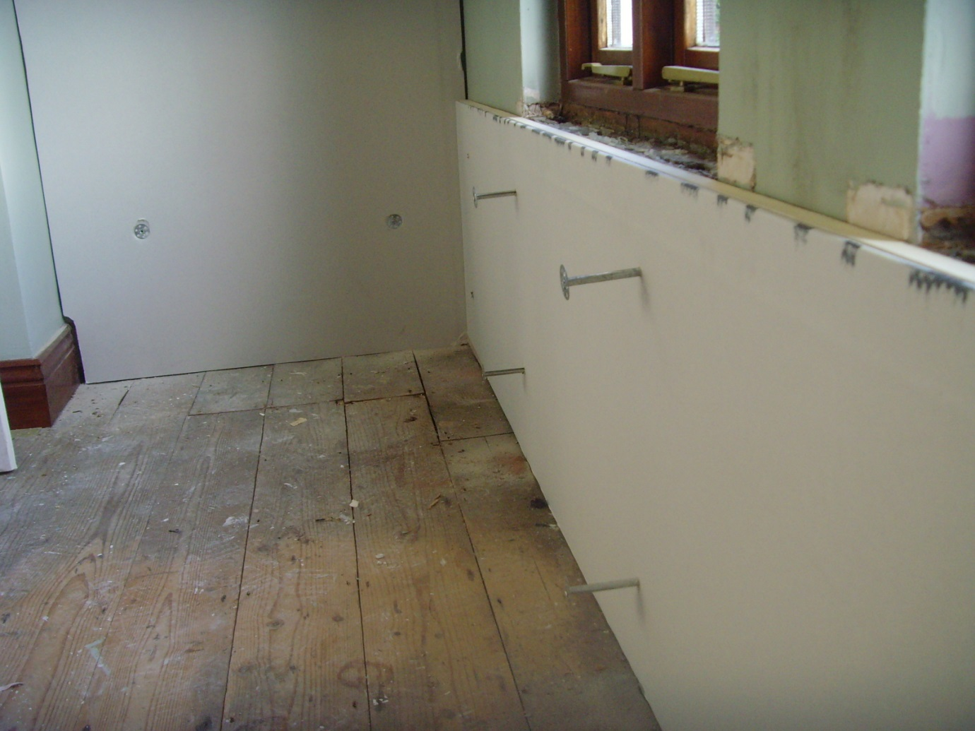

First we cut the boards to size using a Stanley knife alternatively a hand saw can be used, (or should I say destroyed, because if you use it on plasterboard then it will become less effective on wood afterwards.)

Then 8mm holes were made in the wall through the plasterboard 110mm deep.

The mushrooms then are hammered in making sure they are embedded a little into the plasterboard so they don’t stick out when we plaster the walls. Allow about 40-60cm between them.

As we progressed we got closer to the coving which got removed because it had to be altered too.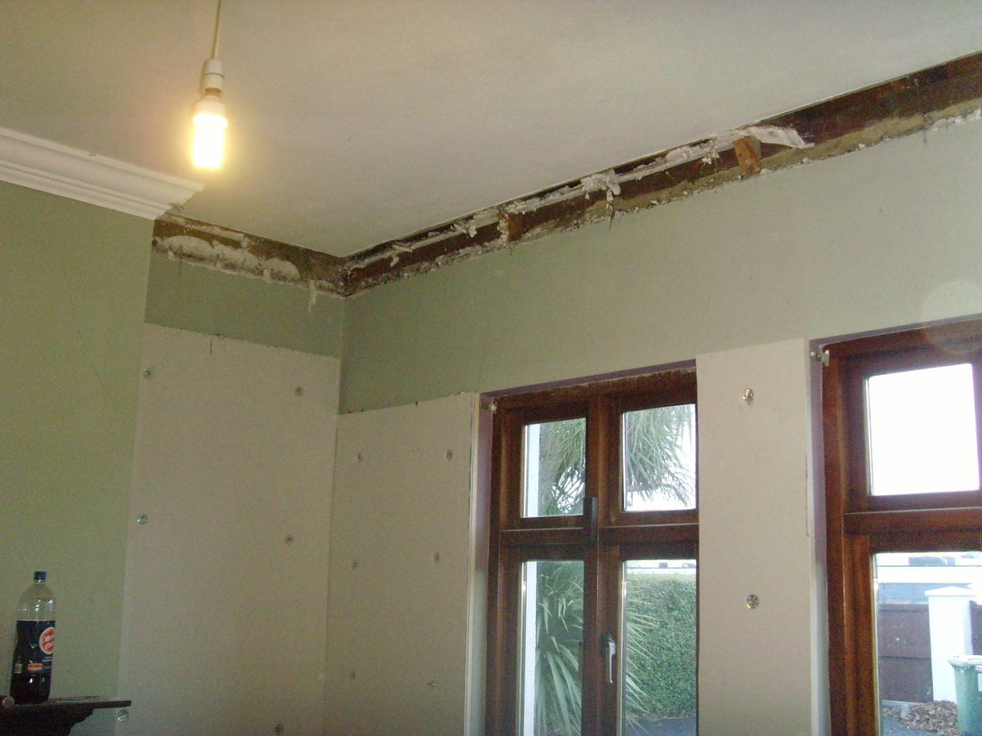

Step 4

We replaced the coving using screws and glue…

Usually the coving is glued on as well as pinned up using nails but this house had wooden coving so it was a bit heavy to just use nails.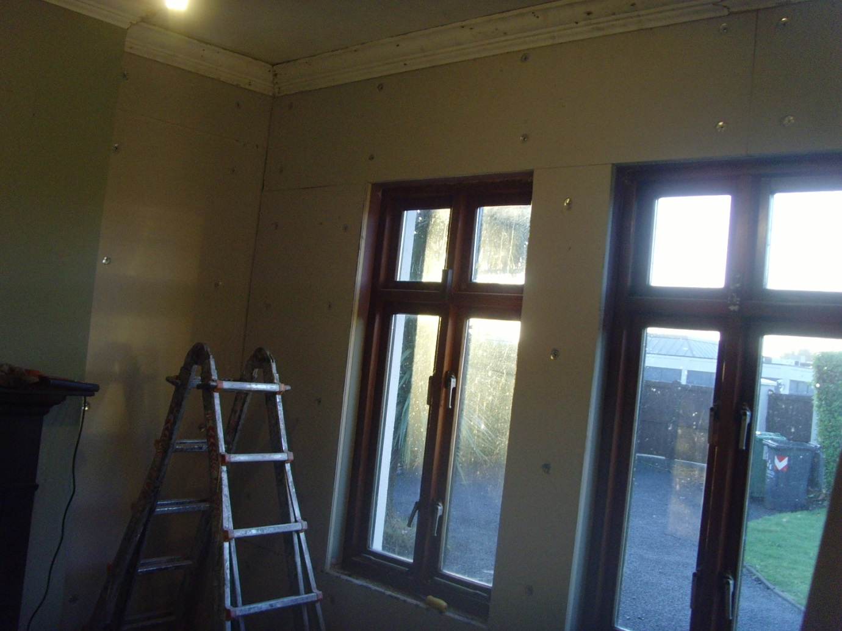

Step 5

Plaster beadings and scrim tape.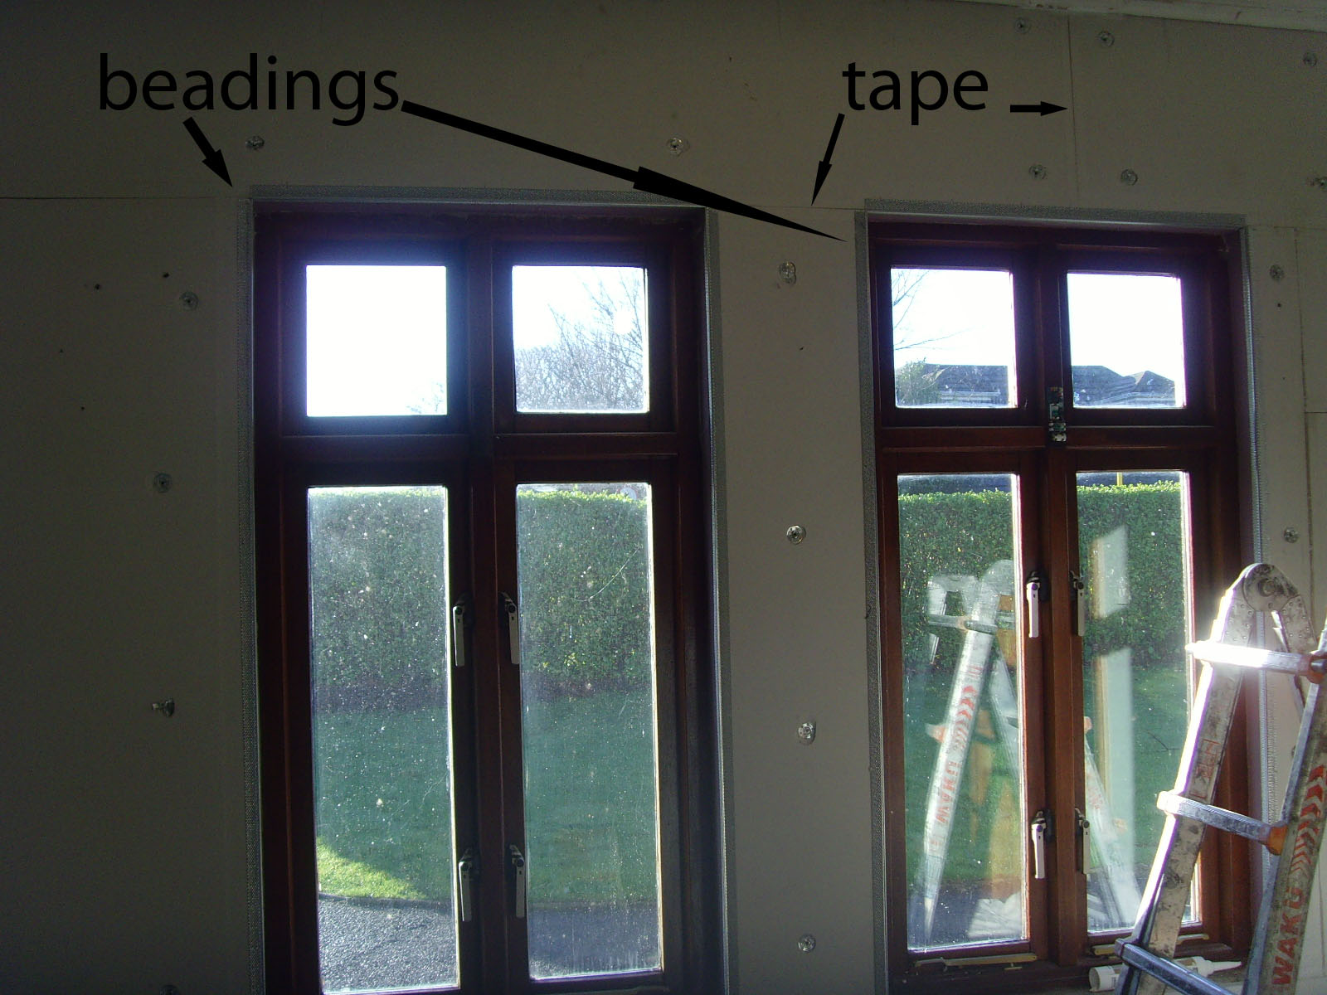

Step 6

Plastering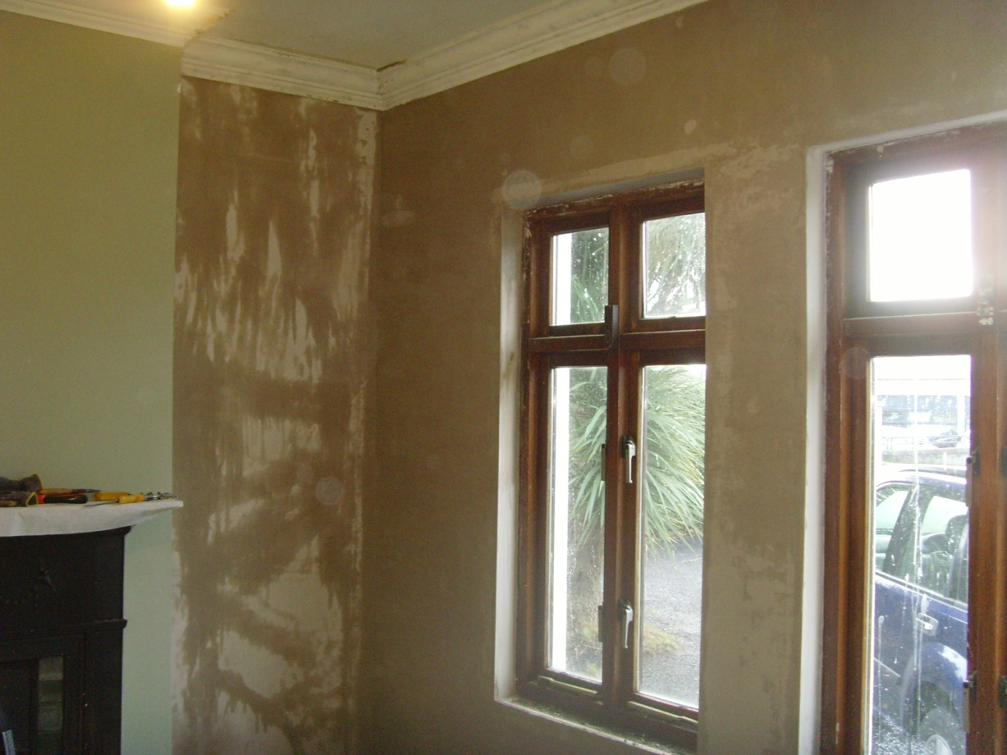

While plastering we have covered the floors with dust sheets to try and keep it clean. Even though we were going to sand it down and varnish it afterwards, it still needed to be covered to avoid any staining from all the water used when plastering…

Step 7

Next is the floor.

We have to do it at this point to avoid a lot of dust on the walls.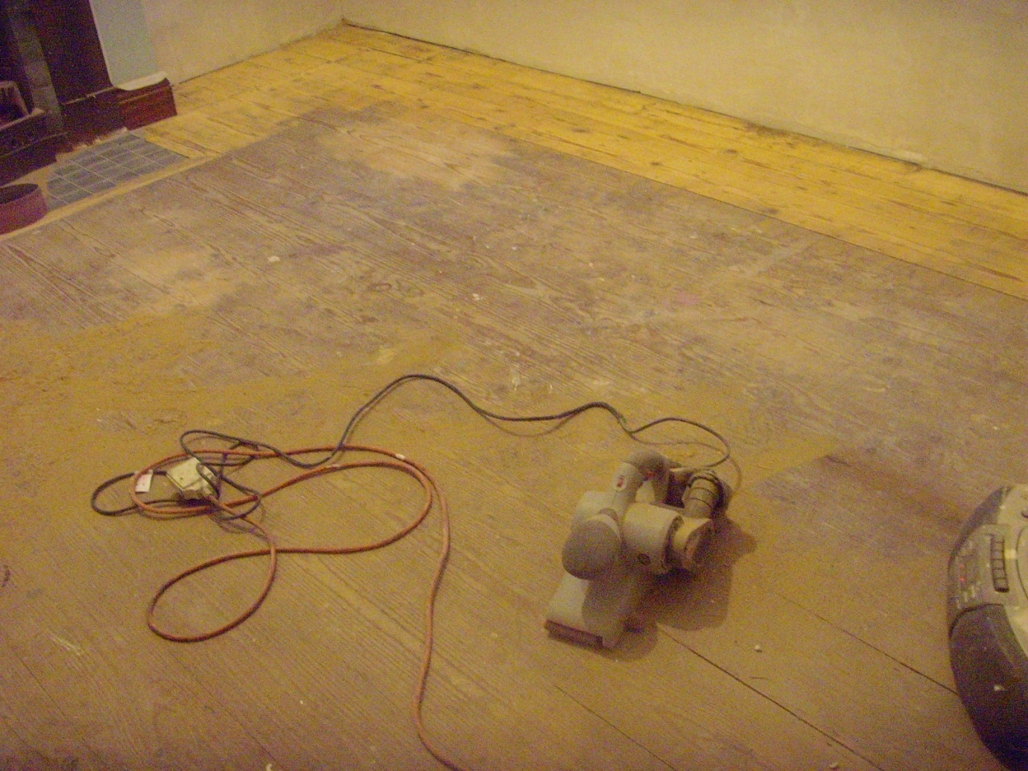

We used a belt sander from B&Q and about 6 belts...

We only sanded the floor at this stage but not varnished it as the painting is done from top to bottom.

Step 8

Painting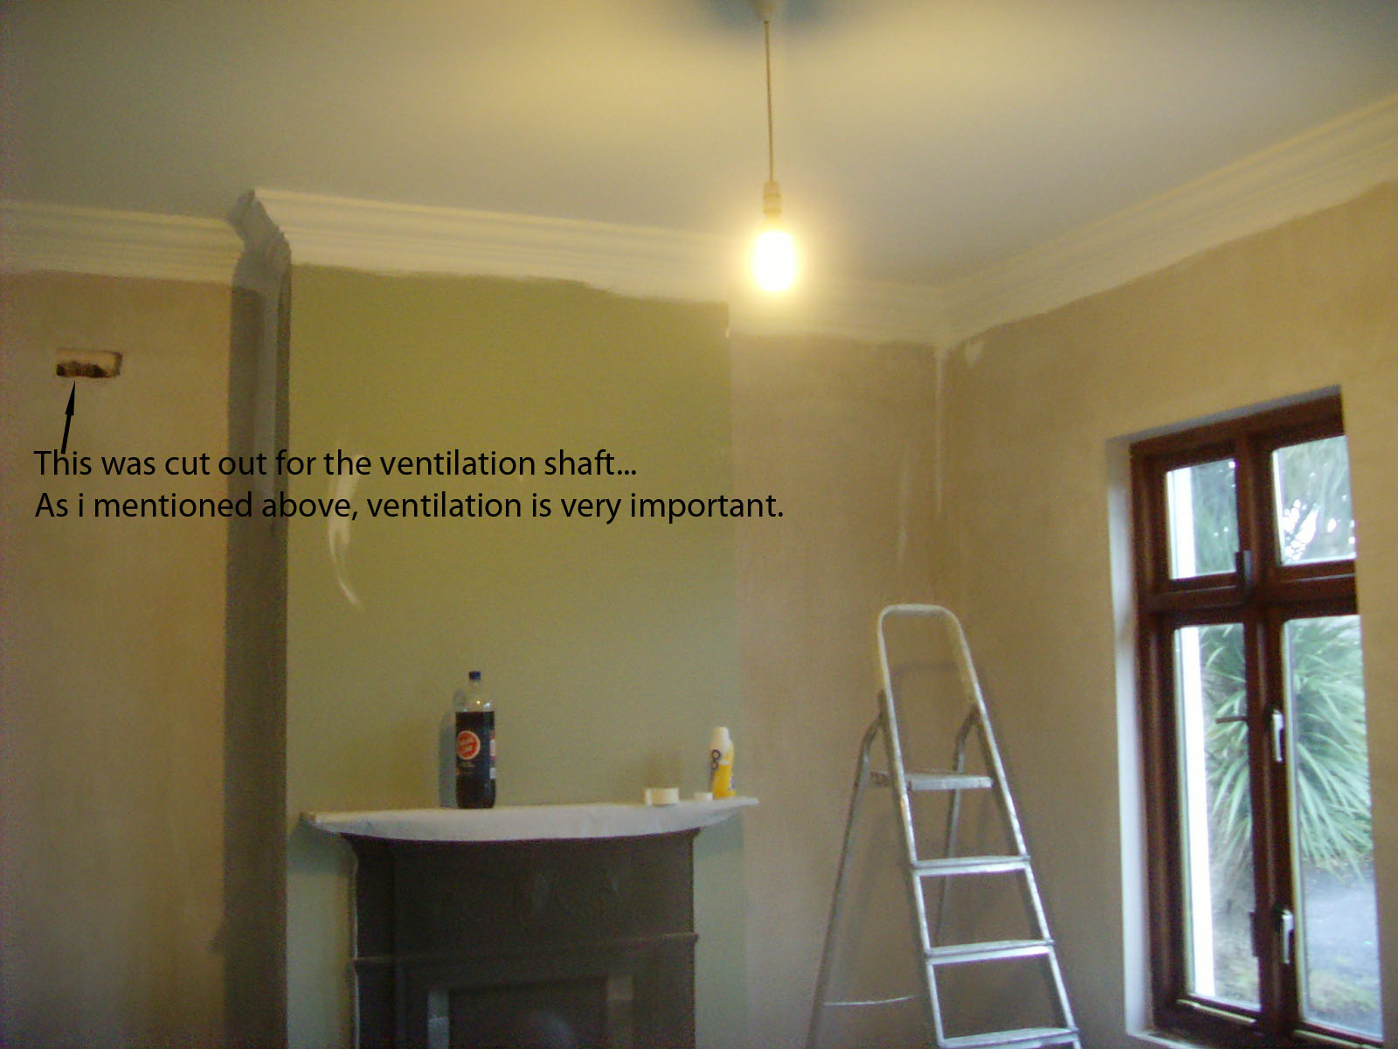

The ceiling is done first making sure the coving is all properly painted going an inch below the intended line.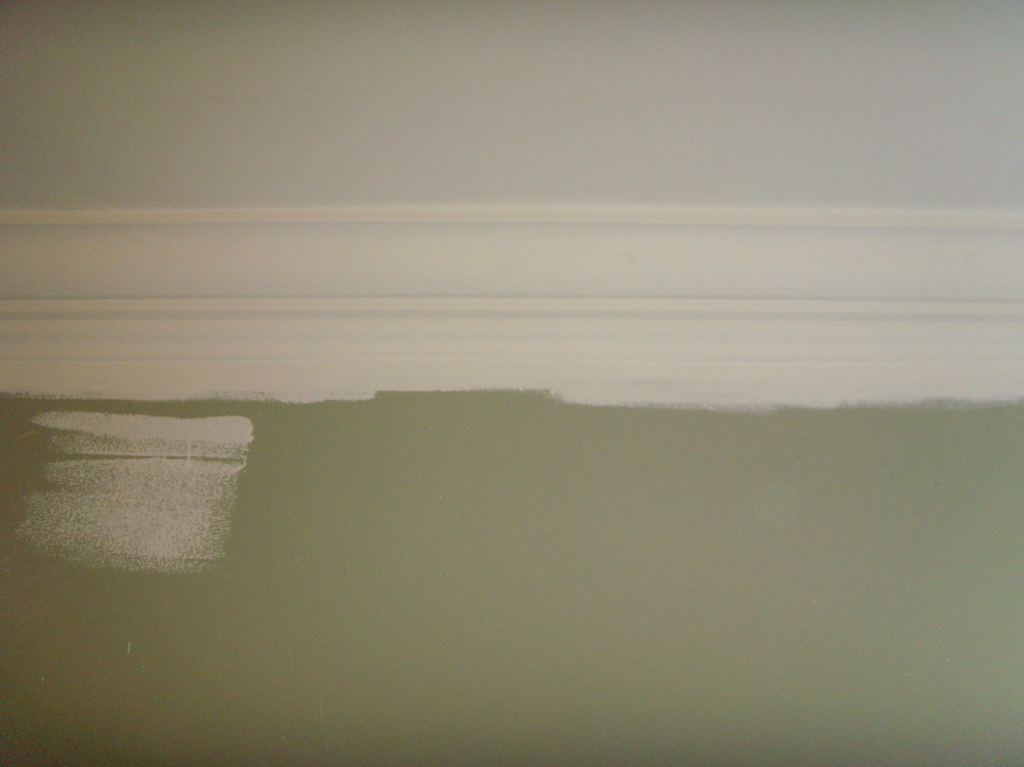

Always apply 2 coats or more.

Next come the walls, starting with the line and like the ceiling: 2 coats.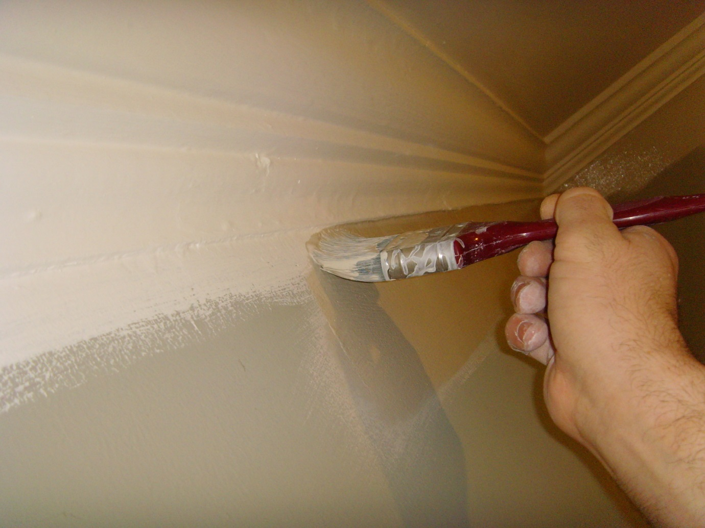

Use a 4inch brush to do the line then a medium roller for the rest of the walls.

Make sure you tape all that needs to stay clean like light switches and sockets… in our case we had to tape the skirting board because it was varnished…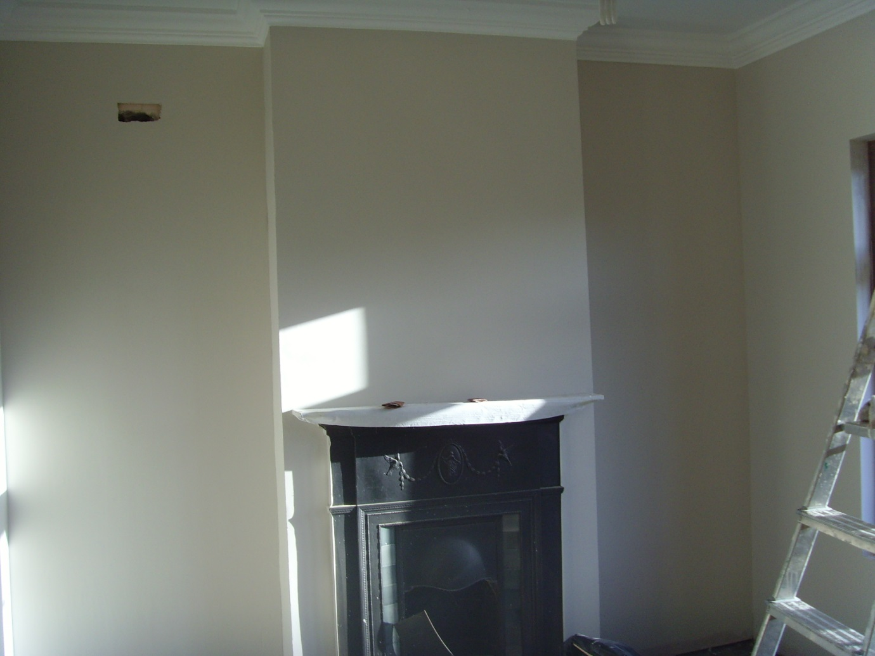

Step 9

Refitting the skirting and window boards…

We first cut the skirting to size then varnished it before fixing it back on the walls using screws and wall plugs.

Window boards were also glued.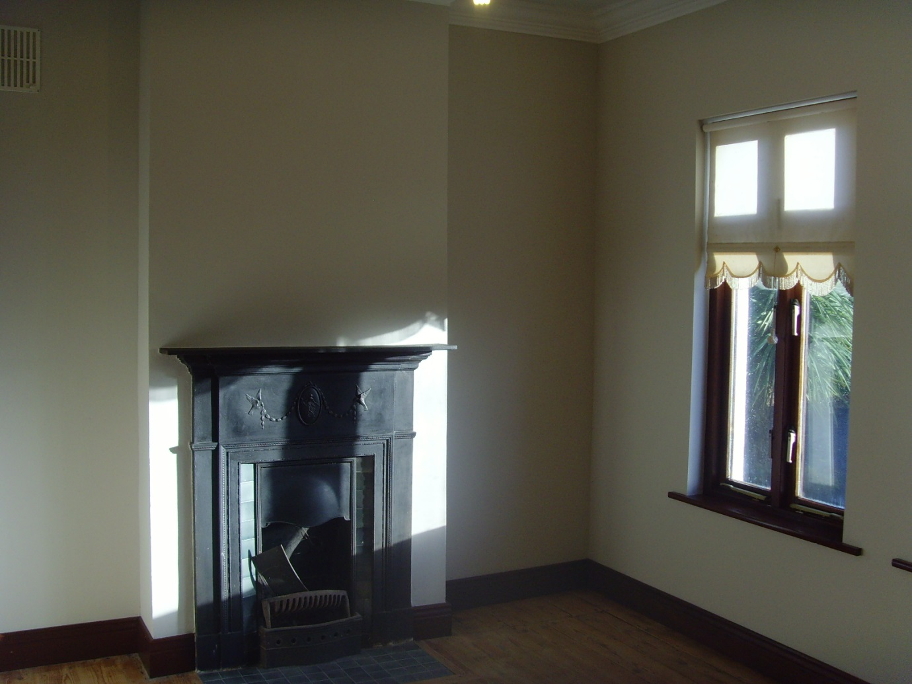

Step 10

Varnishing.

Stained varnish was used for the windows , skirting and door and clear on the floor.

One thing to remember when varnishing with stained varnish is not to over do it and allow it to properly dry before second coating it. Only second coat if necessary, the less you use the better.

I’d also recommend to use oil based varnish rather than water based.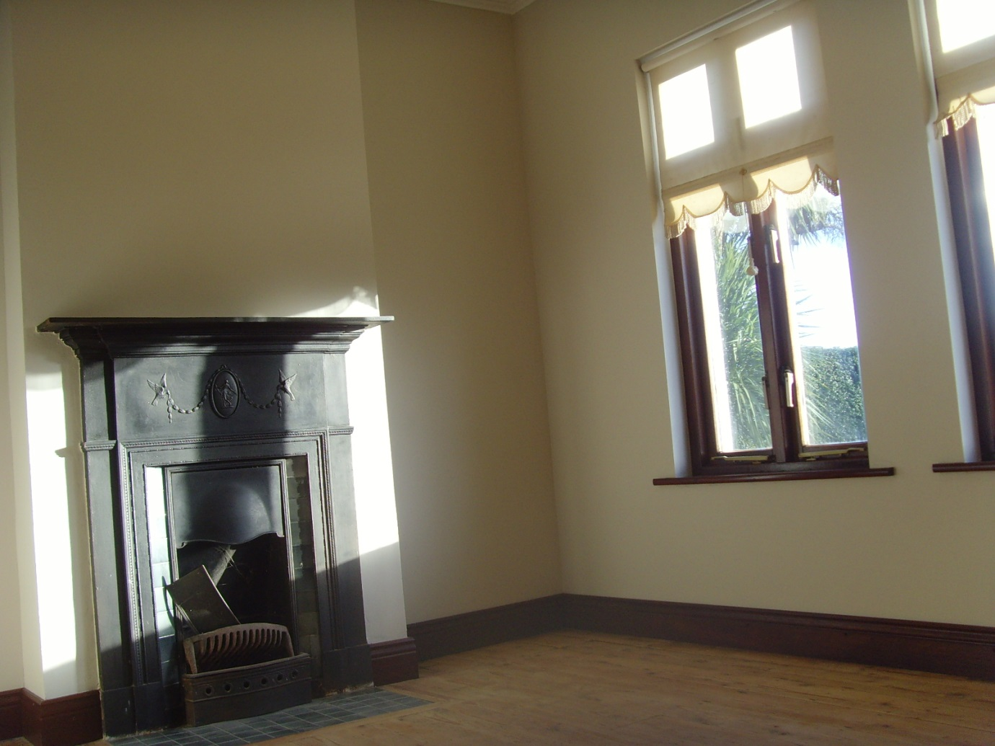

And just like that…we were done!

Best of Luck with your DIY!

Painting In Dublin

www.paintingindublin.ie