Price List

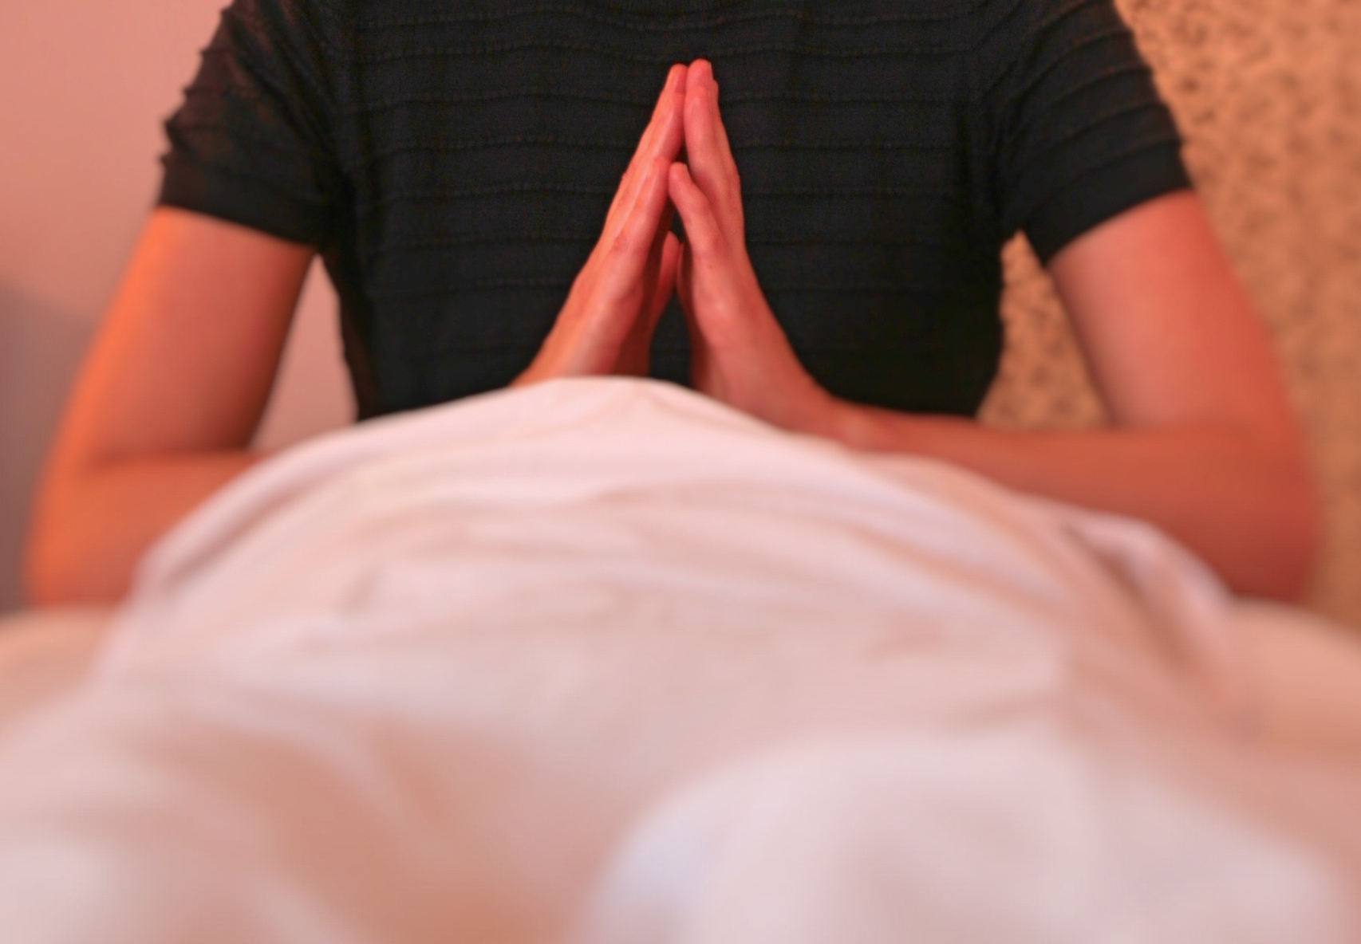
JENNY HAMPTON MASSAGE

Therapeutic Massage

30 MINUTES £25

60 MINUTES £40

90 MINUTES £60

Herbalife Holistic Facial

30 MINUTES £30

60 MINUTES INC HALF HOUR MASSAGE £45

Couples Massage Workshop

2 HOURS £90 per couple

