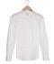 Men's shirts £3.00

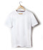 T-Shirts £3.00

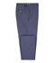 Trousers £4.00

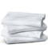 Bed Sheet - Single £4.00
Bed Sheet - Double £10.00
Bed Sheet - King £6.00

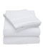 Duvet Cover - Single £4.00

Duvet Cover - King £8.00

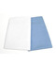 Pillow Case £2.00

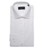 Shirt Folded £3.00

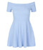 Dress £7.50

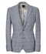 Jacket/Blazer £6.00

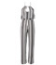 Jumpsuit £5.50

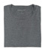 T-Shirt Folded £3.00

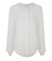 Top/Blouse £4.00

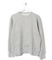 Jumper £4.00

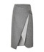 Skirt £3.00

