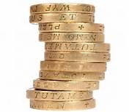

**Fees**

* **First session free then £40 per session**
* **No minimum number of sessions**