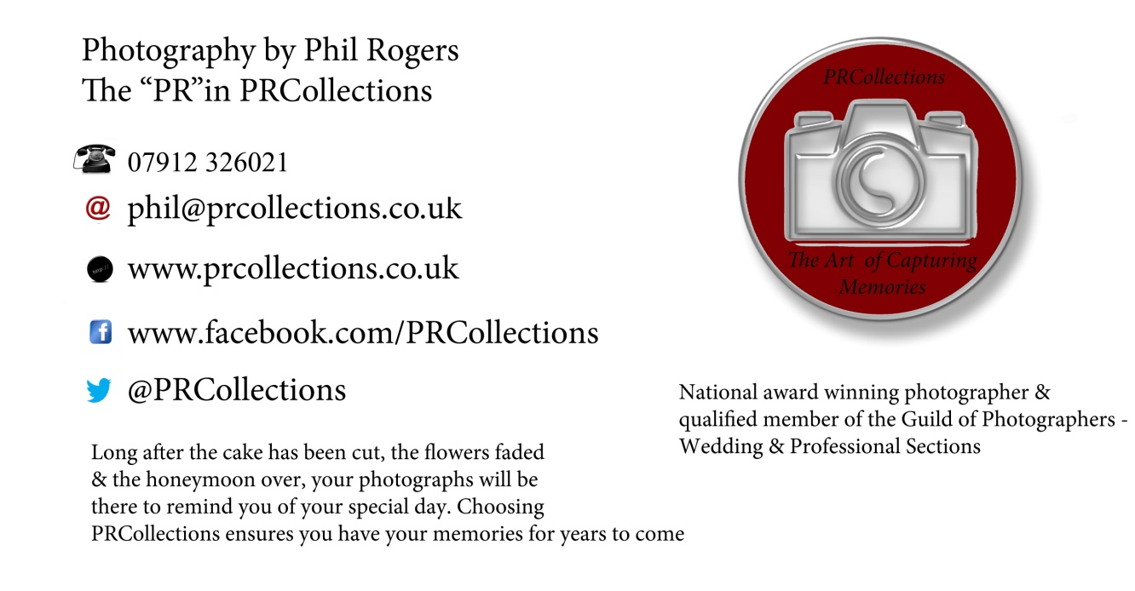

**PRCollections - The Art of Capturing Memories.**​

Long after the cake has been cut, the flowers faded & the honeymoon over, your photographs will be there to remind you of your special day. Choosing PRCollections will ensure you have your memories for years to come.

I only offer one main package with clear and simple pricing and no nasty shocks.

Wedding & Civil ceremony photography across North Wales & Chester - £900.00.

* PRE WEDDING SHOOT WITH SIGNATURE BOARD PHOTOGRAPH OR SIGNING BOOK FOR YOUR GUESTS TO SIGN AT THE RECEPTION. (GET BOTH FOR £100.00 EXTRA.)
* FULL DAY COVERAGE FROM BRIDAL PREPARATION UP TO AND INCLUDING THE FIRST DANCE.
* ALL FINAL IMAGES, PROFESSIONALLY EDITED IN A MIXTURE OF COLOUR & BLACK & WHITE, LICENSE FREE, ON A MEMORY STICK READY FOR PRINTING.
* PRIVATE ONLINE GALLERY FOR 6 MONTHS AFTER THE WEDDING FOR YOU & YOUR GUESTS TO VIEW & DOWNLOAD IF REQUIRED.
* A 20% NON REFUNDABLE BOOKING FEE/DEPOSIT SECURES YOUR DAY.
* INTEREST FREE INSTALMENTS WELCOME.
* BESPOKE WEDDING ALBUMS AVAILABLE FROM £240.00.
* PRINTS/ENLARGMENTS FROM £8.00.
* CANVAS WRAP PRINTS FROM £79.99.
* TRIPTYCH PRINTS (I.E. THREE 10X8IN PRINTS IN ONE FRAME) FROM £120.00.
* SECOND PHOTOGRAPHER - SUBJECT TO AVAILABILITY - £200.00.

Destination Weddings - i.e. outside the UK will cost the same but travel/accommodation charges will apply.

Only require photography for a few hours? Then contact me for a bespoke quote - minimum charges apply.