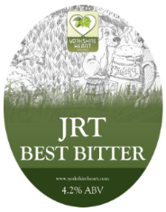
JRT Best Bitter 4.2% ABV

A pint of liquid sunshine, it seduces all the senses. The Syrian Golding hops give extensive aromas of long warm summer days, a great pint to linger over
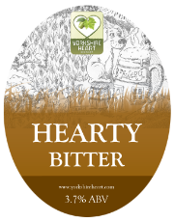
Hearty Bitter 3.7% ABV

A sparkling clear amber brown bitter full of rich aromas of roasted malt. The bitterness and flavour of the hops come in at the finish to create a truly thirst quenching pint
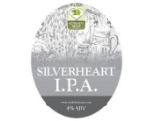
Silver Heart I.P.A 4% ABV

The rich malts and wheat that are blended with gorgeous aromatic hops all go in to brewing this IPA, a superb drink
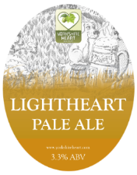
Light Heart 3.3% ABV

A wonderful golden pale ale that really punches above its abv when it comes to flavour. A light easy drinking low alcohol pint.

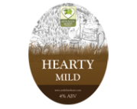
Hearty Mild 4% ABV

This is brewed from a traditional recipe using a blend of four malts to give a delightfully smooth drinking ale. This rich flavoured mild has hints of nut and chocolate and has a natural residual sweetness, an easy drinking ale.

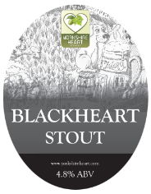
Black Heart Stout 4.8% ABV

Brewed using only a blend of malts and roasted barley to create an ale full of taste and colour. A deliciously smooth pint to while away the time of day

