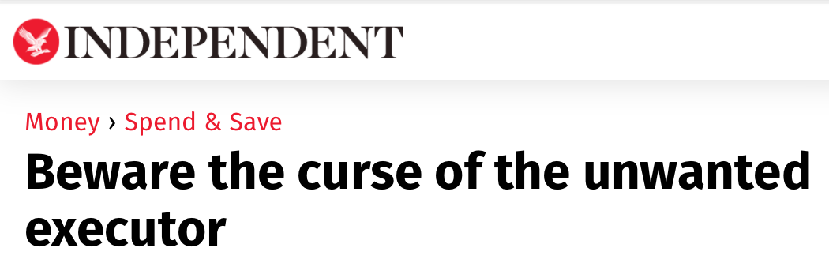
Knight. J, Cavaglieri. C, (2009).
Enticing offers of discount or even free will-writing services may sound harmless enough, but many families who take this route risk paying dearly when it comes to sorting out the eventual estate. Will-writing companies, banks and solicitors may be taking customers for a ride by appointing themselves executors in the will and charging over the odds for taking an estate through probate.
Some banks and will-writers can offer their services as a loss leader; they can recoup their money tenfold by ensuring they are included in the will as executors, then levying bumper fees when the testator passes away. After death, it is difficult to remove executors from a will; as a result, estates can be hit with unspecified charges of as much as 4.5 per cent, or £22,500 on a £500,000 estate.
The law states that if a bank, solicitor or will-drafter is named as an executor or joint executor in a will, they have the absolute right to act and can be removed only by making an application to High Court, which would incur fees well beyond most people.
Consumers should be aware that some will writing companies, banks and solicitors can be insistent about writing themselves in as a joint or sole executor.
For those with a relatively simple estate, family members and close friends are often appointed as executors. Solicitors can then be used and paid for separately if complications arise.
“Appoint someone you know and trust as your executor. Make it clear that if they find something too complex or simply are too busy, they are free to appoint a solicitor at the time and agree the fees for carrying out the work.” Says Mr. McCarthy at Which? Legal Services Department.

