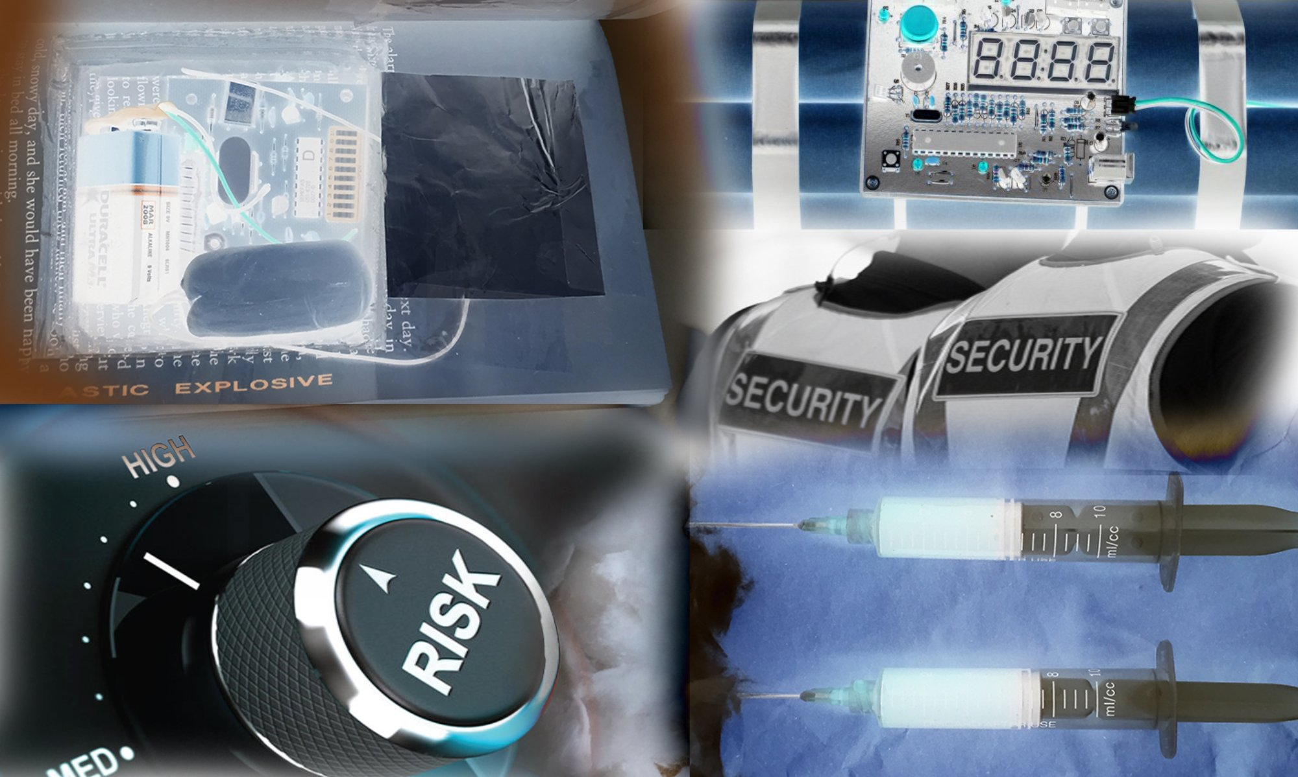

**The Corporate world threats are ever changing, so is the mode of how a message is delivered from a Terrorist, Activist or would be Anarchist.**

**[Ian Griffin](https://www.linkedin.com/in/griff871)**

CEO at i2 Defence Services Ltd

The Corporate world threats are ever changing, so is the mode of how a message is delivered from an activist cell, or how an 'ad hoc' extremist organisation delivers their message. For some, the threat is more than real when their offices are attacked even when they were not the target. Although business are somewhat strong with continuity, your staff need to feel protected in their work environment. The psychological effects after an attack can be devastating to your staff after the event, this is where your staff have time to think about the events and how they were handled by your company. In order to make the business wheels turn, the staff need to turn them. Making every effort to protect your staff will give them a sense of security and is good for their well being. The threats are constantly evolving when terrorists or anarchists believe their message is being ignored. Tactics change when a Terrorist realises their devices have been countered. Keeping ahead of the game through good up to date intelligence and training is invaluable to your team.

One of the well known routes threatening a business is through its postal system. This has been made apparent during the attack on the international monetary fund in France recently. Having a well educated post room department can help stop potential threats entering or being opened before they are detonated by the recipient. Here is the million dollar question, could your post room department identify the risks and and carry out safe practice measures under your company policy and procedures to stop potential threats entering your business?

I am often asked when educating staff on suspect mail for larger Blue-chip companies on the use of x-ray machines what they are meant to do if they find a suspect item? As there are so many factors when dealing with suspect mail and without writing your SOP for you I have decided to break them down into short paragraphs starting with safety which is paramount in the workplace, more so if you are using an x-ray machine.

Before any training takes place a risk assessment to your staff and your business needs to be made. This is fundamental in realising your risks. For example if you have or are being targeted in a campaign against your company you must first understand how and why you have been targeted. An activist or anarchist group targeting your company will initially be organised on a “ad hoc basis”. These groups start at low level and will make their protest peacefully at first before a campaign of threat mail starts to enter your business.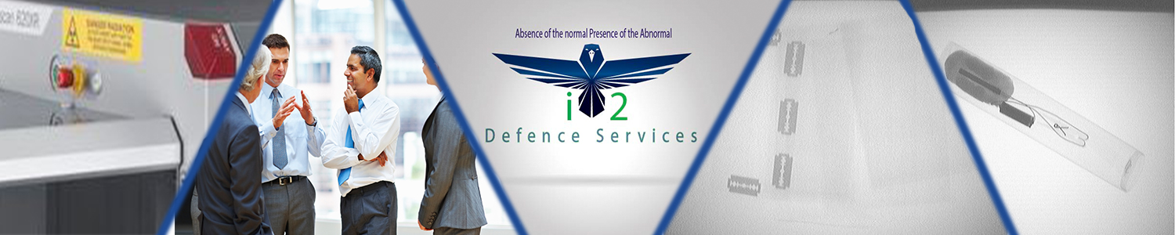

If your company has the benefit of having an x-ray machine on site to help your post room staff check mail, then you have a greater advantage than those who do not. Having the right tools to carry out your work is key in any job and would speed up the process of being able to complete your work. Being able to view items of mail with an x-ray machine is an excellent counter measure, more so if your company has ever been targeted by a would be anarchist.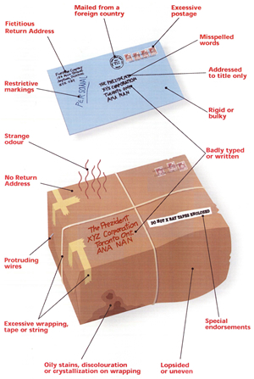

If you do not have the facility to check mail through x-ray then you can still apply some of information below when it comes to recognition. If you feel it is not safe to open then trust your instincts. Absence of the normal, presence of the abnormal.

Your company may have been attacked by low level threats such as words & images or small items posted inside envelopes. You may of even had a substantial item that may of had your post room closed down as a Crime scene. This is the worst case scenario and normally activates your companies business continuity programme as there could be a potential loss of business until the item is contained and deemed safe by the local authorities Police/Military etc.

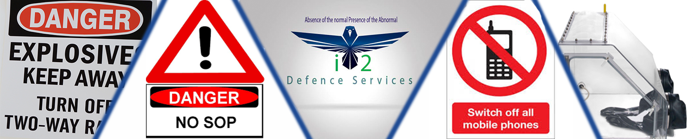

Firstly, you need to have up to date SOP's which relate to your work ethic when using an x-ray machine to visualise mail and potential suspect mail. Your SOP guidelines will help you follow your company’s basic safety guidelines before you switch on the machine. Your X-Ray Team Supervisor will watch you perform machine safety and start up procedures which will also include colouration matter testing during start up and start up machine self testing. If your machine can't detect matter with the right colouration, then it isn't doing its job and needs to be serviced. Your X-Ray Team Supervisor will sign this safety start up process daily as compliance testing which normally is submitted to your head of Department for health and safety on site.

Designated X-Ray Team Supervisors will know who can or can’t use the x-ray machine dependant on their medical conditions etc. Guidance Documents, Radiation-Emitting Products will have operating procedures attached to the machine from the company who engineered the machine which will address system performance attributes or protective measures in light of the operator’s proximity to the source assembly. X-Ray systems pose possible operator exposure concerns due to leakage radiation and back scatter radiation if the safety of the machine is not compliant. The radiation exposure to the operator will be the sum of any radiation leaking from the x-ray tube source assembly (leakage radiation) and any radiation that scatters from the machine if it is not safety compliant, this in itself is an endless subject would steal the small article and send you to sleep, for more information we can help direct you the right way if you are unsure.

 Training is key to having a greater output to your business by your staff when allowing mail to pass through your departments. If your staff can’t identify the basic fundamentals to what encapsulates suspect mail, then this will itself slow down output to the business. Without giving away all our modern and up to date training and search techniques there are the old 1970’s style tell-tale signs for example Protruding wire, colouration on boxes of mail, strange odours, Oily spots, discolouration addressing mistakes, miss pelt words, no return address, wrong titles with names on them, over stamped items and strange smells and the obligatory pipe bomb. Anarchists are a bit more educated than they used to be when trying to get a message across to a company or to close down the operation of a post room or workplace. Although business are somewhat strong with continuity, your staff need to feel protected. The psychological effects after an attack to staff can be devastating. In order to make the wheels turn, the staff need to turn them. The threats are constantly evolving. Tactics change when a Terrorist realises their evices have been countered. Keeping ahead of the game through good up to date intelligence and training is invaluable to your team.

Technology advancements in anarchists trying to counter the counter IED detectors has been proven effective in certain parts of the world where liquid, plastic, wood all play a key role to operators and detectors finding potential hard line suspect devices. You may have noticed this more so at airports where you can only take on board small amounts of liquid. The threats are out there you just need to know how to negate them. This is also a huge subject matter however of you follow the fundamentals in detection through your training you are on the right track.

When using the colouration system on your x-ray machine this will allow you to see Low density organic materials, such as paper, wood, clothing and plastics will show up as various shades of orange. Explosives are organic materials, so will appear as an orange shadow, the darkness of the shadow will depend on the thickness of the explosive material. Explosives may not always appear orange if they are masked by inorganic materials, there could be metal foil around plastic explosive, then the colour shown will be a composite of the two materials and difficult to detect what it actually is.

Denser, inorganic materials such as glass, metal and china will normally show up as green or blue.

Items with a mixture of both organic and inorganic materials will show up as green. High density materials, such as lead and other metals will show up as black. Material containing lead (e.g. lead crystal) will also appear black, and can mask other materials underneath it.

The trick to identifying the make up of a potential suspect item is to marry up the organics as an aid methodically to workout what is actually quite normal to see and what is actually suspect. Each part of the contents of a suspect package plays a vital role. E-Ciggs and Lead crystal seem to throw staff under training conditions while working on x-ray machines. This can play a positive impact for Security guards or Post room staff who are checking bags or briefcases prior to a person entering a venue or a business.

If you receive a package or letter that you believe is suspicious, you need to revert back to your SOP's and remember your best safety practices. How many of you are working within the confines of the x-ray machine area? What type of a suspect package is it? Who needs to evacuate, how do you communicate that you have a suspect package and what it contains? Remember your reporting system may need to see the image or the emergency services may need to get to the x-ray machine and determine what measures will have to be taken next to negate the suspect item.

Would you know how far you need to be away from a suspect device and are you evacuating to safe area unknown to the would be terrorist. The dissemination of terrorist workable practices that have targeted military forces operating in hostile areas and succeeded have given the military a steep learning curve. The picture on the right is from our HEAT training. Most combatants can relate to the words ‘Absence of the normal, Presence of the abnormal. Are you evacuating to an area that has become compromised?

Is there something at the evacuation point that isn’t normally there. This could be a marker of some description. Markers have been used in Afghanistan for some years to alert the local farmers where not to walk or what side of the road to be on.

The same applies to those working in post rooms or walking to evacuation points, if something looks different and out of place it probably is. i2 Defence Services can help your staff awareness.

Ian Griffin i2 Defence Services