
Yoga For All

Beginners Welcome
Yoga Every Thursday 6:30pm-8:00pm

Venue: Anchorage Park Community Centre.PO3 5UB

The cost of the Class is £7.00

The Class is suitable for all ages and abilities.
Improve your overall sense of physical, mental and emotional wellbeing through the use of relaxation, meditation, breathing exercises and the yoga postures at your individual level of ability.

For your yoga class, you will need to bring with you both a yoga mat and a warm blanket.

JOIN ANY TIME!
For more information please contact me, Andy Webb on
Tel: 07766753638 or
E-mail: andywebb402@gmail.com
www.portsmouthyogaandmassage.co.uk
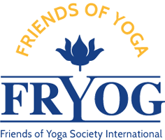
Andy Webb, Dip, FRYOG
(Friends of Yoga Society International)

