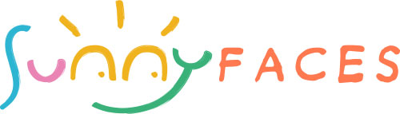

DISCLAIMER - PLEASE READ THIS NOTICE BEFORE QUEUING

You / your child's face needs to be CLEAN and DRY

Please wipe noses & mouths before being seated for painting

I will not paint people who appear to be suffering from: open wounds, cold sores, chicken pox, measles, mumps, runny noses, conjunctivitis, infectious skin conditions, eczema or appear unwell

I do NOT paint unaccompanied children. Children (and their actions) remain the responsibility of the party hosts/ organisers or their parents or guardians at all times.

I will paint something small on the hand or arm of children between 2 and 3 years of age. Please trust my judgement and experience. Sometimes parents are keener than their children. If I feel that a child is unhappy or not enjoying the experience, I WILL stop immediately. Please understand that for ethical reasons, this is very important! Face painting should be a fun experience…….

ANY concerns regarding your child’s possible reaction to face paints? Please discuss with me BEFORE queuing/being painted. I will not paint faces if the child appears to have any type of skin sensitivity.

All of the face paints I use have been designed for professional use and comply with EU cosmetic regulations. As with any cosmetics, some people may be sensitive to any/all of the ingredients. Sunny-faces will not be held liable in the event of any reaction. We can conduct a patch test 30 minutes before painting if you are concerned.

TO REMOVE - please use your normal brand of soap & warm water

Depending on skin type, some colours may linger on the skin (mainly turquoise, black and green)

I will be as careful as possible when painting, however, I accept no responsibility if face paint/ glitter gets transferred onto surfaces, inflatable’s, clothing, carpets or vehicle interiors.