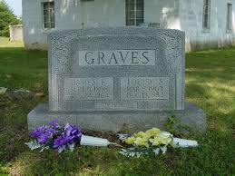

**Order form for Grave tendering service**

.

Name of Account ....................................................................................................…

Address.....................................................................................................................

.................................................................................................................................

Postcode...................................... E-mail........................................………….......

Phone no; ...................................………………………………………………………

Cemetery name & address

................................................ .......................................

................................................ Post code.......................................

Grave no: ………………………………........

Name of deceased Name of grave owner

Forename…………………………….... Forename………………………............

Surname.………………………………... Surname....……………….…………….

Date of Death..............................Home address...............................

………………….……..…………………… Post code.………………….……………….

Work you require …………………………………………....…………………….………………….

Some of the photos of the work we do go on our web sites to promote more work if you don’t want the photos of the work we have done for you please say hear________________________________.

I give AM. Grave tendering service permission to work on the grave on my behalf.

**\***

Print Name…………............................ Position…………............................

AM. Grave tendering service 8 Windmore Close, Wembley Middlesex HA0 2SR.

07760627998