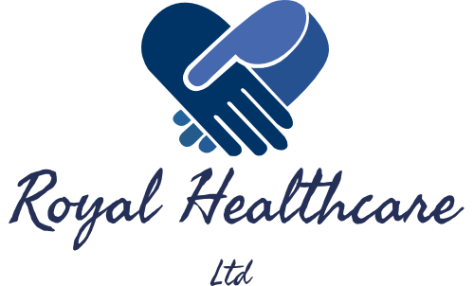

Royal Healthcare Ltd
13 Jenkin Street
Bridgend
Mid Glamorgan
CF31 3AN

Dear Sir / Madam

Royal Healthcare Ltd is a family run business that opened its doors in early 2017. We offer a unique service to local nursing, residential care homes and many other establishments. It is our ethos to employ caring, competent and well-trained individuals to fulfil both temporary and permanent positions within the South Wales area.
Each member of staff meet the Welsh educational and training requirements and undertake stringent vetting checks. We encourage and support any continuation of education and provide training and refresher courses to all our staff. In return, Royal Healthcare Ltd provide staff with competitive compensation, an inviting work environment, excellent pay rates and a flexible work pattern that suits you.

The benefits of coming to us: -
- We pride ourselves in offering the best quality service, which is at the centre of our ethos.
- A professional, approachable team always ready to help.
- On-going quality assurance to our client’s.
- We endeavour to provide continuity to our clients.
- All our staff undertake an enhanced registration check.
- We commit to fully understanding the needs of our clients by treating them as individuals.
- We will provide you with a tailored service with highly trained and experienced staff.
- Delivering a service in a manner which is non-discriminatory, sensitive to the cultural needs of the client and respectful of their environment and traditions.
- Competitive prices
- 24/7 out of hours’ service

Services we provide: -

- Nursing Homes
- Residential Care Homes
- Mental Health Services
- Learning Difficulty Services (Adult and Child)
- Hospitals
- Health Centres
- GP Surgeries
- Prisons

At Royal Healthcare, you will receive a designated consultant who will work on your behalf to source the most suitable staff for both temporary and permanent positions. The days of high charges and long winded procedures are over as we have used all our previous knowledge and understanding of the recruitment industry to create this unique company, to ensure we only provide the best possible service to you.

If you need help filling any temporary or permanent positions, please don’t hesitate to contact our friendly team.

Kind Regards,

Alex Williams Victoria Williams
Managing Director Managing Director

