The Real World Review: Is It Worth It for Freelancers and Digital Nomads?

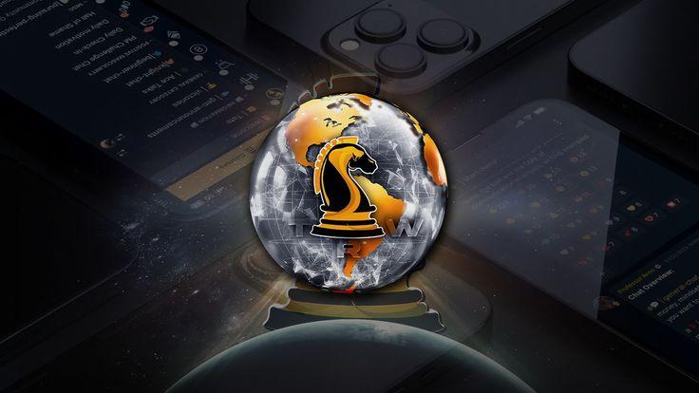

In a world where digital freedom is both a dream and a need, freelancers and digital wanderers are continuously looking for platforms that boost their income and provide mentorship and neighbourhood. One such platform, [The Real World](https://www.therealworld.org/) (TRW), established by controversial internet character Andrew Tate, has gained widespread attention-- some hail it as a modern-day money-making academy. In contrast, others identify it as hype-filled blowing. Beyond the noise, is The Real World worth it for freelancers and digital nomads?

Let's conduct an extensive evaluation to determine what The Real World offers and whether it fits the remote lifestyle of independent earners.

## What Is The Real World?

The Real World is an online platform created by Andrew Tate as a rebrand and advancement of his earlier program, [Hustlers University](https://hustlersuniversity.co). It markets itself as a business-oriented and academic area where users can learn helpful, income-generating abilities from specialists in various digital fields. The community includes courses, mentorship, and real-time obstacles created to help members generate income online.

The platform currently boasts tens of thousands of members from around the globe and charges $49.99 per month for access.

## What Does It Offer?

At its core, The Real World is structured around several "wealth creation schools" that represent different skill locations. These include:

* Freelancing & Copywriting.
* E-commerce (Dropshipping, Amazon FBA).
* Crypto Trading & DeFi.
* Stock Exchange Investing.
* AI and Automation Tools.
* Affiliate Marketing.
* Firm Building (SMMA).

Each campus is led by a "professor" or specialist in the field who supplies video lessons, assignments, live Q&A sessions, and feedback. Students are encouraged to take action quickly, with the platform pushing a "find out by doing" viewpoint.

The copywriting, freelancing, and SMMA schools are the most pertinent for digital nomads and freelancers. They provide actionable suggestions on structuring online service-based organizations and attracting clients.

## The Community Factor

One of the platform's most appealing features is its tight-knit online neighbourhood. Members engage via a personal website-- no longer hosted on Discord-- to guarantee personal privacy and control. Within this space, users share wins, seek responsibility, and help each other troubleshoot challenges.

This sense of belonging and cumulative momentum can be important for freelancers and digital nomads who often run in isolation. An understanding of seriousness and motivation can be infectious, especially for those who battle with discipline.

## Pros for Freelancers and Digital Nomads

### 1. Practical, Real-World Skill Training

Unlike standard online courses that typically remain theoretical, The Real World highlights real-time profits. Whether you're finding out how to pitch independent clients, run paid advertisements, or build sales funnels, the platform pushes members to act fast.

### 2. Worldwide Networking Opportunities

You'll link with countless other location-independent professionals at different phases of their journey. For a digital nomad, this can mean working together on projects, discovering accountability partners, or merely gaining from others' experiences.

### 3. Client Acquisition Focus

The hardest part for freelancers is frequently landing clients. The freelancing and copywriting schools offer strategies on cold outreach, developing authority on LinkedIn and Upwork, and pricing your services. These tips are field-tested and practical.

### 4. Mindset Training

A unique element of TRW is its constant concentration on the frame of mind. From day-to-day motivation to strength training, the platform encourages users to adopt a "war room" mentality—grit, discipline, and hustle. While this can be intense, it does press users to get serious about outcomes.

## Cons and Controversies

### 1. Andrew Tate's Polarising Persona

There's no denying that Andrew Tate's association with The Real World can be a dealbreaker for some. His online existence is known for strong viewpoints and questionable declarations. While Tate himself isn't directly teaching every module, his impact forms the platform's tone—busy, unapologetic, and ultra-masculine.

This could be off-putting for freelancers and nomads who prefer a more neutral or inclusive work environment.

### 2. Membership Model Pressure

At $49.99 monthly, the expense isn't outrageous-- but it does include pressure to earn results quickly. Some users may feel overloaded attempting to validate the cost if they do not see instant wins.

### 3. Variable Teaching Quality

While many "professors" are shown as entrepreneurs, the teaching quality can be irregular throughout schools. Some modules are essential, while others may feel hurried or generic. Freelancers trying to find high-level niche knowledge might discover much better depth on platforms like Skillshare, Udemy, or Coursera.

### 4. No Accreditation or Certificates

TRW isn't the platform for constructing a formal resume or collecting acknowledged certifications. It's strictly results-focused, not resume-focused.

**Freelancing in TRW: A Closer Look.**

The Freelancing Campus inside The Real World is pertinent for anybody offering writing, consulting, marketing, or design services. Here's what you can expect:

**Customer Outreach Templates:** Learn how to cold-email effectively.

**Portfolio Building:** Tips on creating a digital portfolio even if you're beginning.

**Time Management:** Routines and structures for dealing with several customers or juggling tasks on the road.

**Rates Psychology:** How to charge premium rates by placing yourself as a solution service provider, not simply a task-taker.

This TRW location is among the most applauded by users, specifically those who came in with absolutely no customers and left with their first couple of wins.

## Is It Worth It for Digital Nomads?

Suppose you can be self-motivated and take fast action. TRW is a productivity incubator, not a step-by-step hand-holding course. Suppose you're travelling or working from remote areas. In that case, the platform's versatility is a huge plus—you can view lessons, schedule and communicate with the neighbourhood anytime.

A nomadic way of life likewise comes with diversions. Without personal discipline, it's easy to fall back or cancel your subscription after a month of no development.

**Alternatives to Consider.**

If you're uncertain about The Real World, here are a few alternatives that might use different strengths:

**Freelance Business Bootcamp by Freelance Founders:** Focuses specifically on constructing a successful freelance career.

**Remote Tribe:** Offers coaching, jobs, and community listings for digital wanderers.

**Nomad List:** This is not an education platform; however, it offers essential tools and online forums for remote employees.

**The Copywriter Club:** Excellent for writers seeking to get into premium freelance work.

These platforms are generally less aggressive in tone and focus more on long-lasting career structure.

## **Last Verdict:** Is It Worth It?

The Real World isn't for everybody. For freelancers and digital nomads who:

* Yearn for immediate results.
* Want access to effective mentors and real-world strategies?
* Enjoy becoming part of a driven, results-oriented community.

... it can deserve the financial investment.

That said, you'll get out what you put in. TRW does not hand you success-- it pushes you towards it. If you're the kind of individual who thrives under pressure, is hungry to discover, and can handle Tate's brash design and influence, the platform might be a game-changer.

If you're looking for structured, recognised, or slow-paced learning? You may wish to check out other paths.

In a world where digital freedom is both a dream and a requirement, freelancers and digital nomads are constantly on the lookout for platforms that boost their earnings and offer mentorship and community. One such platform, [The Real World Login](https://www.therealworld.org/login) (TRW), established by questionable web personality Andrew Tate, has gotten extensive attention-- some hail it as a modern-day profitable academy. In contrast, others identify it as hype-filled bravado. The Real World is an online platform created by Andrew Tate as a rebrand and advancement of his earlier program, Hustlers University. One of the platform's most enticing features is its tight-knit online community. Freelancers looking for top-level niche understanding might find better depth on platforms like Skillshare, Udemy, or Coursera.