**Lightworxonline LED Amber**

**Magnetic & Fixed Mount Minibars**

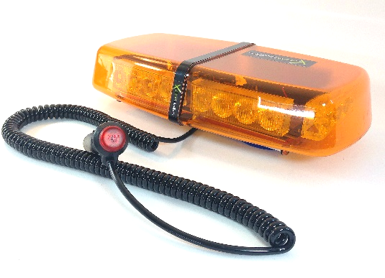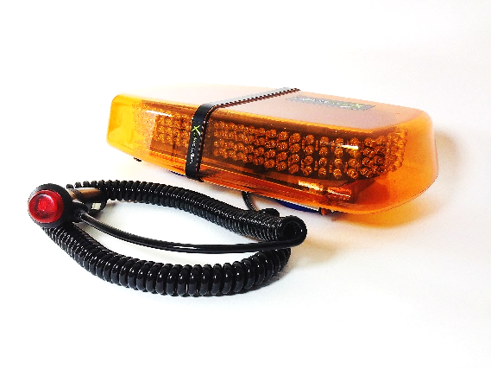

**LWMB.102.A**

**50 Watt**

**LWMB.101.A**

**24 Watt**

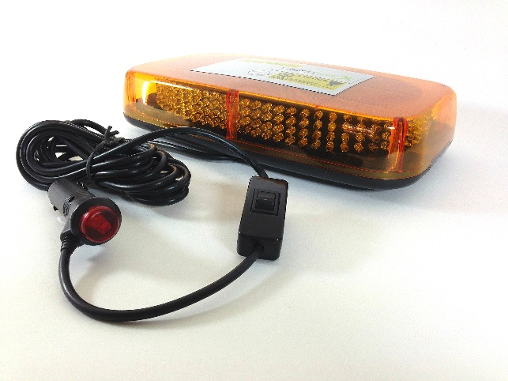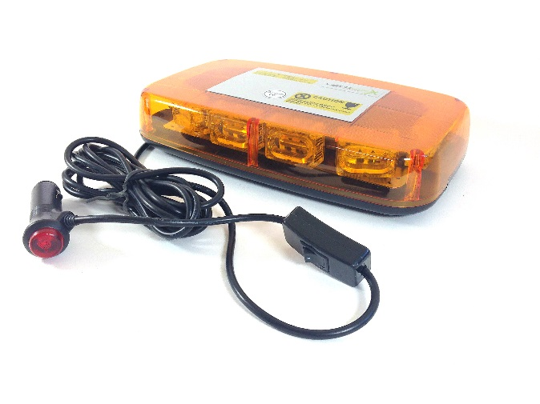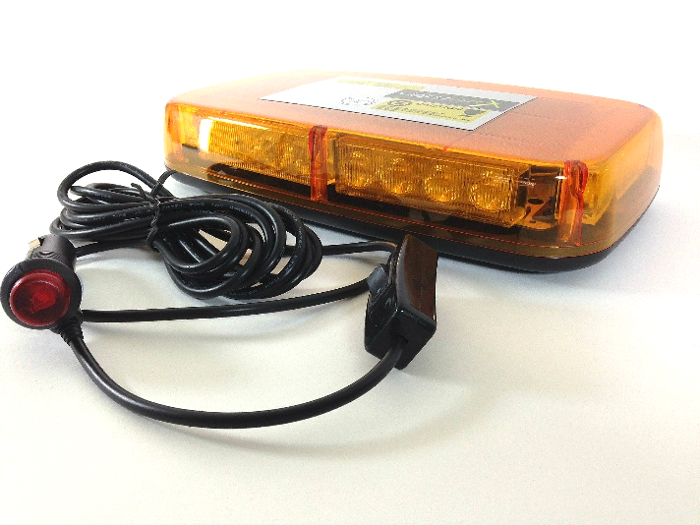

* **12 or 24 Volt (Dual Voltage Capable)**
* **Available in Magnetic or Fixed Mount**
* **Clear or Amber Lens**
* **Lens Material: Polycarbonate**
* **IP 68 rated**

Visit us at:

**WWW.LIGHTWORXONLINE.COM**

**LWMB.201.A**

**24 Watt**

**LWMB.202.A**

**30 Watt**

Contact:

**E-mail: info@lightworxonline.com / Tel: 07415 379 391**

**LWMB.203.A**

**50 Watt**