**Lightworxonline LED Worklamps**

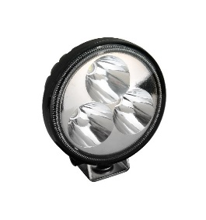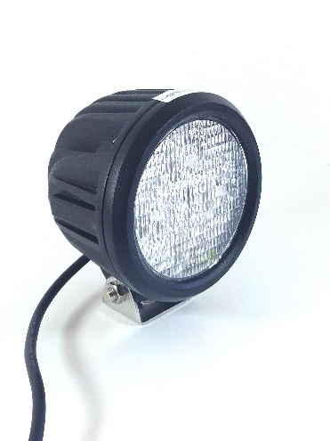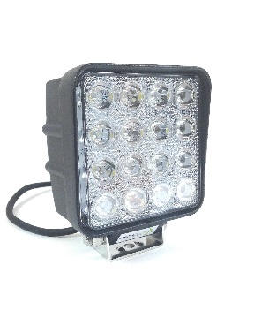 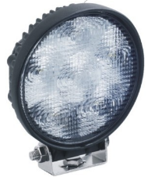

**Key Features:**

* Range 670 – 3500 Lumens
* 3W High Intensity LEDs
* 12 / 24 volt supply capability
* Spot / Flood available
* Aluminium Housing
* Stainless Steel Mounting Brackets
* Fit & Forget Technology:

Lifespan: ≥30,000 hours

* Black Powder Coat finish
* IP 67 Rated
* Low Current Draw
* EMC approved
* Warranty (1 year)

**Lumen Light Output: 3500 Lm**

**Beam: Spot**

**Dims (H*W*D) mm: 137*120*105**

**Part No: LW-WL005**

**Lumen Light Output: 1200 Lm**

**Beam: Flood**

**Dims (H*W*D) mm: 115*110*41**

**Part No: LW-WL002**

**Lumen Light Output: 2900 Lm**

**Beam: Spot**

**Dims (H*W*D) mm: 108*108*70**

**Part No: LW-WL004**

**Lumen Light Output: 1350 Lm**

**Beam: Flood**

**Dims (H*W*D) mm: 115*115*37**

**Part No: LW-WL003**

**Lumen Light Output: 670 Lm**

**Beam: Flood**

**Dims (H*W*D) mm: 83*100*50**

**Part No: LW-WL001**

 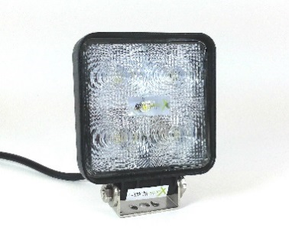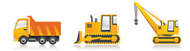

**E-mail: info@lightworxonline.com / Tel: 07415 379 391**

**WWW.LIGHTWORXONLINE.COM**

Contact:

Visit us at: