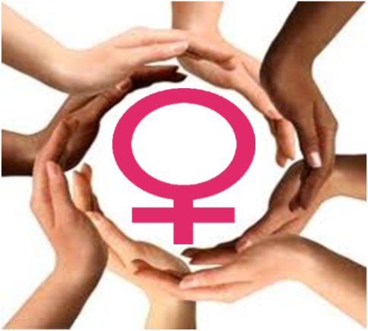

WOMEN SUPPORTING WOMEN
Mentoring Programme for Women Parenting Alone
WOULD YOU BE INTERESTED IN BECOMING
A VOLUNTEER?

Mentoring is a supportive relationship between two women,
one of whom has more life experience than the other.
We offer full training over 4 weeks; 1 day per week, full support and supervision after training.
Course starting on the 28th April
To the 19th of May 2017
From 10 a.m. to 2 p.m. each Friday
if you would like some more information please contact
Women Supporting Women Mentoring Project
Ionad Na nDaoine,
The Gate Lodge, St Mary’s Campus,
Gurranabraher, Cork.
Phone/Fax: 021 4391108
Email: womensupportingwomen@eircom.net
Project of Cork Anti Poverty Network CLG

