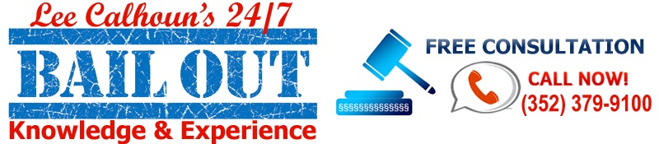

**Business Name**

Lee Calhoun Bail bonds

**Business Address**

3131 NW 13th street suite 9

Gainesville, FL

32609

**Business Phone**

352-379-9100

**Business website**

<https://www.leecalhounbailbonds.com>

**Business Email**

[Leecalhounsbailbonds@gmail.com](mailto:Leecalhounsbailbonds@gmail.com)

**Business Description**

Owned by an experienced as well as local bail agent Lee Calhoun, Lee Calhoun Bail Bonds has benefited countless customers over 15 years in Gainesville, Ocala, and Marion County FL. Considered as one of the most trusted bail agents in Florida, Lee Calhoun has in-depth knowledge of the bail processes in Alachua County Jail, and the Marion County Jail FL. It is his valuable advice and profound experience in posting bail that makes Lee Calhoun a well-known Gainesville Bail Bonds Agency in FL. Lee Calhoun offers an array of bail bond services to their clients needs, including misdemeanors, felonies, traffic, surety, immigration, federal, fiduciary, appeal, indemnity & signature. Lee Calhoun Bail Bonds knows bail bonds, and knows how to get a timely release.

Apart from providing 24 hours’ service, Lee Calhoun offers a provision of car title loan alternative to help its clients with the money they need while posting the bail for their loved ones. This service comes as a savior for small and large bail bonds and Calhoun cash is among the firsts in the Florida to offer it.

**Hours:**

Open today · Open 24

Keyword:  
Bail Bonds

Bail Bonds Gainesville

Bail Bonds Gainesville Florida

Bail Bonds Alachua County

Bail Bonds Gainesville fl

<https://www.google.com/maps/d/viewer?mid=180zwRRPyFhlqB9HVcGxiNV9zNxzPvds&ll=29.705086908017773%2C-82.69950050000001&z=9>