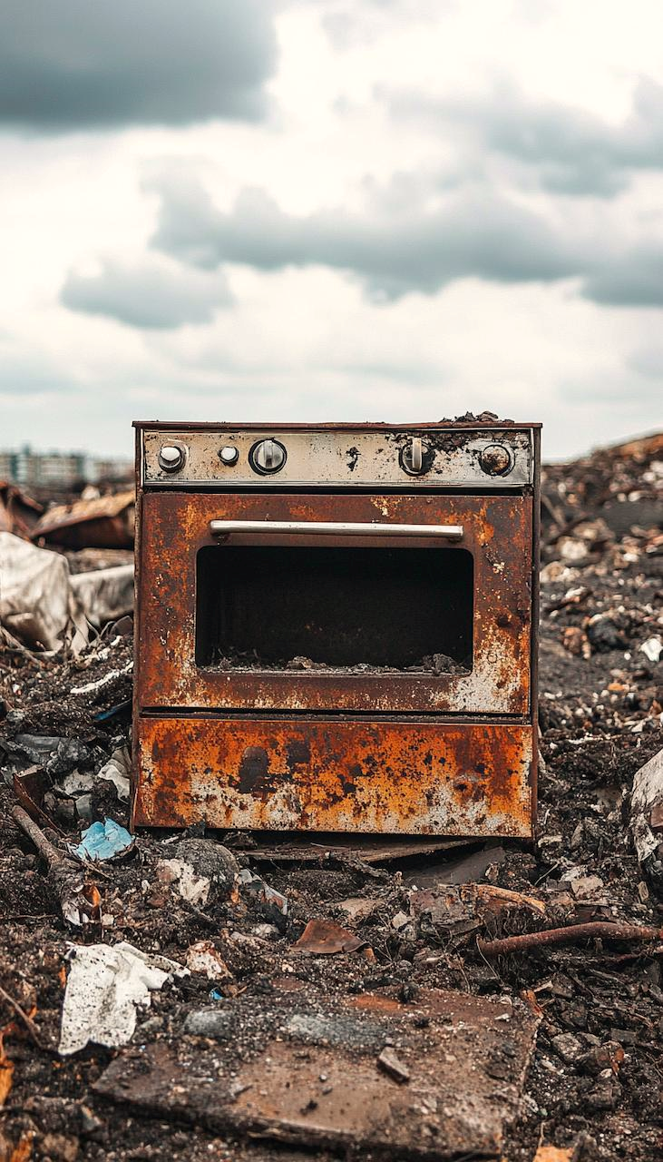  WHY HENLEY BEACH RESIDENTS USE ADELAIDE OVEN REPAIRS  How to Avoid Landfill | To repair or replace?  Introduction: In the coastal suburb of Henley Beach, where seaside living meets culinary excellence, Adelaide Oven Repairs stands as your trusted partner for oven maintenance. We recognise the importance of your kitchen being fully operational, especially in a community known for its love of food and entertainment.  Paul Rohal  Adelaide Oven Repairs: Your Oven Repair Experts in Henley Beach

Henley Beach

Why Choose Us for Your Oven Repairs in Henley Beach?
- Precision Service: We understand the value of your time. Our 2-hour booking window ensures you're not left waiting, allowing you to plan your day effectively.
- Technical Mastery: Our technicians are not just skilled; they're specialists in oven repairs, trained to handle everything from the latest smart ovens to traditional models.
- Community-Oriented: As a local service, we're deeply connected to Henley Beach's lifestyle, providing services that are not just about repair but about enhancing your living experience.

Our Commitment to Environmental Sustainability:
Henley Beach, with its beautiful beachfront and commitment to environmental care, aligns perfectly with our ethos. We prioritise repairs over replacements to reduce electronic waste, supporting local sustainability initiatives like beach clean-ups and community recycling programs. By choosing repair, you're contributing to a greener Henley Beach.

Services We Offer:
- Clear Pricing: You'll know the cost upfront with our fixed pricing, which means no surprises when it comes to your bill.
- Parts and Repairs: We focus on part replacement only when absolutely necessary, promoting sustainability and cost-efficiency.
- Preventive Maintenance: We'll leave you with tips to maintain your oven, helping to prevent future issues and extend its lifespan.

Our Process:
- Online Booking: Enjoy our 10% discount when booking through our website. Book Now (#)
- Swift Service: Calls before noon can often result in same-day service, minimising disruption.
- Quality Assurance: Every repair comes with a satisfaction guarantee, ensuring your oven works perfectly post-service.

Testimonials from Henley Beach Residents:
- "Adelaide Oven Repairs fixed my oven with such precision and care, and their commitment to sustainability really resonated with our beachside community." - Sam, Henley Beach
- "Their service was not only professional but also aligned with our efforts to live more sustainably. Highly recommend!" - Grace, Henley Beach

The Truth About the Industry:
Many repair services in the eastern states offer to replacement your oven rather than fix it. Why? because it’s more profitable! This often includes upselling cabinetry work, plumbing, and electrical services. At Adelaide Oven Repairs, we think it’s false advertising, if we offer to repair but instead want to replace your oven. We focus on genuine repairs, saving you money and reducing waste.

Find Us Online
- Knowledge Panel
- Service Area
- Customer Reviews
- Google Maps
- Facebook
- Linkedin
Conclusion: For Henley Beach locals, Adelaide Oven Repairs is more than just a repair service; it's a commitment to maintaining the spirit of the coast—environmental consciousness, community engagement, and culinary passion. We ensure your oven is functioning flawlessly, supporting the lifestyle and values of our vibrant suburb.
KeyWords
professional oven technician
best oven repair services in adelaide
experienced oven technician near me
professional oven repair solutions
same-day oven repair adelaide
skilled oven repair technician adelaide
top-rated oven repair expert
professional oven repair in adelaide
licensed oven repair specialist near me
affordable oven technician adelaide
quick oven repair service in adelaide
emergency oven repair in adelaide
trusted oven technician near me
affordable oven repair adelaide
fast oven repair adelaide
expert oven technician near me
expert oven repair services near me
oven repair adelaide
oven repair
local oven repairman for hire
certified oven repairman near me
oven repair man near me
Source
Listings
Actions
Apple Maps
We could not find your business listing.
Add
AussieWeb
We could not find your business listing.
Add
AustralianPlanet
We could not find your business listing.
Add
Bing Local
Adelaide Appliance Repairs
617 Goodwoood Road, Panorama South Australia 5041
+61411377955
Edit
Bizrate Surveys
We could not find your business listing.
Add
Brown Book
We could not find your business listing.
Add
Cybo
We could not find your business listing.
Add
Cylex
We could not find your business listing.
Add
dLook
We could not find your business listing.
Add
Facebook
Adelaide Oven Repairs
617 Goodwood Road, Panorama, Australia, 5041
+61411377955
Already Connected
Foursquare
We could not find your business listing.
Add
Fyple
We could not find your business listing.
Add
Glassdoor
We could not find your business listing.
Add
Google
ADELAIDE OVEN REPAIRS
L002 / 617 Goodwood Rd
0411 377 955
Already Connected
Google Seller
We could not find your business listing.
Add
HotFrog
Adelaide Corporate Pty ltd
617 Goodwood Road, Panorama, Panorama, 5041
08 83777115
Edit
Infobel
We could not find your business listing.
Add
Just Landed
We could not find your business listing.
Add
Local Business Guide
We could not find your business listing.
Add
Local.com.au
We could not find your business listing.
Add
LocalSearch
We could not find your business listing.
Add
Local Store
We could not find your business listing.
Add
Nationaldirectory
We could not find your business listing.
Add
OpenTable
We could not find your business listing.
Add
Pink Pages
We were unable to read your profile details from this URL.View
Edit
StartLocal
We could not find your business listing.
Add
StoreBoard
We could not find your business listing.
Add
Street-directory
We could not find your business listing.
Add
Superpages Australia
Finding your business listing…
Add
TripAdvisor
We could not find your business listing.
Add
True Local
Adelaide Oven Repairs
617 Goodwood Rd, Panorama, SA, 5041
0883777115
Edit
Trustpilot
We could not find your business listing.
Add
Tupalo
We could not find your business listing.
Add
Tuugo
We could not find your business listing.
Add
2 Find Local
We could not find your business listing.
Add
Whereis
We could not find your business listing.
Add
White Pages
We could not find your business listing.
Add
Yellow Pages
We could not find your business listing.
Add
Yelp
We could not find your business listing.
Add

