VENUE HIRE AT YORKSHIRE HEART VINEYARD
Providing you with an idyllic and unique rural location to host your own special celebration, whether it’s a birthday, anniversary, christening or wedding here at Yorkshire Heart we are committed to making your event special.
Yorkshire Heart is a small family run business located just outside the picturesque village of Nun Monkton based between Harrogate & York on the A59, what could be better than holding your event on our green settings surrounded by our beautiful vines, excellent opportunity for some fantastic photographs of your special day.
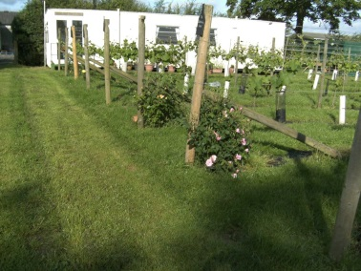
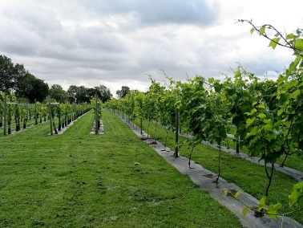
We have different packages available, whether you would like to just hire the venue or take the opportunity of being able to include our fantastic home grown English wines and cask ales brewed just a hop and a skip from the vineyard to your package also.

