About Us

Born out of personal experience with our own parents, we set up Bath Home Companions to help with the everyday tasks which may be proving to be difficult or arduous when on your own. We aim to dispel the loneliness, isolation, loss of self-esteem and motivation that growing older, losing the ability to drive, a period of illness or becoming housebound can bring. In addition, Bath Home Companions can provide support to parents with youngsters or young adults who find they need a helping hand or guidance with daily occurrences or one-off situations that they may find daunting. This support can enable many people to get through a particularly difficult period in their lives or to establish a means to learn and enjoy fending for themselves.

We have worked together for the past 15 years, having previously set up and run a successful, private, CQC registered medical clinic in Bath. Providing a high-class, client-led, caring and compassionate service is at the forefront of everything we do and forms the foundations on which Bath Home Companions is based. Our years of business experience, coupled with that gained working for private clients, enables us to give a bespoke offering. We are not a big, faceless agency with multiple carers, and you will not see a host of different people.

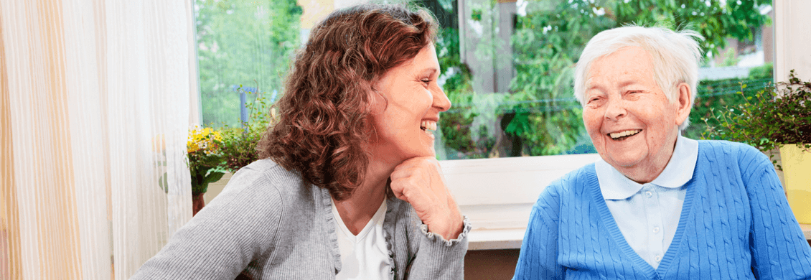

Many people do not like the idea of having someone in their home, are reluctant to accept help or do not feel they are in need. We pride ourselves on taking a gentle, empathetic approach, gradually establishing and building a true companion relationship, so that you view us as a kind friend more than anything else. Our companions are genuinely interested in the lives, experience and stories of our clients, and often feel they gain as much as they give. Listening to your needs will be our prime concern: we will not tell you what you need, but instead be responsive to you, however often your requirements change.
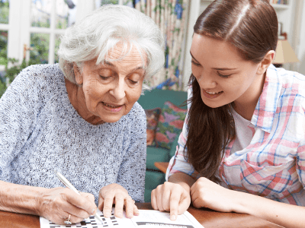
Social companionship has been proven to enhance health, quality of life and happiness. We enable individuals to continue to live independently; we lift the burden of daily tasks and provide assistance and support to meet your requirements.

We recognise that often family members live far away or have work or childcare commitments meaning they themselves cannot provide continuous support for their loved ones. Bath Home Companions offers peace of mind that compassionate and safe support and help will be available whenever needed.

In YOUR home, In OUR care

Staying in your own home, in a familiar environment is the preferred option for most people, and we aim to make this possible by providing you with an individual service that places your dignity and respect at its centre.

With dementia becoming increasingly diagnosed, we are proud to be able to offer specialised support, and our companions are all Dementia Aware trained.

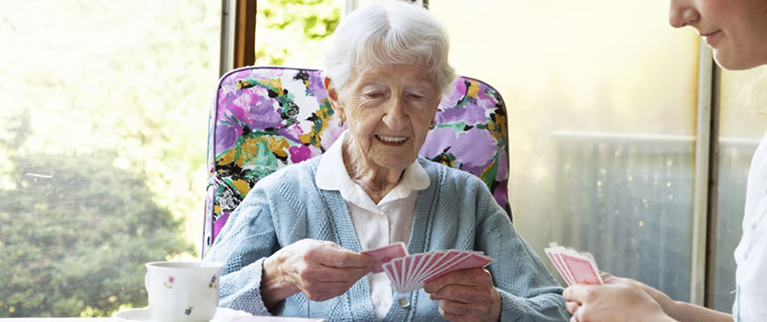

We keep a daily diary of all our visits, and will discuss with you whether you wish information to be shared with family members. Often, family members living some way away like to have a weekly update via email, and we are always available to speak on the telephone if you have particular concerns or enquiries. We ask for telephone numbers of a minimum of two additional people should we need to contact someone if we have concerns or in the case of an emergency.

Service TO you, Led BY you

Our service is bespoke, and we will provide you with as much or as little help as you would like or you require. We have a minimum 1 hour visit, so that our time with you will not feel rushed, and we are available from early morning through to early evening. We accept that needs will change, and we pride ourselves on being able to be flexible and attentive to you.

Most of our clients come to us through recommendation by word of mouth, and we are happy to provide references. Many families approach us directly for help for a loved one. We have also established good relationships with local GP practices, community teams and charities, and with your consent, we will liaise with these when necessary. As a small organisation, we ensure that all our staff have appropriate and regularly updated training and that they all hold clear DBS certification.
"Having Sue and Madeline come to help, means that I can stay in my own home. Millie loves them taking her for a walk, and waits at the door for them to arrive!" Jocelyn, Bath.

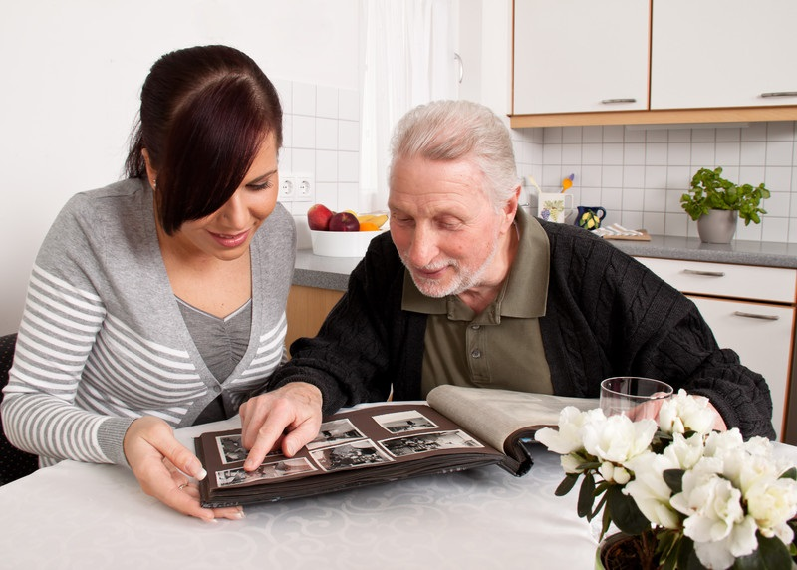

"My family would be lost without the compassionate and kind support Bath Home Companions provide for dad. The visits give him a real lift and their help with all sorts of matters mean that he doesn't worry so much". Katherine, Swindon.

