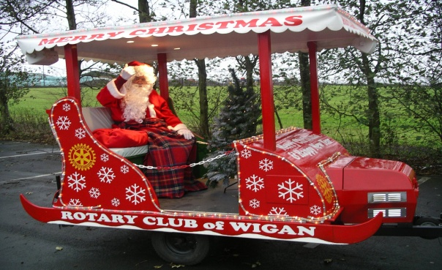



|  |  |  |  |  |  |  |
| --- | --- | --- | --- | --- | --- | --- |
| **Rotary Club of Wigan** | | | **Float Schedule 2014** |  | |  |
|  |  |  | **CONFIRMED** |  |  |  |
|  |  |  |  |  |  |  |
| **Day** | **Date** |  | **Location / Route** | **Start** | **Finish** |  |
|  |  |  |  |  |  |  |
|  |  |  |  |  |  |  |
|  |  |  |  |  |  |  |
| Sat | 29-Nov |  | Visit to Standish Equestrian Centre |  |  |  |
| Sun | 30-Nov |  | Standish West | 17:00 | 20:00 |  |
| Mon | 01-Dec | Council | Winstanley Tan House | 18:00 | 20:00 |  |
| Tues | 02-Dec |  | Gidlow East | 18:00 | 20:00 |  |
| Weds | 03-Dec |  | Gidlow West | 18:00 | 20:00 |  |
| Thurs | 04-Dec |  | Winstanley Pepperwood | 17:30 | 20:00 |  |
| Sun | 07-Dec |  | Tesco | 10:00 | 16:00 |  |
| Sun | 07-Dec |  | Shevington North | 17:00 | 20:00 |  |
| Mon | 08-Dec |  | Tesco | 10:00 | 20:00 |  |
| Tues | 09-Dec | 41 Club | Swinley | 18:00 | 20:00 |  |
| Weds | 10-Dec |  | Highfield Grange | 18:00 | 20:00 |  |
| Thurs | 11-Dec |  | Orrell South | 18:00 | 20:00 |  |
| Fri | 12-Dec |  | Almond Brook | 18:00 | 20:00 |  |
| Sat | 13-Dec |  | Standish East | 17:00 | 20:00 |  |
| Sun | 14-Dec |  | Tesco | 10:00 | 16:00 |  |
| Sun | 14-Dec |  | Standish South | 17:00 | 20:00 |  |
| Mon | 15-Dec |  | Sainsbury's | 10:00 | 16:00 |  |
| Mon | 15-Dec |  | Hawkley Hall | 18:00 | 20:00 |  |
| Tues | 16-Dec |  | Sainsbury's | 10:00 | 16:00 |  |
| Tues | 16-Dec |  | Standish North | 18:00 | 20:00 |  |
| Weds | 17-Dec |  | Orrell North | 18:00 | 20:00 |  |
| Fri | 19-Dec |  | Shevington South | 18:00 | 20:00 |  |
| Sat | 20-Dec |  | Appley Bridge | 17:00 | 20:00 |  |
| Sun | 21-Dec |  | Tesco | 10:00 | 16:00 |  |
| Sun | 21-Dec |  | Whitley | 17:00 | 20:00 |  |
| Mon | 22-Dec |  | Tesco | 10:00 | 20:00 |  |
| Tues | 23-Dec |  | Asda | 10:00 | 16:00 |  |