**Lightworxonline LED Lightheads ECE R65**

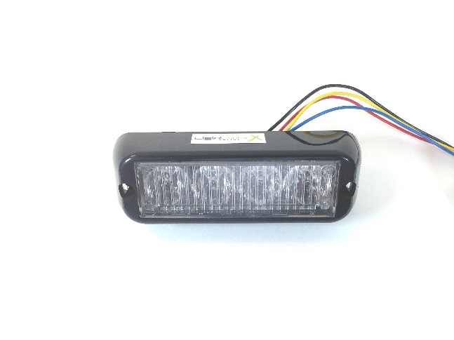

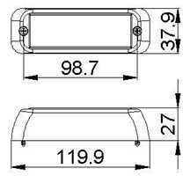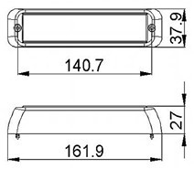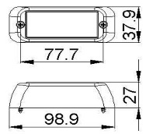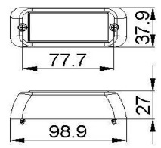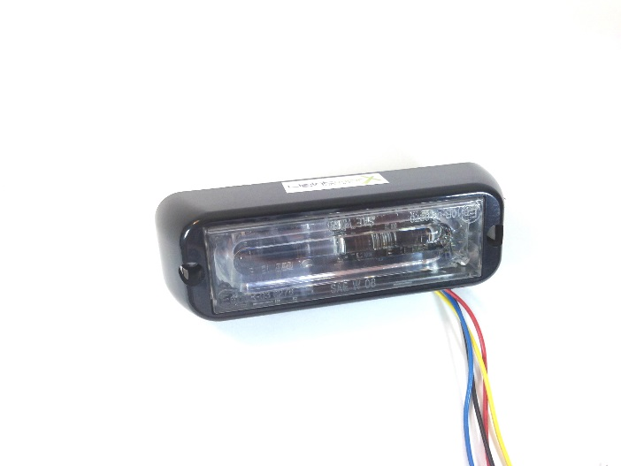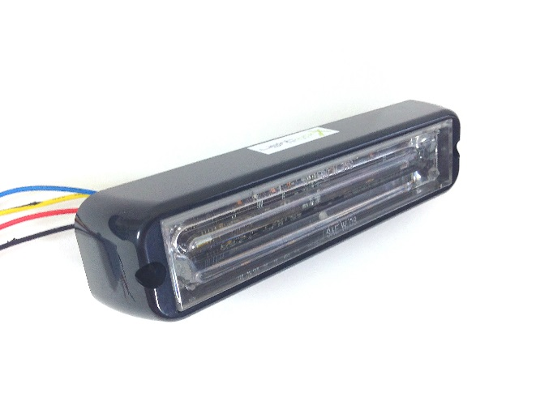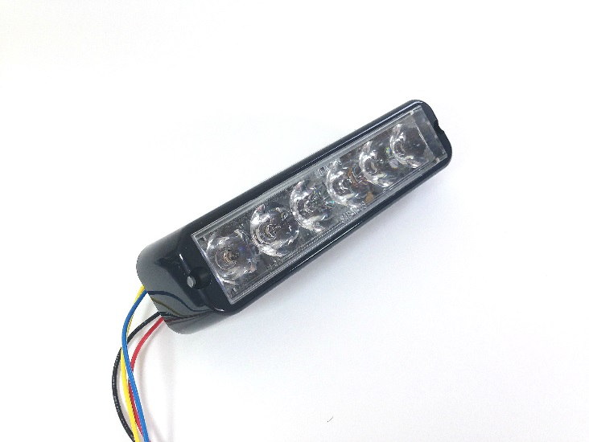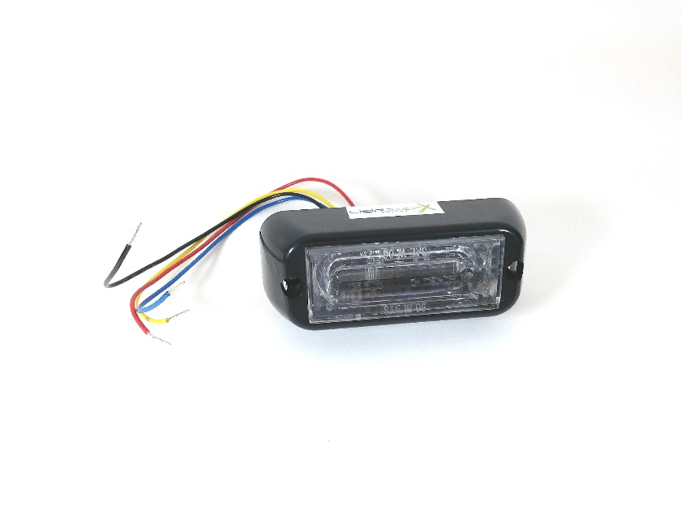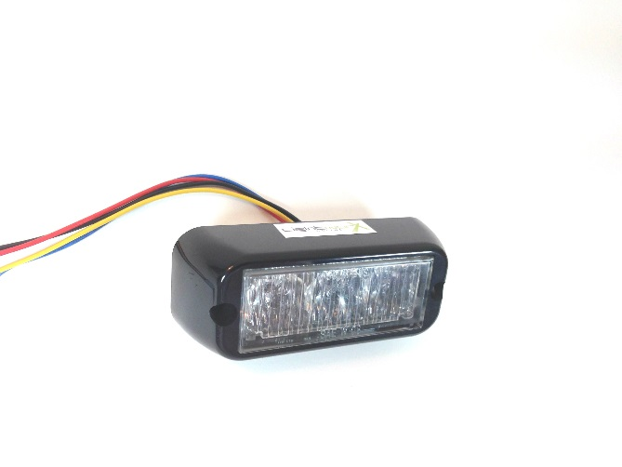 

**LW203.00.DV**

**3 x LEDs**

**LW303.00.DV**

**3 x LEDs**

**3 x LEds**

* **ECE R65 Compliant**
* **12 or 24 volt supply (Dual Voltage)**
* **25 x selectable flash patterns**
* **Tough Polycarbonate lens**
* **Aluminium base for superior heat dissipation**
* **Low Current Draw**
* **Multi - unit synchronisation**
* **IP67 Rated**
* **Compact design**

**WWW.LIGHTWORXONLINE.COM**

Contact:

**E-mail: info@lightworxonline.com / Tel: 07415 379 391**

**LW204.00.DV**

**4 x LEDS**

**LW304.00.DV**

**4 x LEDS**

**LW306.00.DV**

**6 x LEDS**

**LW206.00.DV**

**6 x LEDS**

Visit us at: