

MAMA MARIAM IS A TRADITIONAL HEALER, HERBALIST, PSYCHOLOGIST, SANGOMA, ANCESTRAL MEDIUM AND A MONEY SPELL CASTER. +27714630933

I DO;
Instant Money spells that work same day what’s app +27714630933
*Magic ring spells (POWER AND FAME RING)
*Magic wallet spells
*Amagundwane spiritual rats for money
*Short boys for attraction
*The money lucky Pot
*Magic pot for daily money
*Win LOTTO
*Get big TENDERS in the government
*Boosting your business
*Manifest Wealth, Attract Prosperity,
*wealth spells
*Ancient wealth spells
* Protection
* Bad dreams
* Love spells
* Bring your Ex back
* Land problems.
*Finish court cases
*Win divorce court case
*Revenge spells
*Bad luck spells (traditional cleansing)
Am a powerful traditional healer, Herbalist and spell caster for over the last 18 years helping people with any sort of problem.
I help married couples that are seeking for fertility spells and herbs for child bare. Penis enlargement, Bedroom appetizer for your sexy mood, as well as traditional cleansing for those that move with generational curses, having sex with people in your dreams and so many call or what’s app mama for any assistance.
I would like to say my services are not involving any human sacrifice or blood shading

AFRICAN TRADITIONAL HEALING IS NOT A SCIENCE. ITS BASED ON A BELIEF IN ANCESTORS AND SPIRIT GUIDES. RESULTS WILL VARY FROM INDIVIDUAL TO INDIVIDUAL. PLEASE USE THE SERVICES AT YOUR SOLE

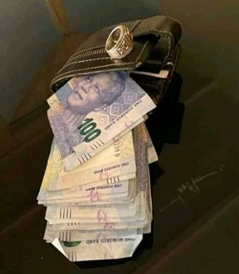MAGIC WALLET / MAGIC RING ATTRACTS MONEY IN YOUR WALLET OVER A NIGHT

