The Tearoom - Winter flavours
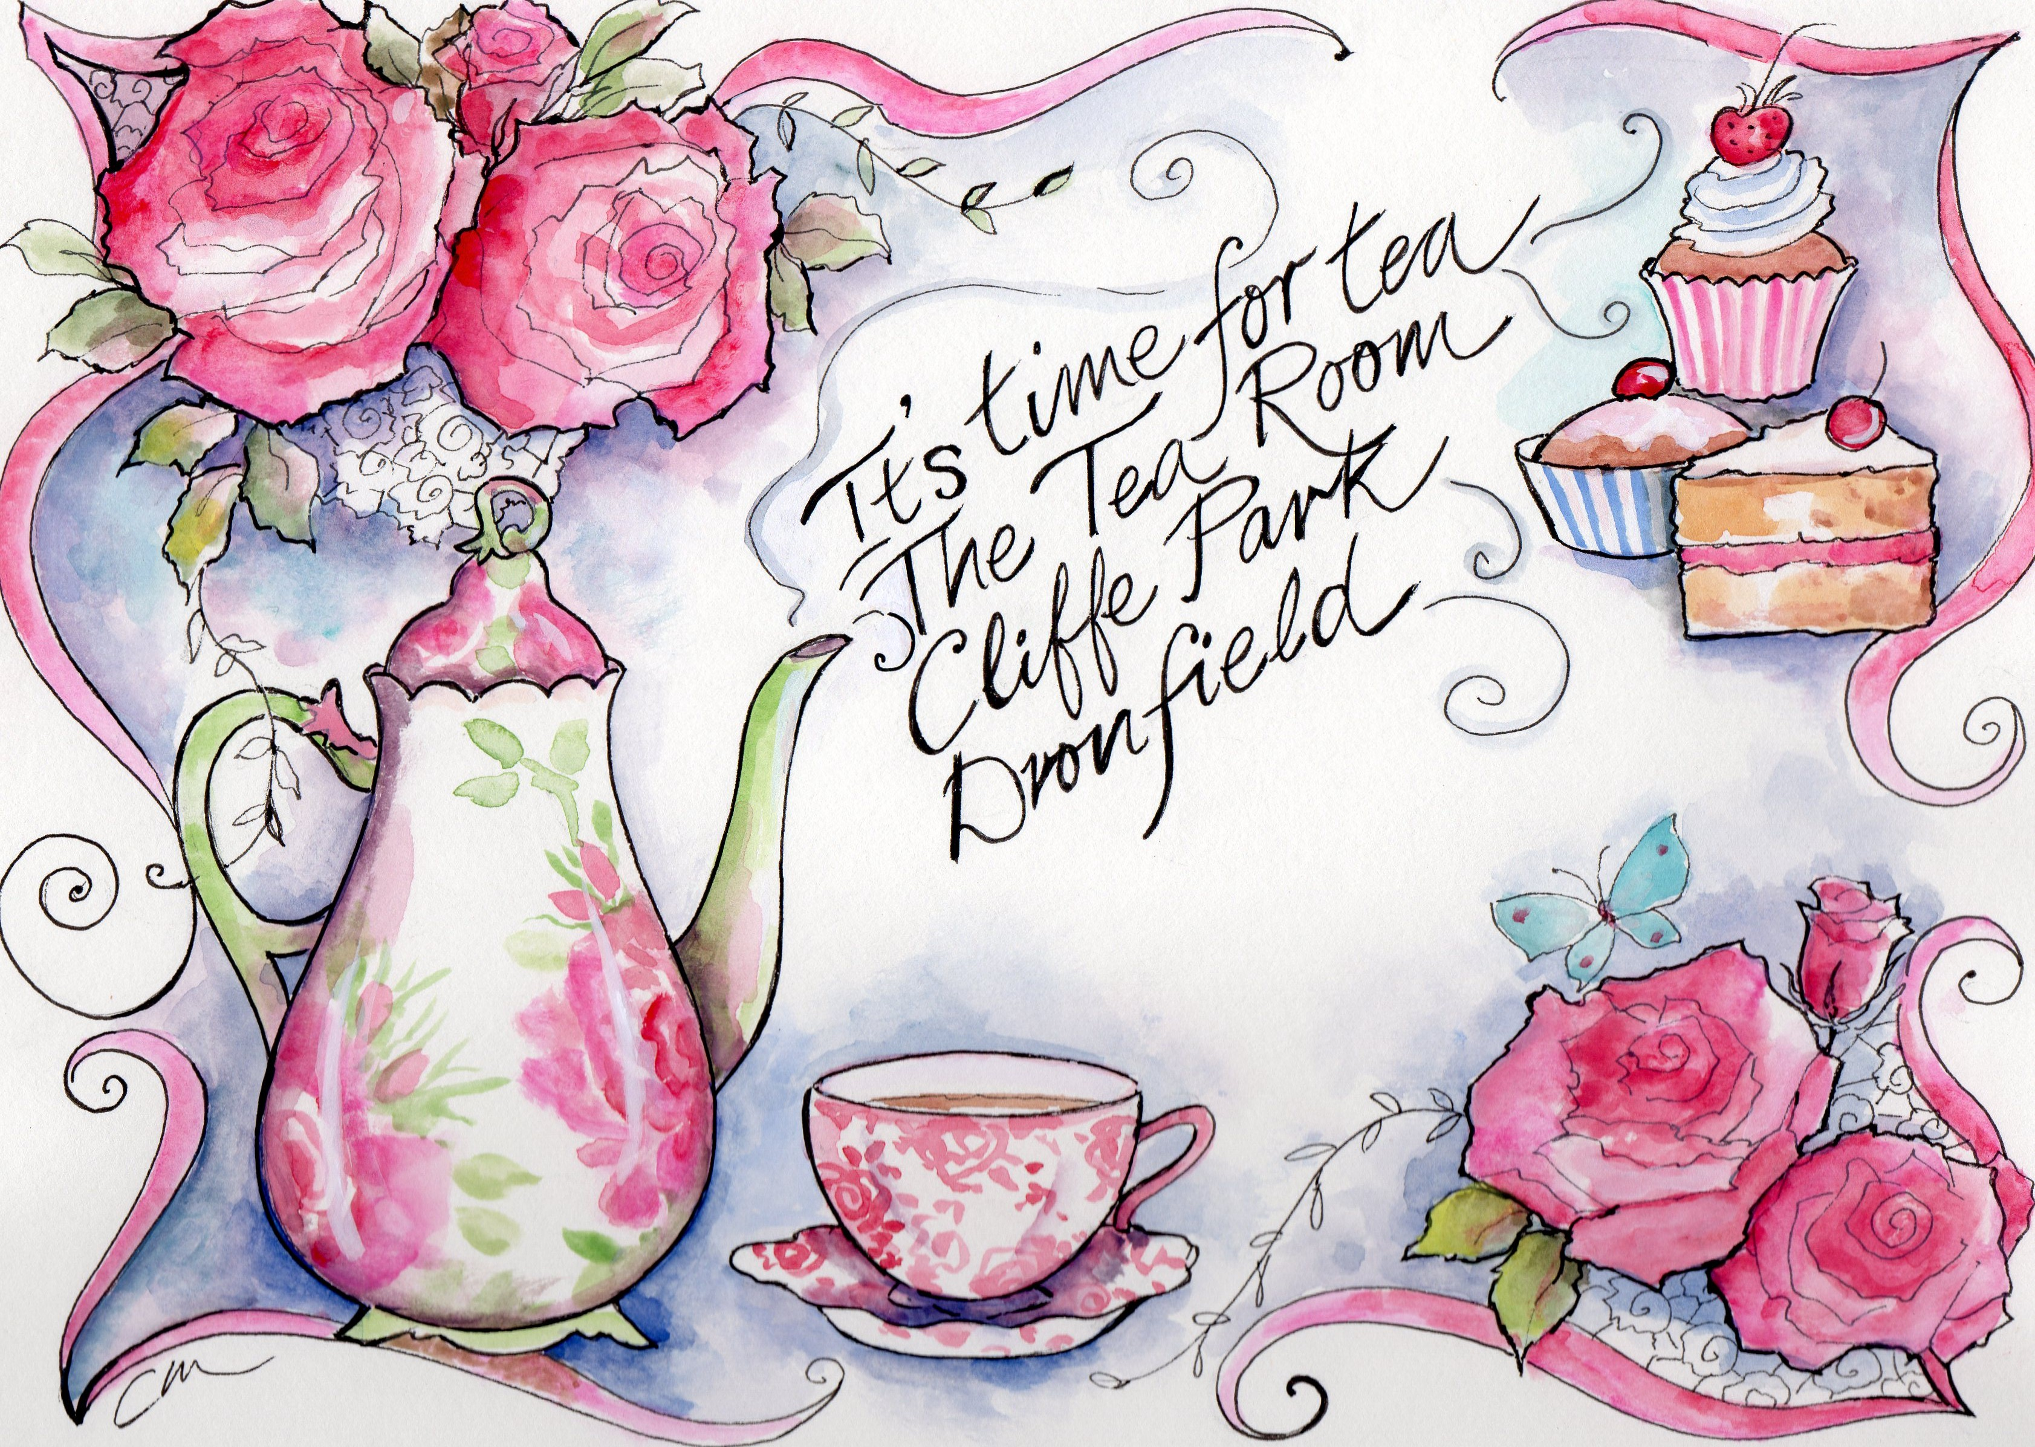
Breakfast menu

Served until 11.30
Croissant with butter £1.95
with butter and preserve £2.25

Crumpets (2) with butter £2.25
with butter and preserves £2.50

Ham and Cheese muffin (1) £2.50

Toast and butter (2) slices £1.75 with preserves £2.00

Fruit bread and butter (2) slices £2.50

Brioches with butter and preserves £2.50

Best bacon bap with sauce of your choice £3.50

Winter menu
Soup of the day with bread £3.95 Delicious winter warming soup
Soup and a sandwich offer £5.95
Enjoy a bowl of our soup with a choice of cheese and chutney, Ham and mustard or Tuna sandwiches or cheese melt ciabatta

Quiche or savoury tart served with fries and salad garnish £5.95

Baked potatoes with salad garnish
- with butter £3.50
- with cheese £3.95
- with beans £3.95
- with cheese and beans £4.45
- with tuna £4.45
- with tuna and cheese £4.95

Beef burger £3.95
Beefburger fries and salad garnish £5.45
Cheeseburger £4.50
Cheeseburger fries and salad garnish £5.95

Adults Chips £1.95 Adults Chip Butty £2.95

Sandwiches with salad garnish and crisps £4.70
Choose from
- vintage cheddar and chutney
- Roast ham and mustard
- Falafel and yoghurt
- Tuna
- Chicken with stuffing and cranberry
- Brie and bacon

Hot dishes (When available) £6.95
Vintage Teas

Crumpet Tea
Two crumpets, butter ,cheese, salad garnish, chutney and a pot of our house tea all served on a beautiful china plate
£5.95 per person

Cheese Tea platter
Enjoy one of our cheese scones, butter, a tasty selection of cheeses, salad garnish, grapes, apple, chutney and a pot of house tea £6.95 per person

High Tea
A selection of freshly prepared finger sandwiches, one of our daily baked scones, clotted cream, preserves and a pot of speciality tea served on a vintage china cake stand
£7.95 per person

Afternoon Tea
A selection of freshly prepared finger sandwiches, cakes, daily baked scone, clotted cream, preserves and a copious amount of speciality tea all served on beautiful china
£12.00 per person

KIDS
Kids Beans on toast £1.95
Kids Baked potato and butter £2.00
Kids Baked potato and cheese £2.50
Kids Baked potato and beans £2.50 Beans and cheese £2.75
Kids Chicken nuggets and chips £3.00
Kids sandwich ham or cheese with crisps £2.80
KIDDIES CHOCOCHINO hot choc & Sprinkles £1.25
KIDDIES BABYCHINO milk & Sprinkles £1.10

Cakes and all things sweet
- Flapjacks, Tiffins, chocolate brownies £1.80
- Cake per slice £2.40
- Frangipanes served warmed with cream £2.50
- Scone with butter £1.95
- Scone, butter and preserves £2.20
- Scone, butter, preserves and clotted cream £2.40
- Cream Tea Scone, butter, preserves, cream with a pot of our house tea £4.50

DRINKS
House Tea £1.95
Earl grey, Assam, Peppermint, Rose, Green, Jasmine, Darjeeling, Camomile, Orange, Blackberry, Rhubarb, Christmas blends(all when available) £2.10
Coffees:
Black Americano £2.00 White Americano £2.20
Cappuccino £2.20 Latte £2.20

Mocha £2.40
Hot Chocolate £2.40 With chocolate,cream& Marshmallows £2.90
Gingerbread Latte £2.90 topped with cream
Nutella hazelnut mocha £2.90
Irish cream Cappuccino £2.90
Hot chocolate Orange or Cherry £2.90
KIDDIES CHOCOCHINO hot choc & Sprinkles £1.25
KIDDIES BABYCHINO milk & Sprinkles £1.10
Loved your visit leave a review on Tripadvisor – The Tearoom within Cliffe Park DRONFIELD
LIKE US ON FACEBOOK Vintage Rose Catering
Twitter @Vrcatering

