**Shopping in Style: Explore the World of Crypto Luxury Store**

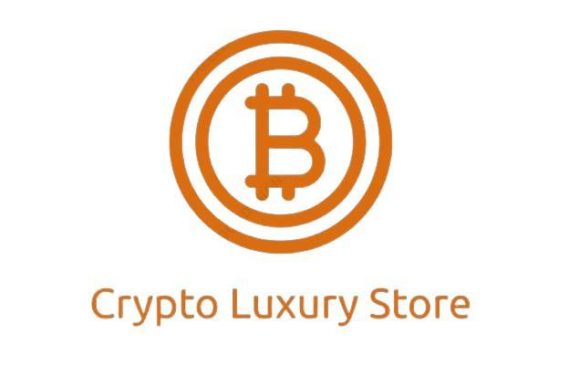

In the fast-paced world of cryptocurrencies, where digital assets are constantly changing hands, it’s no surprise that crypto enthusiasts are looking for new and innovative ways to spend their hard-earned tokens. Enter the [Crypto Luxury Store](https://crypto-luxury.shop/), a haven for those who want to indulge in high-end fashion, accessories, and luxury goods while exclusively using cryptocurrency for their purchases. In this article, we will delve into the exciting world of the Crypto Luxury Store and discover how it is redefining the shopping experience for crypto enthusiasts.

**The Rise of Crypto Luxury Store**

The Crypto Luxury Store is a trailblazing online boutique that caters to the growing community of cryptocurrency aficionados who wish to spend their digital wealth on luxury items. Founded on the belief that cryptocurrencies should not just be a speculative investment but also a medium of exchange for real-world goods, this unique store has gained a reputation for offering a wide range of high-end products, from designer clothing and accessories to luxury watches and jewelry.

**What Sets Crypto Luxury Store Apart?**

**Exclusive Crypto Payments:** At Crypto Luxury Store, cryptocurrency is not just an accepted form of payment; it’s the only form of payment. This exclusivity is a testament to the store’s commitment to the crypto community.

**Curated Selection:** The store meticulously curates its collection to ensure that every product exudes luxury and sophistication. Expect to find renowned brands like Rolex, Gucci, and Louis Vuitton, all available for purchase with your favorite cryptocurrencies.

**Global Accessibility:** The beauty of cryptocurrencies lies in their borderless nature, and Crypto Luxury Store embraces this feature. Customers from all around the world can shop here, eliminating the need for currency conversions and making international luxury shopping a breeze.

**Secure Transactions:** Cryptocurrencies offer a high level of security, and the Crypto Luxury Store leverages blockchain technology to ensure that every transaction is transparent and secure.

**Crypto Education:** For those new to the world of cryptocurrencies, the store provides valuable resources and guidance, helping customers understand the technology and the process of making crypto payments.

**Shopping at Crypto Luxury Store: How It Works**

**Browse the Collection:** Start your shopping journey by browsing the carefully curated collection on the Crypto Luxury Store website. From designer clothing and accessories to luxury watches and jewelry, you’ll find a wide array of premium products.

**Select Your Favorites:** Once you’ve found the items that catch your eye, simply add them to your cart.

**Checkout with Crypto:** At checkout, you’ll be prompted to select your preferred cryptocurrency for payment. The store accepts popular options such as Bitcoin (BTC), Ethereum (ETH), and Litecoin (LTC), among others.

**Secure Payment:** The store employs top-notch security measures to ensure the safety of your transaction. Once your payment is confirmed on the blockchain, your order will be processed and shipped to your doorstep.

Global Shipping: Whether you’re in New York, Tokyo, London, or anywhere else in the world, Crypto Luxury Store offers reliable shipping services to ensure your luxury items arrive safely and promptly.

**Conclusion**

The Crypto Luxury Store is a pioneering venture that bridges the gap between the digital and physical worlds. By offering a diverse range of luxury goods that can be exclusively purchased with cryptocurrencies, this store is not only catering to the desires of crypto enthusiasts but also helping to normalize the use of digital assets in everyday life.

So, whether you’re a seasoned crypto investor or a newcomer looking to dive into the world of luxury shopping, Crypto Luxury Store provides a unique and secure platform to satiate your desires. Embrace the future of shopping and indulge in opulence, all with the convenience and security of cryptocurrencies.