# Where to Buy Lab Grown Diamond Jewellery in Australia

Lots of people, especially in Australia, are really getting into lab-grown diamonds. They're looking for diamonds that are good for the environment, ethically made, and won't break the bank – which makes lab-grown a great choice instead of mined diamonds. This guide will tell you Where to [buy lab grown diamond jewellery in Australia](https://siarabyark.com/blogs/news/where-to-buy-lab-grown-diamond-jewellery-in-australia) and why [Siara by Ark](https://siarabyark.com/) is the best spot in Australia for lab-grown diamond jewellery and give you some important stuff to know before you buy.

## Why Lab Grown Diamonds Are the Future?

Before we explore where to buy lab-grown diamonds, it's important to understand what they are and how they’re transforming the [jewellery](https://siarabyark.com/collections/all) industry.

Lab-grown diamonds are created in controlled laboratory environments using advanced technologies that mimic the natural conditions in which diamonds form. They are chemically, physically, and optically identical to natural diamonds; the only difference is their origin.Here are a few reasons why [lab grown diamonds](https://siarabyark.com/collections/wedding) are becoming the preferred choice:

**Ethical sourcing:** No mining means no harm to ecosystems or communities.

**Environmentally friendly:** Lab grown diamonds have a significantly lower carbon footprint.

**More affordable:** You get more carats for your budget compared to natural diamonds.

**Conflict-free:** Lab-grown diamonds eliminate the risk of contributing to conflicts and human rights violations associated with traditional diamond mining.

**Customization:** They offer more opportunities for customization in size, shape, and color to meet personal preferences.

**Innovative technology:** The process of creating lab-grown diamonds employs cutting-edge technology, showcasing advancements in science and engineering.

**Longevity:** Lab-grown diamonds are chemically identical to natural diamonds, ensuring the same durability and long-lasting quality.

**Variety of options:** Available in a wide range of colors and styles, lab-grown diamonds allow for unique and creative choices.   
  
**No geographic limitations:** You can find and purchase [lab-grown diamonds](https://siarabyark.com/collections/wedding) from a wider variety of sources without being limited by mining locations.  
  
**Increased availability:** With growing production, lab-grown diamonds are more readily available, reducing the scarcity seen in natural diamonds.

**Positive impact:** Purchasing lab-grown diamonds supports sustainable practices and contributes to ethical consumerism.   
  
**Quality assurance:** Each diamond can be traced and certified, ensuring transparency.

The Rise of Lab Grown Diamond Jewellery in Australia

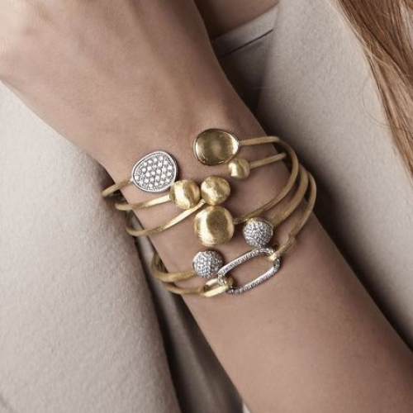

More and more Australian consumers are becoming eco-conscious and focused on sustainability. This change in attitude has sparked a growing interest in ethical alternatives, such as lab-grown diamonds. So, it it's for engagement rings, wedding bands, or stylish statement pieces, shoppers are looking for affordable luxury that aligns with their values.  
  
As the demand for these eco-friendly gems increases, many retailers and jewellers are now offering lab-grown diamond options. However, not all brands are equal in terms of quality and ethics. It’s essential to choose a brand that combines great design with responsible craftsmanship.

So, if you’re wondering where to find lab-grown diamond jewellery in Australia that meets high standards, look no further than Siara by Ark. They're committed to delivering both elegance and sustainability in every piece.  
  
**Where to buy lab grown diamond jewellery in Australia - Discover Ethical Luxury with Siara by Ark**  
[Siara by Ark](https://siarabyark.com/) is an Australian-owned jewellery brand dedicated to redefining fine jewellery through sustainability, innovation, and intentional design. Our mission is to provide best pieces that not only look beautiful but also make you feel proud of your choice.  
  
When you shop with us, you're not just purchasing jewellery — you're making a conscious lifestyle statement.  
  
**What Sets Siara by Ark Apart?**

**1. 100% Lab Grown Diamonds**

We exclusively use certified lab grown diamonds in all our collections. Every stone is conflict-free and traceable, offering you peace of mind and full transparency.

**2. Sustainable Materials**

In addition to lab diamonds, we use recycled 14k and 18k gold to minimize our environmental impact. Our packaging is also eco-friendly — because sustainability matters at every stage.

**3. Elegant and Trendy Designs**

From minimal rings to elegant earrings, our collection blends classic elegance with modern aesthetics. Each piece is designed to be versatile, making it ideal for daily wear or special occasions.

**4. Crafted with Purpose**

Our jewellery is handcrafted by skilled artisans who value quality and detail. We focus on durability and precision, ensuring every piece becomes a cherished heirloom.

**5. Personalized Service**

Shopping for jewellery — especially engagement or wedding pieces — is a meaningful experience. That’s why we offer personalized consultations to help you find the perfect piece that reflects your style and story.

**6. Payment Security**

Ensure the jeweller offers secure payment options and protects your financial information. Look for secure socket layer (SSL) encryption on their website.

**7. Customer Reviews and Reputation**

Check online reviews and testimonials to gauge the jeweller's reputation and customer satisfaction. See what other buyers are saying about their experience, quality, and service.

**8. Physical Showroom (Optional)**

If possible, visiting a physical showroom can provide a better sense of the jewellery's quality and allow for in-person consultation. However, many reputable online jewellers offer excellent virtual consultations and detailed product information.

**9. Insurance Options**

Consider whether the jeweller offers or recommends options for insuring your jewellery against loss, theft, or damage.

**10. Packaging and Presentation**

While not the most critical factor, thoughtful and secure packaging can enhance the buying experience, especially if it's a gift.  
  
**Check out what we've got in store!**

We guarantee that you would not be able to take your eyes off from our awesome selection of lab-grown diamond jewellery, featuring:

**Engagement Rings:** Symbolize your love with an [Engagement Ring](https://siarabyark.com/collections/engagement-bold) that's as conscious as your commitment. Discover ethically crafted lab-grown diamond engagement rings that reflect your values and style.  
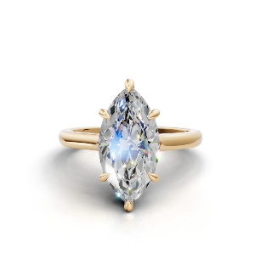  
  
**Bracelets:** Our bracelets blend elegance and simplicity, designed to add a graceful touch to any wrist. Explore timeless bracelet styles crafted with lab-grown diamonds—perfect for everyday wear or special occasions, all made with sustainability in mind.  
  
**Earrings:** Explore our versatile range of [Earrings](https://siarabyark.com/collections/earring)—from classic diamond studs to bold, eye-catching hoops. Each pair is crafted to add everyday elegance or special occasion sparkle.  
**Pendants & Necklaces:** Add a touch of brilliance with our [Pendants & Necklaces](https://siarabyark.com/collections/necklace) collection. These pieces are designed to bring subtle shine and sophistication to any outfit.  
  
**Custom Creations:** Have something unique in mind? Collaborate with our designers for Custom Creations and bring your dream piece to life with our expert craftsmanship and lab-grown diamonds.  
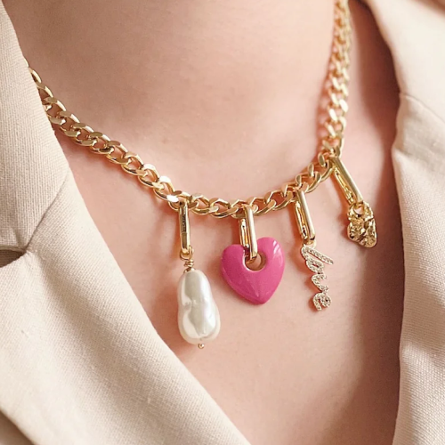

### Frequently Asked Questions

**Q: Are lab grown diamonds real diamonds?**

 Yes! Lab grown diamonds are real diamonds — not simulants like cubic zirconia or moissanite. They have the same physical, chemical, and optical properties as natural diamonds.

**Q: Can I get a lab grown diamond engagement ring in Australia?**

 Absolutely. At Siara by Ark, we offer a beautiful range of lab grown engagement rings, and you can also customize your own design with our expert team.

**Q: Are lab grown diamonds cheaper than natural diamonds?**

 Yes, lab grown diamonds can be 30–40% more affordable than their mined counterparts — without compromising on quality or beauty.

**Q: How do I care for lab grown diamond jewellery?**

 Treat it just like any fine jewellery — clean regularly with mild soap and water, store in a soft pouch or box, and avoid harsh chemicals.

**Q: Can lab grown diamonds be insured?**

Absolutely. Lab-grown diamonds can be insured just like natural diamonds based on their appraised value.

**Q: Will lab grown diamonds last as long as natural diamonds?**

Yes, because they are chemically and physically identical, lab-grown diamonds have the same durability and will last forever.

**Q: Are lab grown diamonds a good investment?**

While the resale market for lab-grown diamonds is still developing, their primary value lies in their beauty, ethical sourcing, and affordability for personal enjoyment.

**Q: Where to buy lab grown diamond jewellery in Australia?**

Siara by Ark offers a special selection of perfect and modern lab-grown diamond jewellery, including customizable options.

**Q: How does buying a lab grown diamond support sustainability?**

Choosing lab-grown diamonds reduces the environmental impact associated with mining and supports ethical sourcing practices.

**Q: Do lab grown diamonds look different from natural diamonds?**

No, even expert gemologists need specialized equipment to differentiate lab-grown from natural diamonds. They appear identical to the naked eye.

**Q: What types of precious metals are used with Siara by Ark's lab grown diamonds?**

We use recycled 14k and 18k gold to further our commitment to sustainability.

**Q: Can I get a custom lab grown diamond ring designed?**

Yes, Siara by Ark offers personalized consultations to help you create your perfect custom lab-grown diamond piece.

**Q: What are the benefits of choosing a lab grown diamond over a diamond simulant?**

Lab-grown diamonds are real diamonds with the same properties, unlike simulants like cubic zirconia or moissanite, which have different chemical compositions and durability.

**Siara by Ark: Your Trusted Source for Lab Grown Diamond Jewellery**

If you're in Australia and searching for lab-grown diamond jewellery or wondering where to buy lab-grown diamond jewellery in Australia, [Siara by Ark](https://siarabyark.com/) offers an enjoyable shopping experience. We've carefully created a stunning collection of ethically sourced and beautifully crafted pieces, making it easier than ever to find the perfect lab-grown diamond jewellery to match your style and values. Whether you're seeking a dazzling engagement ring, elegant earrings, or a prettiest pendant, our selection provides a wide range of options to explore. With our commitment to sustainability and exceptional customer service, finding your dream [lab-grown diamond jewellery](https://siarabyark.com/collections/wedding) in Australia with [Siara by Ark](https://siarabyark.com/) is not just simple—it's a delightful journey.