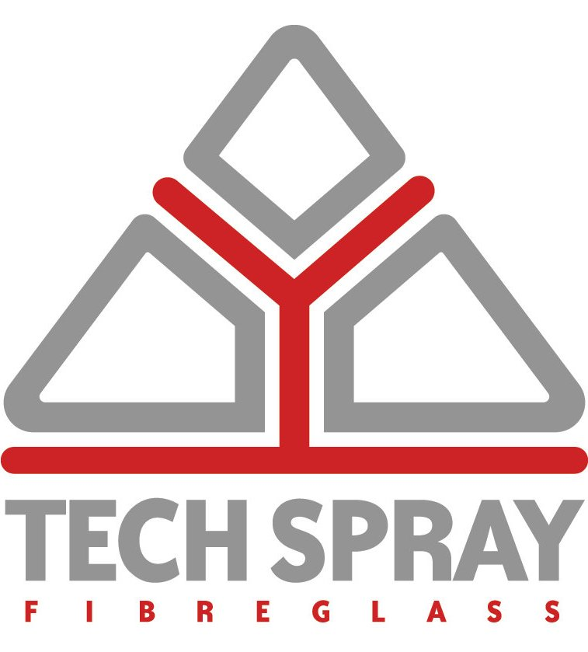

Dear sir or madam,

At Tech Spray Fibreglass Ltd we specialise in the manufacture of GRP using both spray and hand lay-up techniques. GRP stands for Glass Reinforced Plastic commonly known as Fibreglass. It is a product made with a thermosetting resin strengthened by the inclusion of glass as reinforcement. There are many types of resin system available to cope with particular applications and of course different grades of glass reinforcement.

With a wealth of experience in the field of GRP manufacture, repair and renewal along with commercial paint spraying we can assist you from the earliest stages of development through prototyping and mould manufacture to the production of the finished article across all industries including Leisure, Automotive, Train, Construction, Medical and other specialist markets. We endeavour to give our customers only the best customer service and the most competitive prices and are very proud of the quality of our products. Through constantly improving our already comprehensive range through innovative design and production techniques we endeavour to produce aesthetically pleasing and structurally sound products based on your original inspiration.
We are also one of Europe’s few GRP manufacturers that also operates a fully equipped in-house heated paint spraying facility ideal for applying designs and finishes across a wide range of products and materials including:
- GRP / Fibreglass
- Metal & Aluminium products
- Plastics
- Wooden Products
Our fully heated paint spraying booth is located within our 15,000sq ft manufacturing plant and is fully equipped with the most modern apparatus to ensure maximum quality finishes in excellent turnaround times. Our experienced team always provide a close attention to detail and our personalised, bespoke customer service ensures premium finish standards at very competitive prices for all customers no matter their size or industry.
In both our GRP production and spraying facilities we have vast experience in colour matching using RAL and British Standards colouring systems. Some of our happy customers include:
- Kia
- Imagination (Europe) Limited
- Autostyling Truckman
- Global Attractions Group
- Diamond Seating Limited
- House of Play (Europe)
- Zone Green

Remember at Tech Spray Fibreglass Ltd we are there for you and we want you to walk away with pride and confidence in the knowledge that we will give you exactly what you want. We view all enquiries equally and no matter what you require, we want you to be rest assured that you are our number one priority.

Yours truly,

Adam Green
Managing Director

