[www.justmobilesolutions.com](http://www.justmobilesolutions.com/)

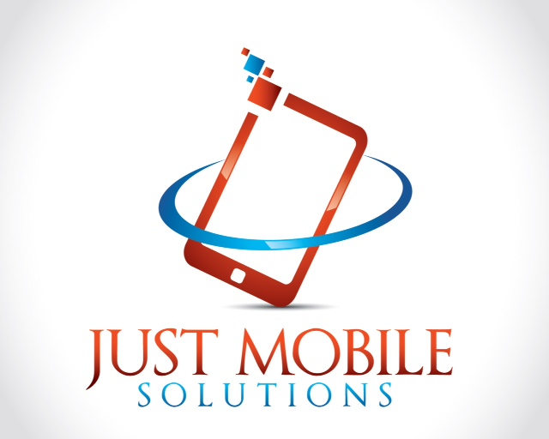

Dear Business Owner

Just Mobile Solutions is a full-service mobile marketing agency specializing in innovative and engaging mobile communication programs, promotions and campaigns. We offer you the chance to use our mobile marketing services and can provide you with the latest smart phone and tablet friendly website with the following benefits for your business:

* Your original online website will remain the same, but we can make it a ‘mobile’ friendly website.
* Customers will be able to call you directly by tapping the number or call now tab on the mobile website.
* The mobile website can have the same graphics as your online website.
* If you don’t have an online website we can still build and manage a mobile website for you.
* Customers can locate you via the find now tab on the mobile website.
* We can set up text message campaigns for special offers and discounts.
* Your mobile web site can have your services, prices, videos and photos.
* We can provide you with weekly analytical feedback on customers using your mobile site.
* We can create QR for your business adverts and literature.

We have included our business card and brochure with full details of the service that we can provide you with.

Please visit our website or contact us direct if you require any further information.

**We offer three levels of service as follows:**

|  |  |  |  |
| --- | --- | --- | --- |
| Mobile Website | Silver | Gold | Platinum |
| One-time set up fee | £250 | £325 | £450 |
| Pages | 3 | 3 - 5 | Up to 10 |
| Touch to Call Button | Yes | Yes | Yes |
| Touch to Map Button | Yes | Yes | Yes |
| Images | 5 | 10 | 20 |
| Slideshow | No | Yes | Yes |
| Page Views | Yes | Yes | Yes |
| Video | No | Yes | Yes |
| Site Changes/Updates | 1 | 5 | 10 |
| Weekly Analytics | Yes | Yes | Yes |
|  |  |  |  |
| Monthly Maintenance | Silver | Gold | Platinum |
| Monthly Fee | £20 | £30 | £40 |

**\*\*\* TRY US FOR FREE \*\*\***

**WE OFFER THE FIRST 30 DAYS FOR FREE WITH NO OBLIGATION**

Contact us today

And we will come and show you how we can help your business.

07462 817476

Or email

justmobilesolutions@gmail.com