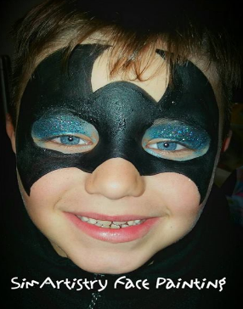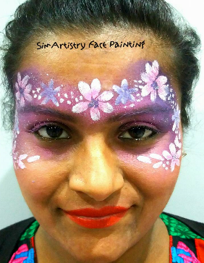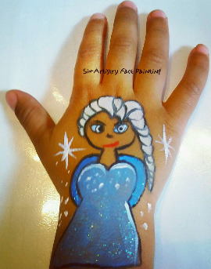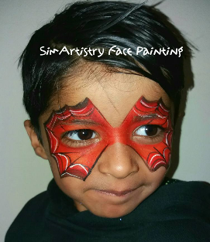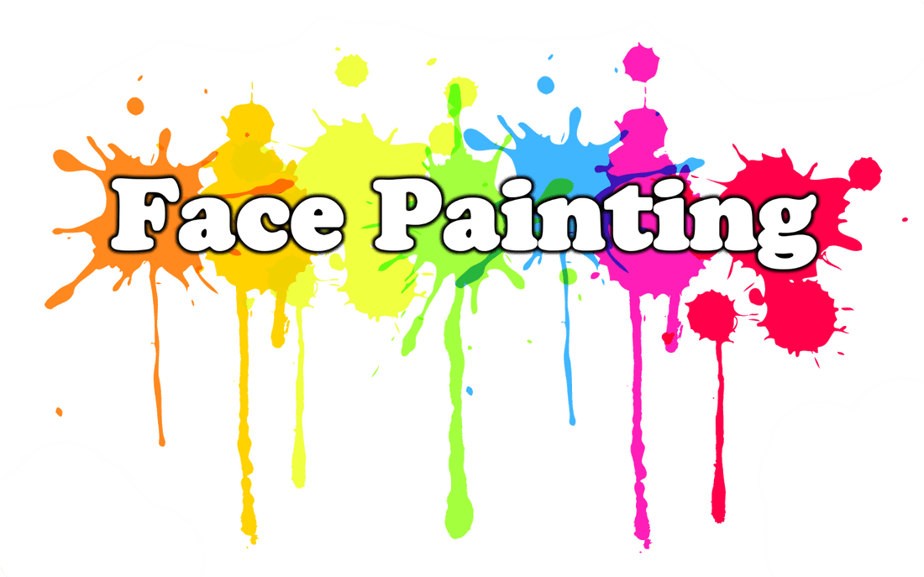 SimArtistry

**Fun Faces Created For Children & Adults!**

**Available for any special occasion**

* **Birthday Parties**
* **Family & Community Events**
* **Weddings & Christenings**
* **Mendhi & Pre Wedding-Events**
* **Charity & Family Fun Days**
* **Corporate Events**

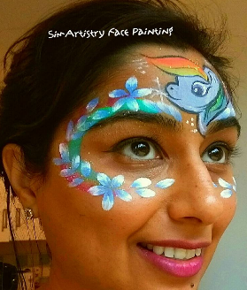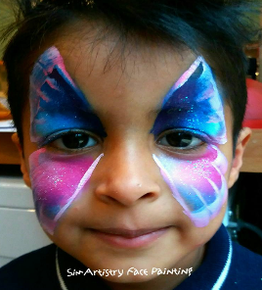

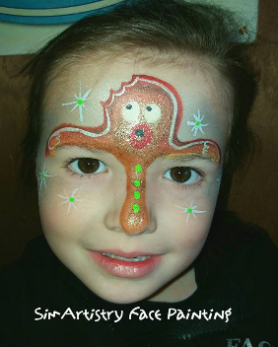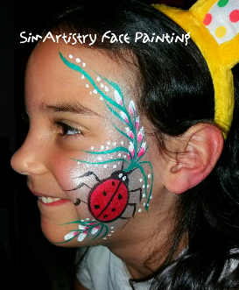

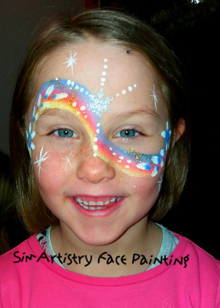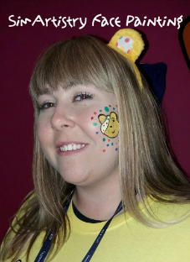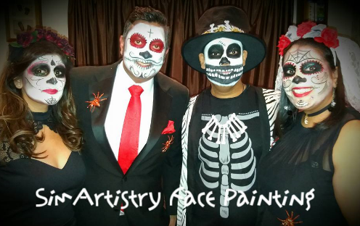

**For more information, contact Sima Umeria: 07859914995 or** [**simArtistry.facepainting@hotmail.com**](mailto:simArtistry.facepainting@hotmail.com)

**SimArtistry-Face Painting**

 **tbc**

Fully Insured and DBS Checked. Able to travel in Leicester only. Using products that are fully compliant with EU and FDA Cosmetic Regulations. Minimum age is 3 years. Painting can be done on face, arm or cheek. All the images on this poster are designed by SimArtistry – Face Painting

** Sima Umeria - 07859914995  simArtistry.facepainting@hotmail.com**

** SimArtistry – Face Painting  simartistry.facepainting**

**Contact me for more information and prices for your event.**