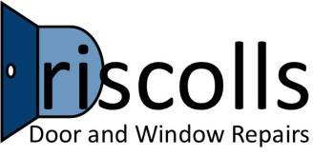
Serving Wakefield and West Yorkshire.

Do you have Windows and doors that have faulty or broken locks or hinges? You may be thinking about buying brand new windows? We say there may be no need!
Why replace windows and doors when you can have them repaired? More often than not you can have locks, hinges and mechanisms brought up like new. Windows and door repairs can be brought to look like their former glory and you can save yourself thousands of pounds in the meantime.
Just imagine the money you could save and have all your windows and doors looking like brand new again.
We have a totally free no quibble quote for all your window and door repairs.
Remember to contact us for more information.

We have over 25 years’ experience in Window and door repair, fitting, locks and mechanism we’ll even get you a shiny new letter box fitted if that’s what you need.

Windows are a main entry point for the burglar (obviously) don’t wait until it’s too late. Imagine getting home to find your windows have been broken and your possessions have been taken. Not only the psychological factor this can have on you and your family your insurance premiums go up. You may even want to move house.
Ensure all your windows and doors have the highest security possible. It’s a fact that some burglars will move to a neighbouring area if the property they pick has properly fitted security locks and hinges.
Not that we want to get your neighbours burgled but this is a fact that they check the lock mechanisms and more often than not leave your property alone is the prevention has already been put in place.
We would prefer to come round and secure your home properly than come round and repair your windows and doors after a break in.
Please feel free to visit us and ask us any questions at all regard your Window and door repairs in Wakefield.
Or call Marcus on

07549 140335 or 01924 782050

