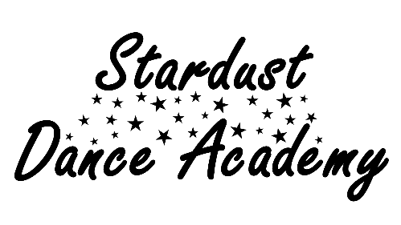
Registration Form

CHILD’S NAME:
CLASS(‘S) ATENDING
CHILD’S DATE OF BIRTH: |  | CURRENT AGE:
PARENT/GUARDIANS NAME:
E-MAIL ADDRESS:
(Please print clearly)
EMERGENCY CONTACT NUMBER:

Health Questions
Does your child have or ever experienced any of the following? | Please circle
A bone, joint or muscular problem? | Y / N
Asthma or any other respiratory problems? | Y / N
Any allergies? | Y / N
Is your child taking any medication? | Y / N
Has a doctor ever advised your child not to exercise? | Y / N
Is there any reason not mentioned above why any type of physical activity may not be suitable for your child? | Y / N
If you have answered YES to any of the above questions, please write full details here:

In signing this form, I the parent/guardian for the above named child, affirm that I have read this form in its entirety and have answered the questions accurately to the best of my knowledge. I also agree that I have read and agree to the Stardust Dance Academy Terms & Conditions as found on the website:
www.stardust-dance-and-fitness.co.uk.
Parent/Guardian Signature: ........................................................ Date: .................................

During the general course of activities such as classes, shows and performances there may be the opportunity to publicise Stardust Dance Academy which may involve images of your son/daughter. This could be photograph, video or web based images. It is a requirement of the Data Protection Act that we have your consent to use such images.
I hereby give permission to Hannah Batchelor and Stardust Dance Academy to use my child’s photographic likeness in all forms and media for advertising, trade, and any other lawful purposes.
Parent/Guardian Signature: ........................................................ Date: .................................

