BOOKING FORM

30 Mancroft Road Caddington Beds. LU1 4EL. Tel: 01582 730 000

Email: [info@riorodeo.com](mailto:info@riorodeo.com) Mobile: 07540 572 701

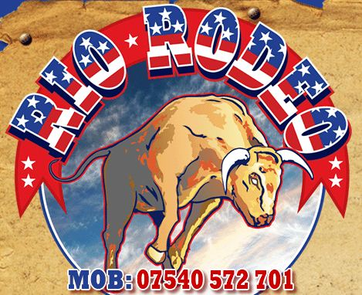

|  |  |  |  |  |  |  |  |  |  |  |  |
| --- | --- | --- | --- | --- | --- | --- | --- | --- | --- | --- | --- |
| **Contact/Company name:** |  | | | | | | | | | | |
| **Address:** |  | | | | | | | | | | |
| **Contact details:** | ***Office:*** | | |  | | | | | | | |
| ***Home:*** | | |  | | | | | | | |
| ***Mobile:*** | | |  | | | | | | | |
| ***Email:*** | | |  | | | | | | | |
| **Day & date of function:** |  | | | | | | | | | | |
| **Time of hire:** | ***From:*** | |  | | | | | ***Until:*** | |  | |
| **Function address:** |  | | | | | | | | | | |
| **Type of function:** |  | | | | | | | | | | |
| **Motion unit required:** | ***Real Bull / Reindeer / Horse/ Unicorn / Sheep / Surfboard / Pig / Pumpkin / Football / Rugby Ball / Spider / Beach Ball / Disk/Dragon / Rodeo Camel Magic Carpet / Meteor Mayhem*** | | | | | | | | | | |
| ***Inflatable:*** | ***Black / Purple Halloween themed*** | ***Yellow /***  ***Western style*** | | | | | ***White /  Xmas themed*** | | ***Cream / Beach Themed*** | | ***Pig / Bull Pen*** |
| **Western Games *and Side games:*** | ***Yes*** | | | | ***No*** | | | | | | |
| **Marquee & Lighting:** | ***Possibly / Yes*** | | | | ***No*** | | | | | | |
| **Dress Code / fancy dress choice:** |  | | | | | | | | | | |
| *Additional information ie. car parking facilities/costs / additional operator/any other special requests* |  | | | | | | | | | | |
| **Price Charged:** | | | | | | **£ payable on arrival** | | | | | |
| Deposit required  *(payable immediately by cheque payable to B Johnson,  or BACS payment to: HSBC Bank, Sort Code 40-23-11, Account No. 31282611.)* | | | | | |  | | | | | |
| Balance outstanding  *(payable one week prior to function by cheque payable to B Johnson,  or by BACS to:  HSBC Bank, Sort Code 40-23-11, Account No. 31282611. …or cash upon arrival if agreed with Rio Rodeo beforehand.)* | | | | | |  | | | | | |
| How did client hear of us/booked through | | | | | |  | | | | | |
| Date booking made | | | | | |  | | | | | |
| Rio Rodeo Mobile Contact | | | | | | Bonnie on 07540 572 701 or Liam on 07530 756 911 | | | | | |