**Heavy Sheet Metal Fabrication Manufacturers in India**

Blue Peter group is one of the leading heavy sheet metal fabrication manufacturers, two wheeler saddles, central heating system, design & development, progressive tools and die, jig fixtures, strip layouts, and CNC precision components manufacturer in India. When a company provides a wide range of products with unmatched service, it climbs the ladder of success to reach the apex position. The dedicated effort of the team and years of experience have made Blue Peter Group one of the leading names in the industry. When we talk about heavy metal sheet fabrication or CNC precision components manufacturer in India, Blue Peter Group is always at the top.

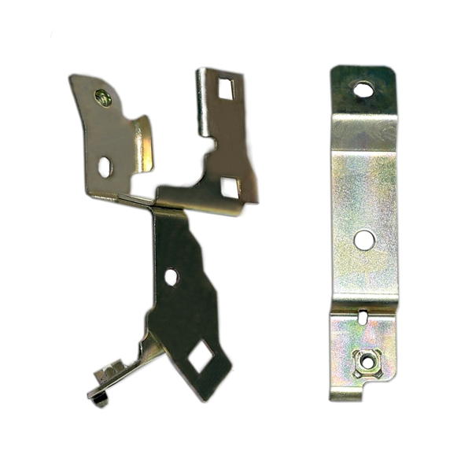

Owing to the high proficiency Blue Peter Group offers state of the art sheet metal assemblies and is one of the leading [**heavy sheet metal fabrication manufacturers in India**](http://www.bluepeterindia.com/Product.php). Their products for precision sheet metal components are widely known for the use of top quality raw materials like mild steel, aluminum, brass, and stainless steel. It is the perfect combination of best in class products and impeccable service that Blue Peter Group has become the leading heavy sheet metal fabrication manufacturer and top **CNC precision components manufacturer in India**.

Their well designed products and stringent quality checks ensure that clients get nothing but the best. Innovative thinking along with latest technology has made it possible to bring out state of the art products that match international quality.

There are numerous precision components manufacturers in India, but when listing the top CNC precision components manufacturer in India, Blue Peter Group is a name that cannot be missed. With a wide range of high quality products, the company has become the preferred choice of many. The key driving force for the company is quality and it is true that clients never have to make compromise on quality. For Blue Peter Group, attaining the highest level of customer satisfaction is also of utmost importance. [**http://www.bluepeterindia.com/**](http://www.bluepeterindia.com/)

**Contact Us:-**

8/41,, Block 8, Kirti Nagar Industrial Area, Kirti Nagar, New Delhi, Delhi 110015, India

**Phone No:-** 01123270216

**Email:-** info@bluepeterindia.com